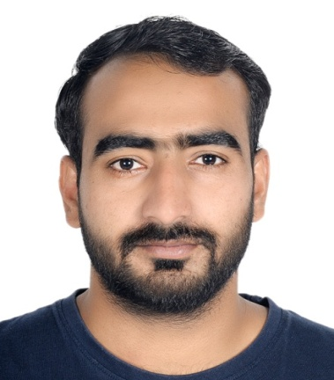 |  | shoaib khan  Contact - +971 525316058  Shoaib.eo77@gmail.com
Profile  To work in Dynamic organizations where efforts are recognized and rewarded through elevation in status and where ample opportunities for learning and career advancement exist & to ensure effective and efficient utilization in finance sides. Goal oriented, Analytical, Quick learner, Adjustable, Team worker, can work well in stressful conditions, good communication and writing skills. An experienced and having ample of knowledge in Document controller & Store keeper field.  EDUcation  B ,A  Diploma in agriculture -(Archery P. Road Agriculture University of  Peshawar of Pakistan  Technical skills  Operating systems: Windows –98, MS window -2000XP, MS updated.  Application: MS office, Tally  Typing: High.  Programing language: VB NET.  Personal details  Name – Shoaib khan  Father’s Name –Rahim Bakshah  Nationality – Pakistani  Gender – Male  Material status – single  Date of Birth – 3rd Fub 1991  Language known – English, Hindi Arabic  Passport details  Passport no – CTI4130632  Issue Date – 25-07-2019  Expiry Date – 23-07-2024  Place of issue –Pakistani  Visa status – Employment.  Technical skills  Operating systems: Windows –98, MS window -2000XP, MS updated.  Application: MS office, Tally  Typing: High.  Programing language: VB NET |  | WORK EXPERIENCE  CUSTOMER SERVEC & Document controller  Engineering office -Dubai  2018 - Present  Being receptionist we meet and greet customers,  Providing a positive and friendly attitude  Coordinate all activities related to Document controller system, Including technical documents, Shop drawings, Request for Information (RFI) and other related correspondences.  Receives and stamp incoming official document from project site and office.  Input & Output documents data into the standard registers (log) ensuring that the information is accurate and up date for distribution purposes.  Ensure that controlled copies of latest approved documents are given to the appropriate employee or affiliated organization.  Creates folders and segregates files in the system (server) for each disciplines related to structural, Architectural and MEP for the department.  Categorize the file based on their latest revision, supersedes the unnecessary for safekeeping and record.  Preparing progress reports for the submittal documents on daily basis.  Preparing transmittal / Submittal for RFI, AFA, NCR, SIR, shop drawings and any types of documents for official submission for project site and office.  Ensures proper document classification, Sorting, filling and proper electronic archiving.  Scanning, Image, Organize and maintain hard copies of documents for record purposes.  Typing of memo’s and letter for project and office.  Store keeper  Engineering office -Dubai  2015 - 2018  Prepares SRV (Store Receipt voucher) against purchase orders and SDR (Supply discrepancy) if any material discrepancy found against PO and packing  list/  MESC (Material Equipment Standardization code) number to be marked each piece of material for proper identification.  Small item to binned in a sequence and bulk item to be located at pallet racks. Location number to be marked in SRV for inputting in computer.  Identify any damages during the course of the inspection process and generate the overage damage shortage report (OSDR) for forwarding procurement department as well as the concerned official.  Doing all type of materials transferring from store to store physically.  Doing manual checking for stock. Attending stock checkers and auditors. Attending all type of queries form inputting in computer.  Attending all type of queries from procurement, Inspection and operation department. Assigns and checks work of subordinates.  Supervises the training of new employees.  Generate daily and weekly report on the material received status, OSDR’s Inventory status as well as material requisition status and forward it to the respective engineers as well as the corporate office  Provide input on all the material requisition notes the availability of the same on site and status of any pending arrival

- Carry out any other duties as requested by the direct supervisor.
- Responsible for receiving, Checking and issuing the structural instrumentation and equipment spare parts required by operation department.

Was copleated in working filed projcts
- CONSTRUCTION OF AMALFI LAUXRY VILLAS AT ISLAND 2, JUMAIRAH
- CONSTRUCTION OF LAST EXIT @ AL LISSILLI
- CONSTRUCTION OF LAST EXIT @ JEBL ALI
- CONSTRUCTION OF LAST EXIT @ Al KHAWANEEJ
- CONSTRUCTION HORSE STABLE @ STUD FARAM
- CONSTURCTION DOG KENEL @ NADHAL SHEBA
- CONSTRUCTION OF FALCON HOUSE @ MARGUM
- CONSTRUCTION OF STAFF ACCOMMDATION @ NAKHALI PALACE
- CONSTRUCTION OF M7 STABLE @ AL LISSILLI
- CONSTRUCTION OF LAMER VILLAS @ JUMEIRAH

Self – declaration
II hereby declare that above mentioned information is correct up to the best of my knowledge and I bear the responsibility for the correctness of the above mentioned particulars.

Shoaib khan

