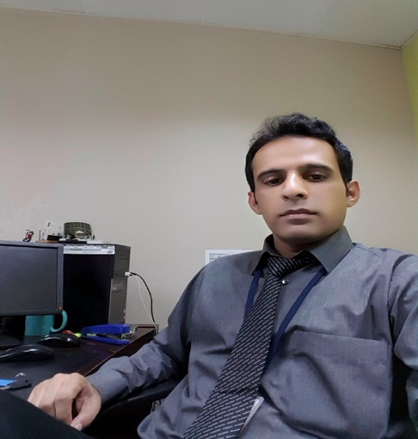

**Place picture with white background**

**Haroon Arshad**

***Experienced Sales & Retail Operations Specialist***





Haroon-Arshad

onlyharoon@gmail.com

EF1916851



+92 30004605666





November 28, 1984

Why ***Haroon?***

* Self-driven & detail-oriented professional having 11+ years of experience in retail operations, purchasing & buying management, business development, brand building, distribution strategy, channel management and promotional activities; possesses expertise in key accounts management, B2B/B2C sales, market & competitive analysis, corporate sales agreement, sales analysis, strategic planning and market intelligence & segmentation
* Performance-oriented professional with potential to propel organization to top tier of its industry by utilizing communication & management skills; possesses strong professional background in procurement management, inventory management & warehouse management with extensive knowledge of store requisition, store return, material transfer & rejection note, negotiating contracts, drafting bills and analyzing work-place efficiency
* Active team player capable of exhibiting eminent multitasking abilities; highly skilled in product positioning & launch, category management & market share rating. Proficient at conveying skills in merchandising & planning trade marketing strategy to map potential customers, generate leads and accelerate business growth
* Level-headed professional with skills in strengthening public relations & streamlining processes, command on market data analysis while analyzing consumer behavior; has demonstrated ability in portfolio management

|  |  |  |  |
| --- | --- | --- | --- |
| **CORE STRENGTHS & ENABLING SKILLS** | | | |
| * Sales Analysis & Management * Retail Operations Management * Purchasing Management | * Business Development * Inventory Management * Warehouse Management | * Business Reporting Skills * Team Building & Leadership Skills * Communication & Presentation Skills | |

|  |
| --- |
| **MAJOR ACHIEVEMENTS** |

* Achieved ***Certificate of Recognition*** from Carrefour for opening of 1st store in Pakistan
* Selected to serve for successful opening of 2nd store at Dolmen Mall Karachi
* Participated as Household Eastern region In-charge in expanding Danube Markets in Eastern region KSA

**PROFESSIONAL EXPERIENCE**

**Tamimi Market, Riyadh, KSA**

Working as ***“Stock Control Manager”,*** September 2019 – January 2021

**Responsibilities/Accomplishments:**

* Proficiently reconciling inventory by recording deliveries & shipments on daily basis while analyzing demand and documenting characteristics of inventory. Anticipating future trends while evaluating data
* Skillfully placing orders to replenish stock & avoid overstocking. Fostering positive relationships as well as evaluating suppliers and negotiating contracts to secure cost-effective deals by using best fit practices
* Maintaining coordination with warehouse employees & other staff to achieve business & revenue growth. Formulating reports related to stock levels and issues to senior management for process improvements

**Tamimi Market, Riyadh, KSA**

Worked as ***“Assistant Store Manager”,*** June 2017 – August 2019

**Responsibilities/Accomplishments:**

* Spearheaded team of professionals, injected motivation and conducted training needs analysis of staff members while developing sales targets and conducting meetings with all associates for smooth working
* Adroitly executed purchasing process of new items while monitoring stock levels. Addressed & resolved customers complaints and queries while handling employees’ conflicts and problems in accurate manner
* Rendered expertise in preparing various promotional materials & in-store displays as well as skillfully ensured store location standards in collaboration with head office as per company’s rules and regulations

**Danube Hypermarket, Khobar, KSA**

Worked as ***“Household Department Manager”,*** March 2014 – April 2017

**Responsibilities/Accomplishments:**

* Analyzed performance of team while overseeing sales activities. Delivered excellent customers services while greeting customers and addressing queries and complaints to achieve higher customer satisfaction
* Supervised team of sales, inventory-taking & customer services professionals while managing inventory stock & reordering process. Actively oversaw department’s slow moving & sleeping stock on weekly basis
* Scrutinized merchandising process while ensuring pricing and visibility of company’s product at stores while guiding staff on difficult & complicated sales. Resourcefully executed weekly household promotions

**Carrefour MAF Hypermarket, Lahore, Pakistan**

Worked as ***“Section Manager – Textile”,*** March 2009 – February 2014

**Responsibilities/Accomplishments:**

* Skillfully coordinated with suppliers for new merchandising to reduce cost and achieve revenue & business growth. Aptly oversaw competitors’ prices & activities to maintain lowest selling price in market
* Utilized key skills in new display techniques for capturing customers’ interest. Prepared schedule of more than 25 employees, adroitly organized staff & stock on daily basis and proactively conducted official visits
* Competently handled seasonally and yearly stock audit while arranging products barcode wise. Executed daily stock ordering while managing warehouse & selling area and selecting new products & promotions
* Supported in market price and product comparisons while allocating & planning spaces for extra displays and promotions. Escalated root causes & issues of products and prices while interacting with head office

**HKB – DHA Branch, Lahore, Pakistan**

Worked as ***“Asst. Floor Manager”,*** August 2008 – March 2009

**Responsibilities/Accomplishments:**

* Adroitly managed ordering process of garments while executing promotional activities to achieve daily & monthly sales targets. Efficiently maintained record of inventory & formulated sales report to accountant
* Effectively managed internal transfer of stock IN & OUT while balancing demand and supply combination of stock. Supported in scheduling of 15+ employees, displaying items and increasing customer satisfaction

**PROFESSIONAL TRAININGS & CERTIFICATIONS**

* Attended Diploma in **“Supply Chain Management”**, University of Punjab, Lahore (2008)
* Attended Certification in **“Computer Basic”**, Bader Institute , Hasilpur (2005)

**PROFESSIONAL QUALIFICATION**

* **Bahauddin Zakariya University, Multan, Pakistan** (2003 – 2005)

B.Sc.

**HOME ADDRESS**

* House -12, Block-5, Police Flat, Misri Shah, Lahore

**LINKEDIN RECOMMENDATION**