**APPLYING FOR SALES ASSISTANT**

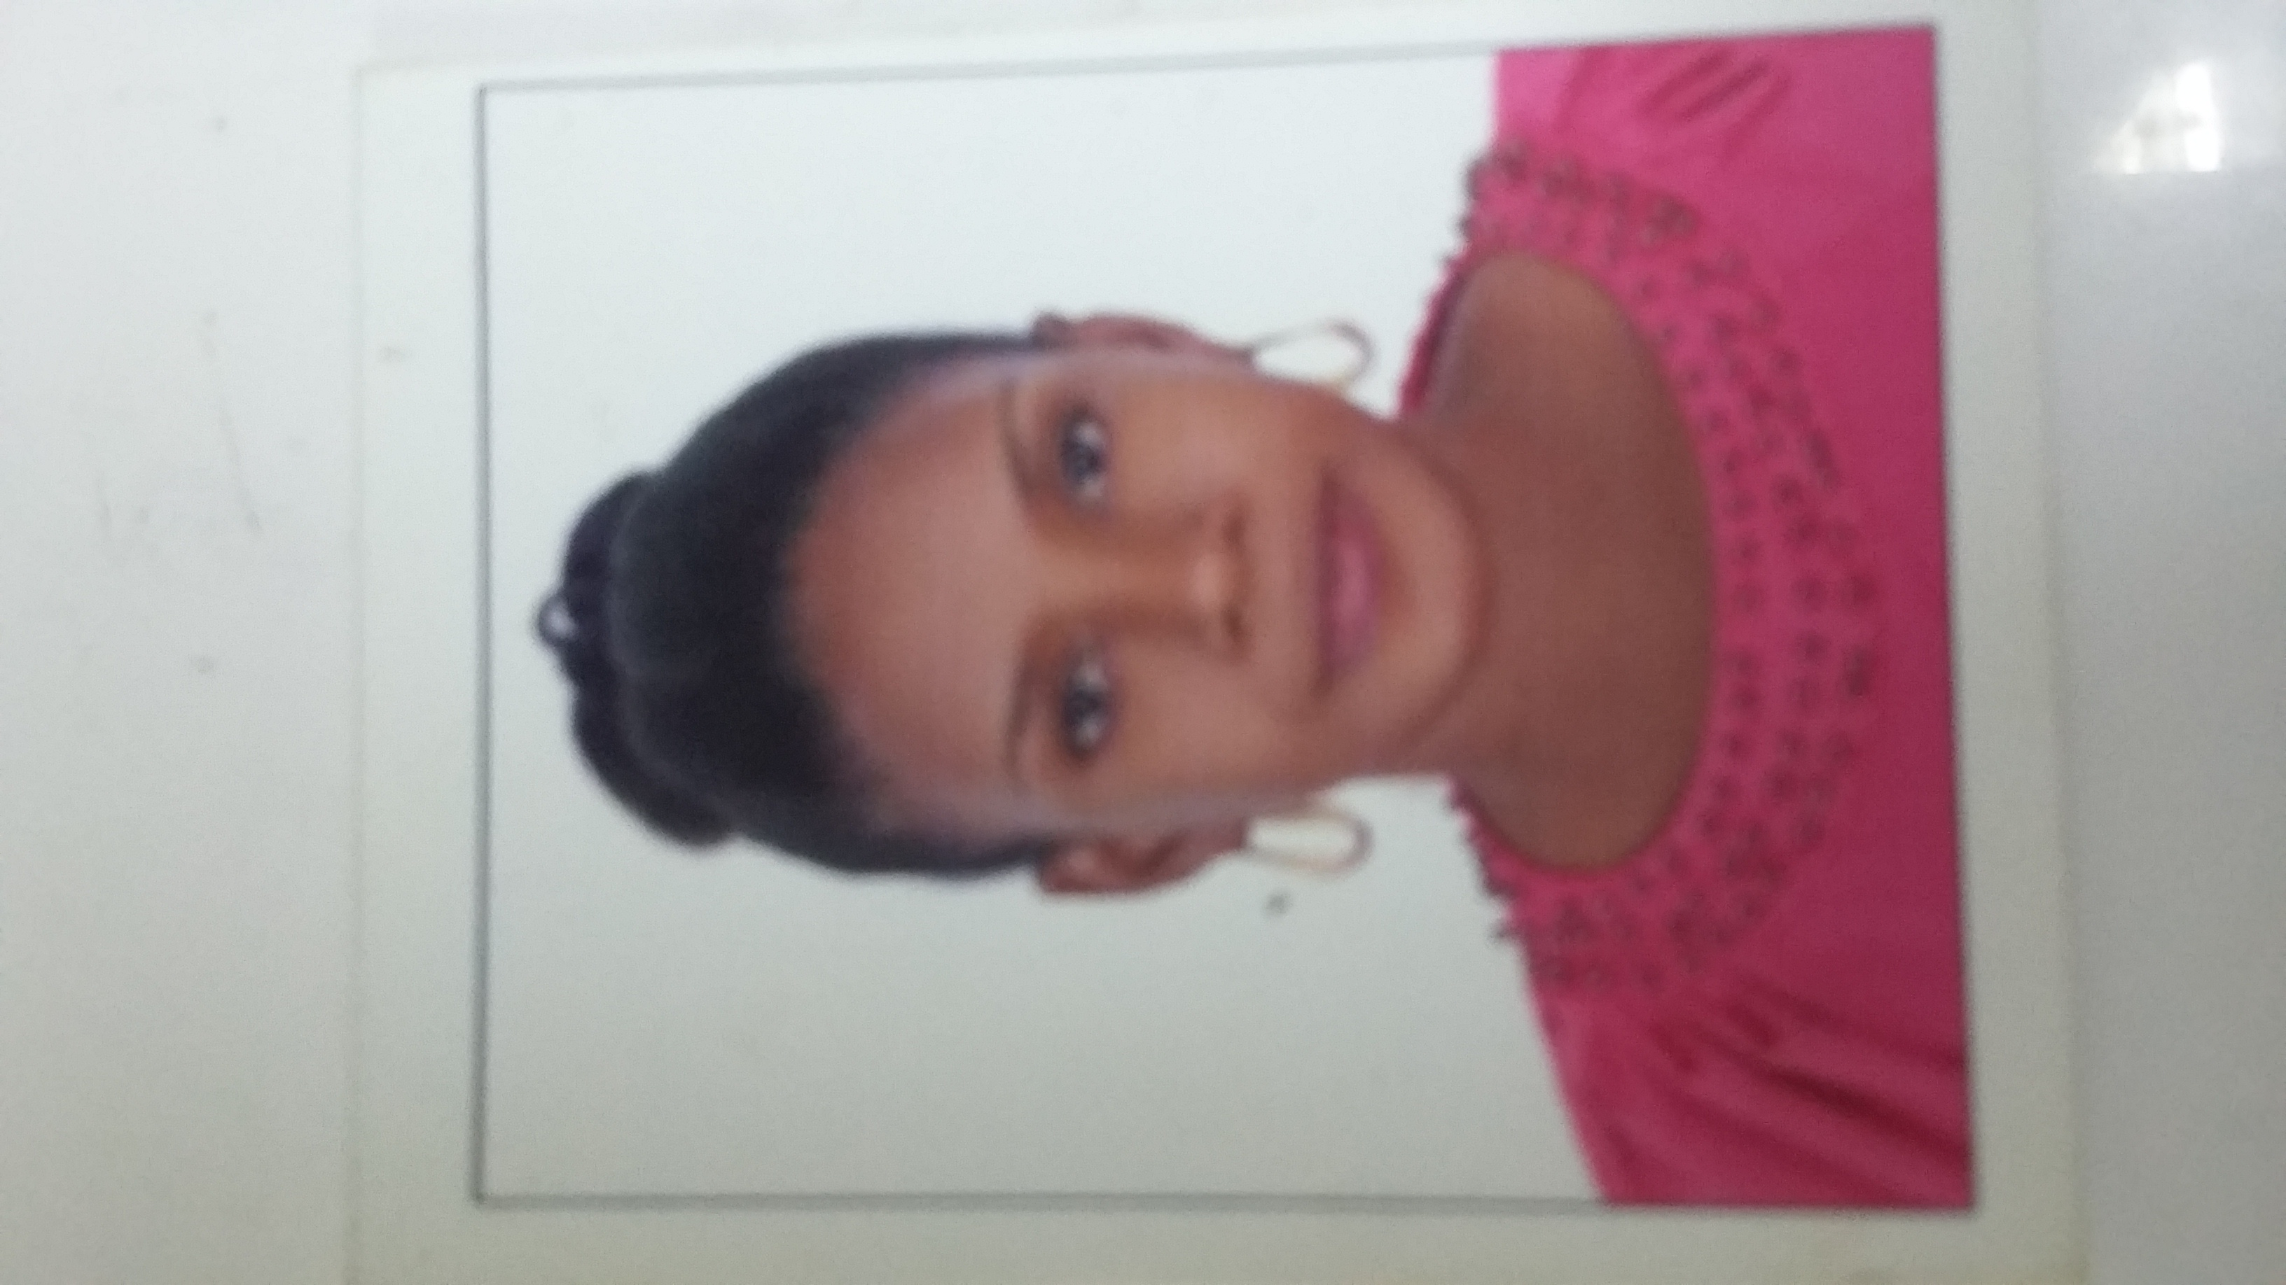 **Aisha Kagoya**

Mobile: +971589819704

Email:

[akgoya50@gmail.com](mailto:akgoya50@gmail.com )

Location: Abu Dhabi UAE

Visa Status: Employment

**Objective:**

I have a high-quality personal service to all customers. I soon learned the intricacies of the roles and made sure I gained full knowledge of each company’s stock to ensure all customer queries were handled. I am happy to work as part of a team, but also use my initiative when necessary. I work well under pressure

**Work Experience:**

Company: AL DANA NURSERY SCHOOL

Inclusive dates: 1 year and 7 month

Position: Assistant Teacher

**RESPONSIBILITIES:**

* Work with the lead teacher to monitor the class schedule.
* Assist teachers with lesson preparation by getting materials ready and setting up equipment.
* Revise lesson material with students individually or in small groups.
* Ensure the classroom environment is safe and clean.
* Oversee students during non-classroom times including in-between classes, during lunch, and on field excursions.
* Help lead teachers to create lesson plans.

**RESPONSIBILITIES:**

* MS Office
* Excellent communication skills
* Highly patient
* Great people skills

**Work Experience:**

Company: Kinkizi traders (Kampala,Uganda)

Inclusive dates: 3 years

Position: Sales Assistant

**RESPONSIBILITIES:**

# Building great relationships with customers, colleagues, and suppliers.

# Ensured that the visual standards of the store met the company’s high standards.

# Strong organisational and planning skills with close attention to detail.

# Completing transactions at the checkout.

# Gained valuable experience in using effective sales techniques.

**PERSONAL ATTRIBUTE:**

* Am always available and I can work any time
* Am a problem solver
* Am extremely easy to correct
* I can fit in any department
* I will never question your decisions

**Educational Qualification:**

* A Level Certificate

I **Aisha Kagoya** hereby declare that all the information furnished above is true and correct to the best of my knowledge and belief.