**Customer Service Agent, Sales Agent, Cashier**

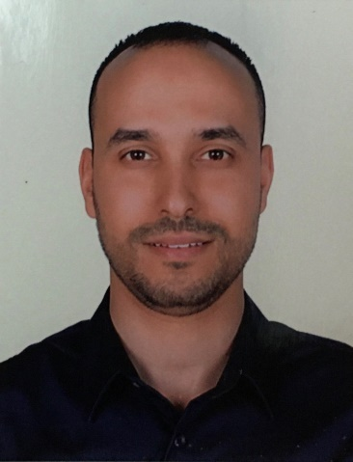

**Mohamed Ben Ameur**  Tunisian Nationality

Dubai, United Arab Emirates Married

Mobile +971-567424549 17 April 1982

Email: rientog@gmail.com UAE Driving License

Looking forward to join a progressive organization where I can pursue a successful career by utilizing my skills, abilities and experience to the maximum extent with full potential. Being a professional, I feel confident that I can achieve level performance, which is nothing short to perfection.

Sales and customer service professional with over 13-year experience and proven talent for making new contacts, closing orders, and generating repeat/referral business through effective account management and excellent customer service. Exceptional communication, presentation, and negotiation skills with an outstanding ability to earn customer loyalty. Ability to apply strong problem-solving skills, persistence, and resourcefulness to achieve positive results.

**• Trilingual; Arabic, English and French. • Leadership Development**

**• Quality and Productivity Improvement • Public Relations**

**• Problem Resolution • Performance Evaluations**

**• Personnel Supervision • Cross-Cultural Communications**

**• Well-Developed Listening Skills • Time Management**

**• Oral Communication • Very pleasant personality.**

**Professional Experience**

***Juin 2016 to present MERAAS HOLDING, DUABI, U.A.E***

***Customer Service Agent /Retail Associate/Cashier***

* Greeted customers and determined their needs and wants
* Discussed type, quality and number of merchandise required for purchase
* Recommended merchandise based on individual requirements
* Advised customers on utilization and care of merchandise
* Provided advice to clients regarding particular products or services
* Explained the use and advantage of merchandise to customers
* Answered customers’ queries and concerns
* Demonstrated live working of items
* Prepared sales contracts and accepted payment through cash or credit card
* Assisted in display of merchandise
* Maintained sales records for inventory control
* Investigate customer complaints and provide solutions accordingly

***August 2013 to April 2016* SAMSUNG GULF ELECTRONICS, DUBAI, U.A.E**

***Sales Assistance \ Customer service Agent***

***Mobile and IT Department***

* Offering customers products and services
* Performing administrative functions
* Responsibility of dealing with customer complaints
* Take charge of the customer by pointing him/her in the direction of what he/she is looking for.
* Maintains customer rapport by explaining estimates and expected return of products; obtaining customer's approval of estimates; obtaining and providing contact telephone numbers; answering questions and concerns;
* Developed and implemented a range of marketing operations.
* Trains establishment personnel in equipment use, utilizing knowledge of electronics and product sold.
* Recommends equipment to meet customer requirements, considering salable features, such as flexibility, cost, capacity, and economy of operation.
* Maintain and develop good relationship with customers through personal contact or meetings or via telephone etc.
* Provide accurate feedback on future buying trends to their respective employers.

***2011 to 2013* SALES ASSISTANCE \ CUSTOMER SERVICE AGENT**

**GEANT HYPERMARKET, DUBAI, UAE**

**Mobile and Electronics department**

* Manage selling and customer service activities, so to optimize and sustain sales performance, profitability and customer satisfaction.
* Manage costs, overheads and all factors affecting the profitable performance of shop.
* Dealing all inquiries needs of the customers.
* Utilize a guest quality service and cleanliness to enhance guest’s satisfaction.
* Follow through promptly to resolve customer complaints.
* Follow up, encouraging customer to return.

***2006 to 2011 Customer Service Agent***

***Orange Telecommunication Company***

**Tunis, Tunisia**

* Ensured that distribution, merchandising, and price-point objectives were achieved.
* Ensured efficient operation of all stockroom and back stock areas.
* Engaged clients and make them loyal by conveying brand values.
* Coordinated sales and promotional activity of store managers.
* Developed and implemented a range of marketing operations

***EDUCATION***

* SECRETERIAL SKILLS COMPUTER AND INTERNET CERTIFICATE - 2010
* BLS-AED Certificate (European Resuscitation Council) – 2010
* Instructor course Certificate (European Resuscitation Council) – 2010
* NURSING ASSISTANT CERTIFICATE – 2010
* BACCALAUREATE CERTIFICATE – 2004

**Languages**

* Arabic - Mother tongue
* English - Fluent
* French – Fluent

**Personal Interests**

Cinema, sport, economics, sociology, aircraft and aviation, travel.

**References on request**

***MR Mohamed El Arabi***

***Commercial Coordinator***

***0507195169***

***0565348224***