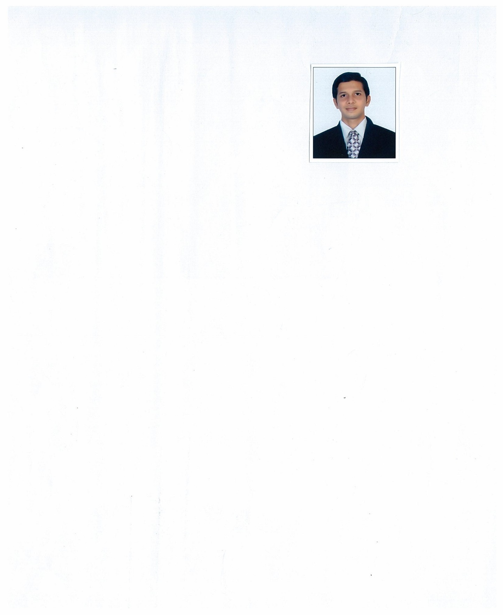 k. Rajasha

# 

|  |  |
| --- | --- |
| **Contact No:**  Mobile: 09962437552  Saudi No: +9660508039228  Skype ID: rajasha552@yahoo.co.in  **E-mail: -** [Rajasha2016@gmail.com](mailto:Rajasha2016@gmail.com)Address for Communication: No.25 Tiruvalur street  Chennai - 600088 Personal Details: Father’s name: D. Kumar  Candidate Name: k. Rajasha  Date of Birth : 16-05-1986  Age : 36  Sex : Male  Nationality : Indian.  Marital status: unmarried.  Passport No : T5943070  Date of issue: 08-05-2019  Date of expiry: 07-05-2029  Place of issue: Chennai  **Languages Known:**  English, Tamil, Hindi  **Extra Curricular Activities:**  Yoga and swimming  Participated in yoga competitions in International, State & District level | Objective:  To obtain a position that allows me to utilize my skills to pursue a challenging career and grow with the organization.  Education:   * Bachelors Degree in Commerce * Diploma in Airport Management in Frankfinn Institute   Technical Skills:  Operating Systems: All Windows based Operating Systems (Basic)  Tools : MS Word, Excel, PowerPoint, (DCA), Tally ERP 9  **Typewriting** : Higher and Lower in both English & Tamil, Office Automation course  Personal Attributes:   * Result oriented attitude & self control. * Enjoy working in a team * Flexible and adaptable to changing priorities   Professional Experience:  Organization: **TVS Electronics**  Duration : August 2009 to December 2009  Position : Customer Service Executive, sending mails,etc (office job)  **Organization**:  **Indigo Airlines**  Duration: Jan 12, 2010 to Feb 28, 2014  Position: Customer service Agent& Security (Dual functions)  Document Filing, Receiving Couriers, sending mails, staff ID updating, Passengers Boarding pass check-in, Safety & Security Measures  **Organization: Air costa Airlines**  Duration : March 7, 2014 to Oct 30, 2016  Position : Sr.Customer Security Executive  Staff attendance, Documents filing, Xerox, other office related jobs  **Organization** : **Phoenix International WLL (QATAR)**  Duration : Nov 2,2016 to till June 30, 2017  Position : Office co-ordinator updating customers Annual Agreements contract, Tracking, Time sheet, Leave Record, Exit Form  **Organization**: **HERMES I TICKETS PVT LTD**  Duration : From Sep 2017 to Nov 2019  Position: : Customer support Executive (Handling customer calls, Solving queries, staff Attendance etc.) and Admin related job |

**Organization: ACGC (Arabian Castles for General Contracting Company)**

**Position:** **SITE ADMINISTRATIOR** in **King Salman Air Base** (**opt & Maintenance**) Saudi Arabia, Riyadh

Duration: From 16th Dec 2019 till Date

**Job Description**: Accommodation In charge, Site In charge, Site Accounts Petty cash report to be Maintained in Excel, Time Sheets of Staffs doing in SAP, Man hours, Man power updating, Monitoring of Warehouse Materials Incoming & Outing, Staffs Annual Leave Request sending to Head office, Local Leave Request, Passport Renewal, Base pass Renewals, Document Control, sending Manpower list to Head Office, MPR Reports, Mail Receiving & Sending from Head Office, Vehicle Renewal and Expiry follow up, Monthly and Weekly Reports, Over all Site and Villa Activities. Meet & Assist. Opening Bank Accounts for New staff, Villa Hygienic Check with Safety Staff. Exit Staffs Documents sending to Head office, Over Time Request Sending to Head office for Approval, Memo’s to be filed in the Staff board, Meet & Assist of Project Manager, MD etc. from Head office looking for arrangements, Arranging New Staffs Induction Training, Worked in BAE Software A Site, System of New staff Request to IT etc.

**Area of interest:**

* Administration
* Hospitality management
* Airline
* Customer Service

**Academic Qualifications:**

|  |  |  |  |
| --- | --- | --- | --- |
| COURSE | BOARD/  UNIVERSITY | SCHOOL/  COLLEGE | YEAR OF PASSING |
| **Diploma in Airport Management** | Frankfinn Institute of Airhostess Training, Nungambakkam, Chennai | .  Frank Finn Institute | 2010 |
| B.com (CS) | Madras University | Guru Nanak college | 2008 |
| Higher Secondary Education  [Plus two] | State Board | Nehru Govt.Higher secondary school | 2005 |
| Secondary School Leaving Certificate [SSLC] | State Board | Nehru Govt.Higher secondary school | 2003 |

Declaration:

I here by confirm that the details furnished above are true to the best of my knowledge and understanding.

Date:

Place: Chennai **RAJASHA.K**