**CURRICULUM VITAE**

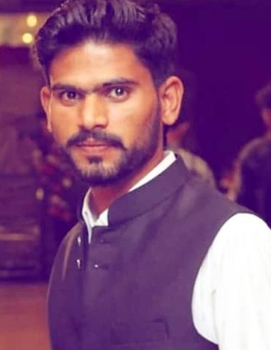

**QASIM HUSSAIN**

**+971 52 478 0380 (UAE)**

**+92 3018895277**

**Dubai, UAE**

**Email: hussainqasim044@gmail.com**

OBJECTIVE: **MOTORBIKE messenger**

To seek a suitable position, utilizing my skills and experience to contribute towards the progress of the organization at the same time as having the prospect for professional growth and development of my career.

EDUCATIONAL QUALIFICATIONS:

# 12th Passed at Government College Sheikhupura.

EXPERIENCE :

* **Nfpc as a oprearter**
* **Worked as a “Helper” with “China State Contracting” L.L.C in Dubai, for 2 years.**

PERSONAL SKILLS:

# Having a friendly and engaging personality.

# Comfortable working with members of the public.

# Have a confident manner, helpful and polite.

# Able to work smart appearance and articulate.

# Good written and oral communication skills as well as documentation skills.

PERSONAL PROFILES:

* Name : Qasim Hussain
* Father Name : Muhammad Sarwar
* Date of Birth : 11.10.1987
* Nationality : Pakistani
* Gender : Male
* Religion : Islam
* Marital Status : Single
* Languages Known : Urdu & English
* Passport no : XL 6892301
* Date of Issue : 15.02.2013
* Date of Expiry : 13.02.2023
* Date Of Place : Pakistan
* Visa states
* Visit vi :

CONCLUSION & DECLARATION:

I hereby declare that the above mentioned statement is correct and true to the best of my knowledge & belief.

**QASIM HUSSAIN**