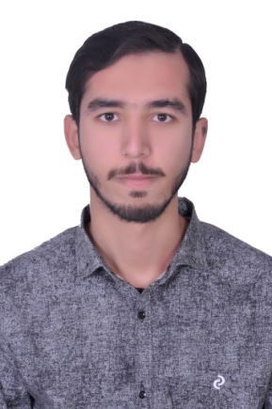

**FARAZ AHMED**

CONTACT DETAILS

MOB: +971544648399

EMAIL: mianfarazahmed111@gmail.com

CURRENT ADRESS: Al Muroor road, near Al Wahda mall Abu Dhabi.

**OBJECTIVE:** Acquiring professional skills, Improvement in interpersonal skills, Building long term professional relationships,

Applying skills and expertise to achieve both organizational and personal goals.

**QUALIFICATION:**

* MATRICULATION Board of Intermediate and Secondary Education

Gujranwala Pakistan (2012)

* PROFESSIONAL DIPLOMA DAE from Punjab board of Technical

Education Lahore ( 2015) with ‘A’ Grade in Civil.

* PROFESSIONAL DEGREE BSC in Civil Tech From Superior University

Lahore with ‘A’ Grade ( 2021)

**WORK EXPERIENCES:**

1. Company Name: **AZAN Associates Engineering and Construction**.

Job Title: Site Engineering and Draftsman (1 Year)

Work Include:

1. Estimate for construction.
2. Making Layouts and work on it.
3. Reading Sectional drawings.
4. Reading Architectural drawings.
5. Land Surveying.
6. Working on Interior and Exterior drawings.
7. Project Planning.
8. Checking of Excavator work during Excavation.
9. Working on Structural drawings.
10. Inspection of farm work.
11. **Office Computer Designing Master:**

Worked as Auto-Cad operator( 1 Year)

**PERSONAL DETAILS:**

* Nationality : Pakistani
* Passport No : SW1178421
* Date of Birth : 13-09-1995
* Material Status : Single
* Language Spoken : Fluent in English

Fluent in Urdu, Punjabi and Hindi

* Visa Status : Visit Visa (3 months)

**SOFTWARE SKILLS:**

* Auto-Cad (2D+3D)
* MS OFFICE
* Solving Computer Problems
* Solving Windows Problems

**Interest:**

* Auto-Cad
* Data Operator
* MS OFFICE
* Surveying

**HOBBIES:**

* Reading Holy Books
* Playing Football
* Solving Windows Problems
* Searching Software and Browsing

**OTHERS:**

Computer-Operational Knowledge on Windows and MS Office and the Softwar’s related to the account.