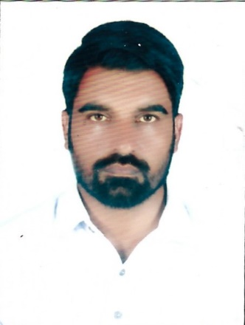

CURRICULAM VITAE

NAME : Faisal Mahmood

ADDRESS : DUBAI-UAE

GENDER : Male

MATERIAL STATUS : Married

DATE OF BIRTH : 23/10/1978

NATIONALITY : Pakistan

RELIGION : Muslim

ID NO : 784-1978-7647927-6

MOBILE : 056 3651004

**CAREER OBJECTIVE :**

I am hardworking individual able to build a territory and initiate a strategy to achievelong term services that will boost the company revenue . Right now, I am looking for a position with a company that rewards hard work , commitment and loyality.

**SKILLS :**

**.** Strong ability to troubleshoot mechanical problems under strict deadlines and stressful senarios talent for quickly learning setup ,maintenance, and repair procedures for new

equipment .

**.** Willingness to work closely and efficiently with diverse personnel to ensure optimal equipment functionally and rapid problems resolution.

**.** Effective communication skills needed to develop reports and translate technical information about equipment functions,errors and solutions into layman’s terms to ensure that colleagues understand.

**WORKING EXPERIENCE :**

**.** Company Al Shamil

Position : Duct Technician

Years : 04 Years

**LANGUAGE :**

**.** English

**.**Urdu

**.** Punjabi

**EDUCATION :**

Matric (in science)

**DECLARATION :**

I do hereby declare that all details mentioned above are true and correct as per my knowledge.

Yours sincerely

Faisal Mahmood.