KIRAN BABU 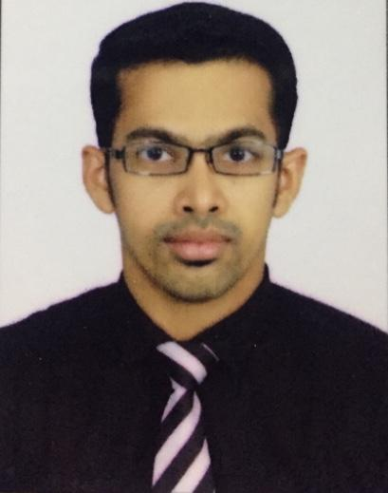

Mobile : +971 507851057

E-mail : [team_kiran@yahoo.co.in](mailto:team_kiran@yahoo.co.in)

**CORE COMPETENCES**

**Managerial:-**

* **Strong sense of Organization.**
* **Proven ability to meet the deadlines.**
* **Ability to quickly understand and provide solutions to customer and management needs.**

**Technical:-**

* **Responsive to new market trends within the industry.**
* **Ability to learn quickly.**
* **Creative approach to project management and concept development.**
* **Understanding of Financial statements.**

**Communication:-**

* **Ability to get on well with people in an international environment.**
* **Achievement of results through teamwork.**

**Working Experience**

* **Guest Services Management**

**JUMEIRAH AT ETIHAD TOWERS, ABUDHABI, UAE.**

**Since March - 2012 till March -2020.**

**Had a great exposure in the customer service operations. Had been in a role where to look after the whole customer satisfaction and service in the Lounge and in Outlets and to retain the business with them.**

**Also be responsible for the revenue generation and to meet the monthly and quarterly targets.**

**Be the person to look after the cost effective standards in operation. Also responsible for purchase and utilization of raw materials and its storage.**

**Responsible for the human resources management – selection, recruitment, training and development.**

**Also to be responsible to guide the operations according to the guidelines from ADTC and other governing bodies.**

**Department Trainer:-**

**Handled the position as Department Trainer who is responsible for the training needs of the staffs in various Outlets within the property, and coordinating with Learning &** Development Department in the orientation and Appraisal processes of colleagues.

* **Guest Service Executive**

GOLDEN TULIP KHATT SPRING RESORT AND SPA

(5 STAR RESORT BY FLAMINGO HOTEL MANAGEMENT)

RAS AL KHAIMA.

Sept-2010 to Aug-2011.

* **GUEST SERVICE ASSOCIATE**

THE ZURI KUMARAKOM KERALA RESORT AND SPA

(Formerly, THE RADISSON PLAZA, RESORT AND SPA), Kerala, India.

Awarded for the best employee based on the job performance and good guest comments and feedbacks.

Sept-2009 to Aug-2010.

**Educational Qualification**

**BACHLOR OF SCIENCE**

**2009**

***CATERING SCIENCE AND HOTEL MANAGEMENT***

SCHOOL OF HOTEL MANAGEMENT, VLBJCAS

BHARATHIAR UNIVERSITY, COIMBATORE

PASSED WITH FIRST CLASS MARK OF 72%.

**HIGHER SECONDARY EDUCATION 2006**

PLUS TWO – COMMERCE

SBHSS, THRISSUR

PASSED WITH FIRST CLASS MARK OF 74%.

**Professional Certifications**

* SUPERVISORY DEVELOPMENT PROGRAM (SDP)
* Human Resource Management.
* Train The Trainer
* Basic First Aider
* Disciplinary Action Process Training
* New Management Skills & Techniques

**Job Responsibility**

* Responsible for the daily operations ensuring that all Guests are served as per the standards.
* Responsible for all those activities concerned with Customer satisfaction and Feedback, developing a rapid healthy customer relationship.
* In charge for making staff allocations, staff schedules and delegation of work.
* Responsible for maintaining records and reports, such as Competency Matrixes, Profit and Loss report, Inventory report, Staffing duty hours report, Cost control Variance reports etc.
* Managing staff throughout their shift and providing them with feedback.
* Operational and behavioral training of the team.
* Holding for staff daily briefings at the shift and allocating them duties and special tasks.

**Career Related Key Strengths**

* Career related strengths includes ability of handling monotonous and repetitive tasks with same level of enthusiasm, energy, comfort and ease as innovative and challenging tasks.
* Capability to handle volumes of work.
* Excellent team building skills as well as capable of handling tasks independently with same efficiency. An ability to put people together towards set goals.
* Good interpersonal skills.

**Computer Proficiency**

MS Office, Micros, Opera, Epicure

**Personal / Contact Details**

* Gender Male
* Age& Date of Birth 32, 27/02/1988
* Nationality Indian
* Father’s name Babu Kundukulam
* Blood group B Negative
* Religion Christian (Roman Catholic)
* Languages Known English, Hindi, Malayalam & Tamil
* UAE Driving **licence Light vehicle**

**PASSPORT DETAILS:**

Passport no : S9816687

Place of issue : Abu dhabi

Date of issue : 27/02/2019

Date of expiry : 26/02/2029

**Declaration**

  I, Kiran Babu, hereby declare that the above written particulars are true to the best of my knowledge and belief.

**Kiran Babu**