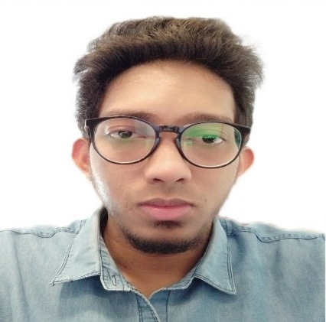
SAHIL M.M.V

MOBILE : +971 567 124635
EMAIL : sahilmmv@gmail.com

CAREER OBJECTIVE

TO HOLD A CHALLENGING POSITION IN ACCOUNTS/ADMIN DEPARTMENT, THAT PROVIDES A CHANCE TO DEVELOP PROFESSIONALLY AND PERSONALLY. MY IMMEDIATE OBJECTIVE IS TO BE ASSOCIATED WITH A WELL ESTABLISHED COMPANY THAT WILL PROVIDE OPPORTUNITY FOR CAREER ADVANCEMENT,

ACADAMIC QUALIFICATION

- BACHELOR DEGREE IN COMMERCE (UNIVERSITY OF KANNUR – 2013)

WORK EXPERIENCE

POSITION : JUNIOR ACCOUNTANT/ADMIN
DURATION : FROM MAY 2018 TO APRIL 2021
COMPANY NAME : CIVIC BUILDERS

- THREE YEARS OF RELEVANT WORK EXPERIENCE IN A REAL ESTATE FIRM.
- PREPARATION AND MAINTENANCE OF CASH AND CHEQUE.
- RECORDING OF FINANCIAL TRANSACTIONS AND OTHER RECORD KEEPING FUNCTION.
- DEALING BANKING RELATED TRANSACTIONS.
- PERFORMED GENERAL OFFICE DUTIES AND ADMINISTRATIVE TASKS.
- MANAGE A HIGH-VOLUME WORKLOAD WITHIN A DEADLINE-DRIVEN ENVIRONMENT.
- RESPONSIBLE FOR CUSTOMER SERVICES, DUTIES INCLUDED CUSTOMER QUERIES, PROBLEM SOLVING AND PROVIDING DETAILED INFORMATION.

COMPUTER PROFICIENCY

- MS EXCELL
- PACT
- TALLY
- MS WORD

LANGUAGES KNOWN

- ENGLISH
- ARABIC
- MALAYALAM
- HINDI

PERSONALITY TRAITS
- QUICK LEARNER
- HONESTY AND INTEGRITY
- HARDWORKING AND DEDICATED.
- POSITIVE ATTITUDE TOWARDS JOB AND COLLEAGUES.
- ABILITY TO WORK UNDER PRESSURE AND MANAGE WORK INDEPENDENTLY.

PERSONAL INFORMATION

FATHER’S NAME : ABDUL RAHMAN
NATIONALITY : INDIAN
DATE OF BIRTH : 24-06-1992
PASSPORT NO : K6222621
DRIVING LICENSE : VALID AUTOMATIC (UAE)
RESIDING LOCATION : SHARJAH
MARITAL STATUS : SINGLE
VISA STATUS : CANCELLED VISA

DECLARATION

I HEREBY DECLARE THAT THE ABOVE GIVEN INFORMATION IS TRUE AND CORRECT TO THE BEST OF MY KNOWLEDGE AND BELIEF.

