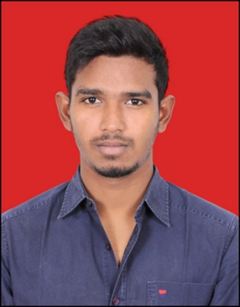**Benny Jones M**

2-1, P.N. Nagar, Kuniyamuthur, Coimbatore - 641008

+91-8220613301

benyjone@gmail.com

**Profile Summary**

To work in a firm with a professional work driven environment where I can utilize and apply my knowledge, skills which would enable me as a graduate to grow while fulfilling organizational goals.

Backup Expert with knowledge in Veritas Backup Exec solutions, by providing guidance to customer and partners with the best practices and troubleshooting in custom environments to backup and restore servers. Specialized in data management using Deduplication Disk Storage, and Linux servers.

Seeking a position in consulting or solutions firm where my expertise can be used to meet immediate standards and goals.

**Work History**

**Senior Representative Operations** (July 2018 – Till Data)

Concentrix, Chennai

To ensure complete backup and recovery protection for business to cover all data wherever it resides, using a proprietary commercial software.

Data storage for maintenance, management, retrieval and restoration of backup data for any individual, application, computer, server or any computing device.

**Senior Engineer** (December 2016 - June 2018)

CSS CORP, Chennai

Provide support to end users for the VoIP devices and products, help them troubleshoot and fix the issue in a timely manner.

Creating tickets and following up with customers to update on issue resolution.

Helping users with their technical inquiries and maintenance.

**IT Engineer** (April 2015 - December 2015)

Lycatel, Chennai

Maintaining and troubleshooting networking hardware for day-to-day use to keep them running.

Performed daily monitoring, management, administration and support of alarm systems.

Analyzed user-generated trouble tickets to determine causes of problems and took appropriate action for resolution.

Worked closely with the network administrators and server engineers to ensure quality service.

Maintained documentation for all telecommunication systems, including equipment inventory and floor plans.

**Working of Telephone Exchange – Internship** (June 2012)

Regional Telecom Training Centre, Chennai

Switching, Transmitting, Broadcasting and Multi-play, Mobile Technology and Wi-Fi

Read technical manuals and literature to stay abreast of new technology.

**Education**

**Bachelor of Engineering** (2014)

Karpagam University, Coimbatore

Electronics and Communications Engineering

Presented a project in *Voice Input Voice Output Communication Aid*

**Intermediate** (2010)

Karunya Residential International Matriculation Higher Secondary School, Coimbatore

**High School** (2008)

Lisieux Matriculation Higher Secondary School, Coimbatore

**Language Proficiency**

English (read, write, speak)

Tamil (read, write, speak)

French (read, write)

**Interpersonal Skills**

Ability to built relationship and setup trust.

Confident and determined.

Potential to cope-up with different situations.

Excellent analytical and presentation skills.

*I hereby declare that the above information is true to be the best of my knowledge.*