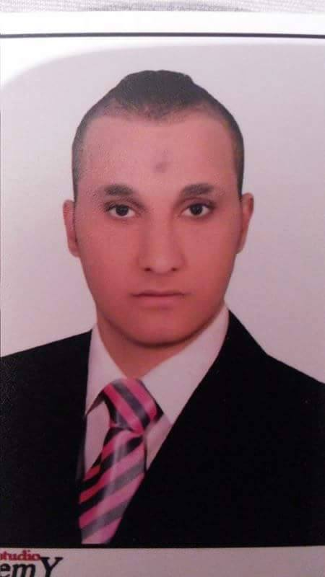
Name : Taha Ahmed Mahmoud Taha
Nationality : Egyptian
Mobile : +971501273013
Email : tahaa.ahmed2020@yahoo.com
10+ Years in Italian cuisine operating in many restaurants across Egypt and UAE
Creative, enthusiastic Italian chef, with over 10 years of experience managing kitchen operations while liaising with senior management to develop strategies.
Passionate about the culinary arts and the creation of novel recipes. Instrumental in driving improvements in productivity by overhauling processes and implementing positive kitchen cultures.

AREAS OF EXPERTISE
- Italian cuisine * Training and mentoring * Customer service
- Menu design * Leadership * Kitchen management
- Recipe Development * Product selection * Regulatory compliance
Professional Experience | Mo café (3 years) Second Chef - First Chef (Certificate of experience included)  - Trained by Chef Ahmed Abdelsatar – Famous Chef in Cairo.  - Successful catering experience.  - Started as a Second Chef then after one year I got promoted to second Chef.  - Maximizing kitchen productivity and staff performance
 | Restora (18 Months) head of hot cuisine Department
- Head of hot cuisine for the restaurant serving Italian, French, and Continental cuisine.
- Hire, train, and direct three cooks/chefs.
- Plan menu, assure quality control, and minimize waste.

 | Gosto (2 YEARS) chief department
- Supervised 6 cooks/chefs.
- Managed back house operations.
- Specializing in Italian and Hot cuisine.

 | Putary (8 Months)
Chief department
- Managed 6 Chefs and oversaw production of high-volume establishment for the restaurant specializing in Italian cuisine.

la piatra
chef department
Managed 6 people and oversaw production of high-volume establishment for the restaurant specializing in Italian cuisine.

Majid Al futtaim retails l.l.c
.Chef department .
Oriental food, pizza and salad
From april 2016 till now .

Education & Qualifications | Technical Commercial Institute  .hygiene certificate – Carrefour UAE  3 years Experience certificate.
Additional Information
Languages : Arabic (Native), English (Fluent)
Marital status : Married
Age : 30
References & Supporting Documentation Furnished Upon Request

