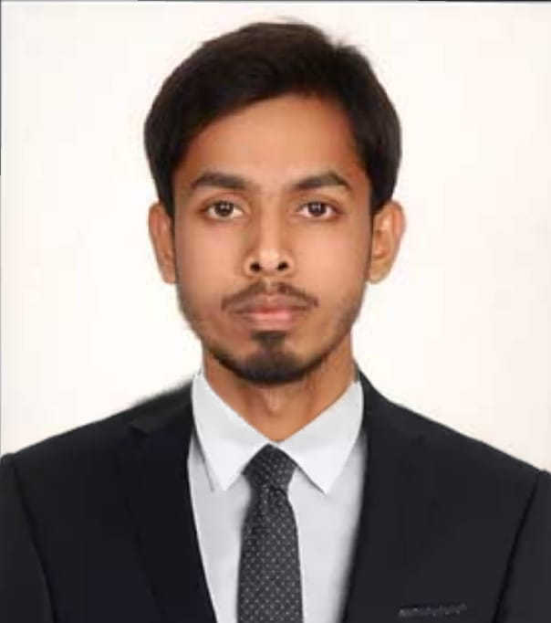

AREAS OF EXPERTISE

*Supervising . Sales support*

*Customer Satisfaction Presenting SWOT Report Graphical Presentations.*

PROFESSIONAL MODULES COVERED

*PGDC*A

*Microsoft office ( word, Excel, PowerPoint )*

*OPERATING SYSTEMS*:

*Windows XP / Win 7, 8 , Professional, ltimate, 10 etc.*

*INTERNET SKILLS* ;

*Browsing, Mailing , surfing etc.*

*GRAPHICAL & PICTURE PRESENTATION SKILLS.*

PROJECTS UNDER TAKEN

*PROJECT TITLE :*

*“Job Satisfaction”*

*On Aurobindo pharma ltd.*

*PROJECT DETAILS :*

*Live study on Job satisfaction.*

*COMPANY :*

*Aurbindo Pharma Ltd.*

Syed Mushthaq Ahmed

*Mobile: +971 528948577*

*Email:* [*syedmushtaq7869@gmail.c*](mailto:syedmushtaq7869@gmail.c) *om*

Dubai, UAE

PERSONAL SUMMARY

A reliable, capable and enthusiastic supervisor who is able to take on the management and coordinating duties of any leadership role. Possessing extensive experience of supporting, developing and motivating teams to do better and to drive continuous improvements across a range of work activities. Also having a track record of coming up with practical improvement initiatives which enhance a company’s overall effectiveness and harnesses the latent potential of its workers.

Currently looking to join a suitable organization that rewards hard work and offers good opportunities for career development.

WORK EXPERIENCE

***Cognizant Technology Solutions India Pvt Ltd***

Process Executive (Data). Jan 2019 – Jan 2020

***Bait-al-mandi Arabian restaurant (Warangal)***

Supervisor & Cashier (co-proprietor). May 2017 – November 2018

Developing, managing and implementing promotions in order to drive sales. Monitoring Key Performance Indicators, managing and disciplining staff of the restaurant.

## Sky Touch Innovative Shades Pvt Ltd Company – India.

Production Supervisor. May 2016 – March 2017.

Worked as head of a team and supervising the Team Members. Responsible for the day-to-day tasks and duties of the company production.

## Boyz Street Pvt Ltd – India.

Floor Supervisor & Cashier . April 2014 – March 2016.

Carrying out staff appraisals, managing performance and disciplining staff team and achieving the sales targets. Responsible for the day-to-day sales Tasks and other duties of the company.

## Duties:

* Creating and maintaining effective business relationship with staff and management.
* Clear cut understanding of organizational goals and work accordingly to Achieve the goals.
* Delegating work duties to individual staff members.
* Deputising in the absence of the management team.
* Approving time records and requests for time off.
* Writing reports for senior management and delivering presentations.

PROJECT PROFILE

*Visiting the Aurbindo pharma ltd meeting the Emloyees,and other Administration staff.*

*Knowing the wants & measuring the levels of Job satisfactory on the employees.*

*Collecting the info from group of employees on satisfaction on their jobs.*

*Emloyees needs & preferences.*

*Making Graphical presentation of the report*

PERSONAL SKILLS

*Self-confidence & optimistic attitude.*

*Dedicated to work.*

*Good interpersonal relation skills.*

*Capable of working under pressure.*

*Flexible & approachable.*

HOBBIES

*Travelling. Playing cricket. Racing.*

PERSONAL DETAIL

*Sex: Male*

*Date Of Birth: 22-10-1992*

*Nationality : Indian*

*Religion: Islam*

*Visa Status: Visit Visa Valid Till 24thMay 2020*

* Managing, Motivating, & extracting the results from team of Employees / Members.
* Providing support for marketing events and exhibitions as required.
* Co-ordinating with internal and external staff as necessary.
* Monitoring inventory, stock and ordering supplies as necessary.
* Creating and modifying documents using Microsoft Office.

KEY SKILLS AND COMPETENCIES

* Strong organizational, administrative and analytical skills.
* Excellent in graphical presentation and computer skills.
* Excellent working knowledge of all Microsoft Office packages.
* Ability to produce consistently accurate work even whilst under pressure.
* Assigning tasks to staff & clearly explaining how those duties are to be done.
* Solving the case studies, giving the SWOT report & analyzing the case for conclusion.
* Ability to type at least 60+ wpm.

ACADEMIC QUALIFICATIONS

MBA : Master of Business Administration ( Human Resource )

## Kakatiya University 2014 – 2016.

B.B.M : Bachelor of Business Management.

## Kakatiya University 2011– 2014.

**A levels** : Commerce (A) English (A) Civics (B) Economics (B)

## Sri Bhadrakali College 2009 – 2011.

REFERENCES – On Request.

DECLARATION

# I assure you that the above given information is true and correct to best of my knowledge and belief.

*Passport No S8835791*

Place: DUBAI. (**SYED** **MUSHTHAQ** **AHMED**)