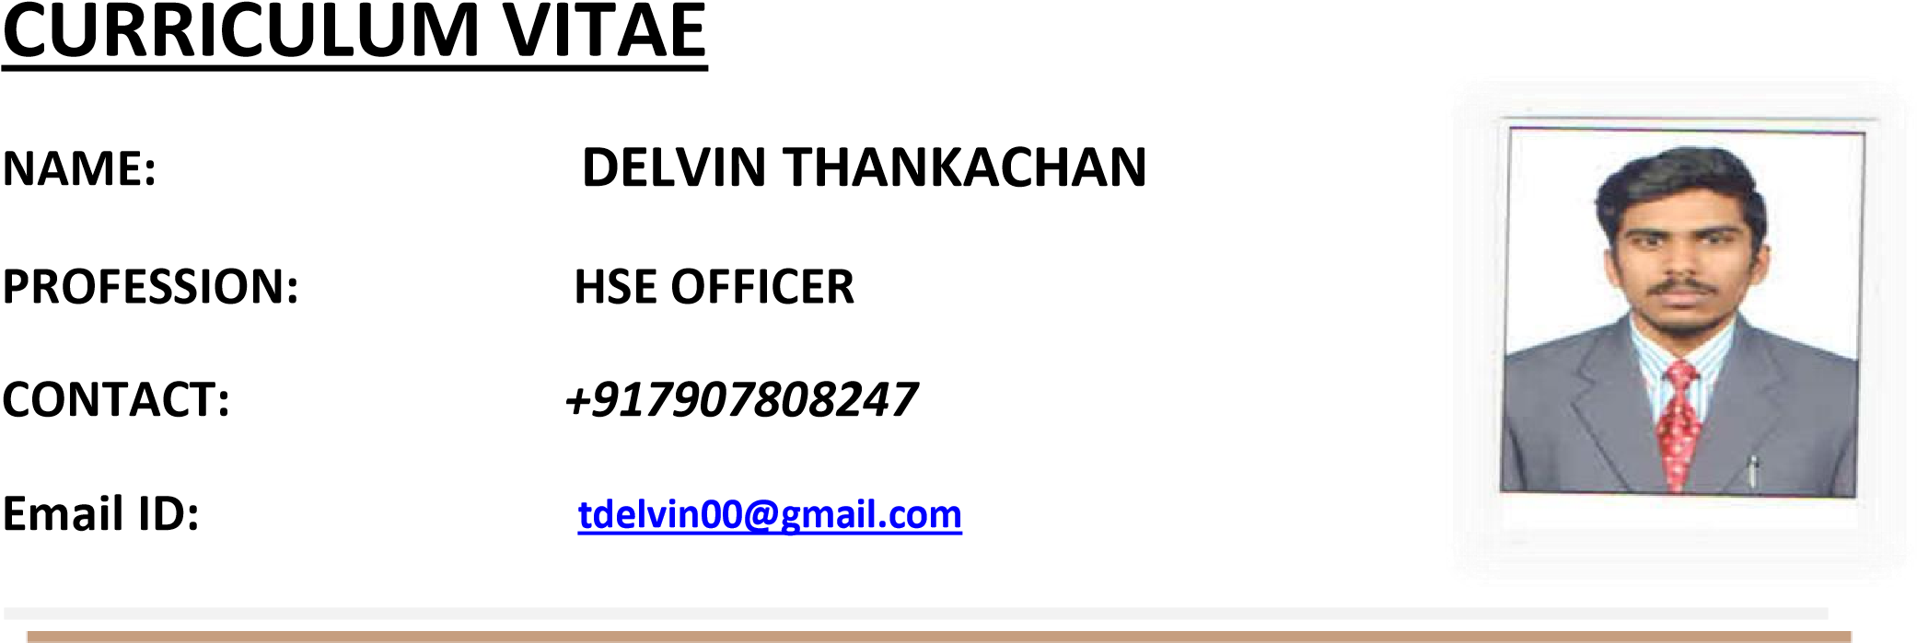

**OBJECTIVE:**

To succeed a challenging position in the field of Health and Safety, where my capabilities can be exploited for the growth of the company and provides ample scope for career growth. Presently looking for a well reputed company, where I will be able to widen my experience and exploit my capabilities.

**EDUCATIONAL QUALIFICATION**:

* **Diploma in Fire and Industrial Safety Management** with **distinction.**
* **Diploma** in **Mechanical Engineering** from **Council of Technical Education**.
* **HSC** from **Kerala State Board** of Higher secondary Examination with **distinction.**
* **SSC** from **Kerala State Board** with **distinction.**

**PROFESIONAL QUALIFICATION**:

* **NEBOSH (IGC)** health and safety at work qualified in 2018 with **credit**.
* **IOSH (MS)** Managing safely awarded in October 2018.
* **HABC** Level 1 **International Award in Fire and safety** assessment passed in June 2018.
* **MEDIC FIRST AID** training attended in June 2018.

**PROFESSIONAL EXPERIENCE**:

**Projects Handled:**

1. **FORAYS SERVICES & CONSTRUCTIONS (P) LTD**  2018 April -2020 December

Project**: EPCC 04 Revamp & Shutdown**

Client**: HPCL VISAKH REFINERY**

Position: **HSE OFFICER**

Duration**: 2018 April – 2020 December**

**2. Contract Resources Petrochem Services India Pvt Ltd (CR Asia) 2021** Jan – till date

Project**: HGU Shutdown**

Client**: HMEL BATHINDA REFINERY**

Position: **HSE OFFICER**

Duration**:** **2021 Jan – till date**

**PROFICIENCY/STRENGTHS**

* Fluency in English Language and a vast command over the language.
* Establishing workplace safety and health committees.
* Superb report writing skills.
* Investigating/recording incidents, accidents, complaints and cases of ill health.
* Undertaking risk assessments and site inspections.
* Ensuring that equipment is installed correctly/safely.
* Identifying potential hazards.
* Determining ways of reducing risks.

**PERSONAL INFORMATION**

Candidate Name: **DELVIN THANKACHAN**

Father’s Name: Thankachan KP

Date of Birth: 18.03.1997

Nationality/religion Indian

Language: English, Hindi Tamil and Malayalam.

Sex: Male

Marital Status: unmarried

Passport No: S5032989

**Permanent Address**

Village - Thodupuzha

Post + Pin – karippalangadu -685601

District - Idukki

State – Kerala

***DECLARATION:***

*I HEREBY DECLARE THAT, THE DETAILS GIVEN ABOVE ARE TRUE AND CORRECT TO THE BEST OF MY KNOWLEDGE & BELIEF.*

DATE 12.02.2021

PLACE Bathinda Punjab

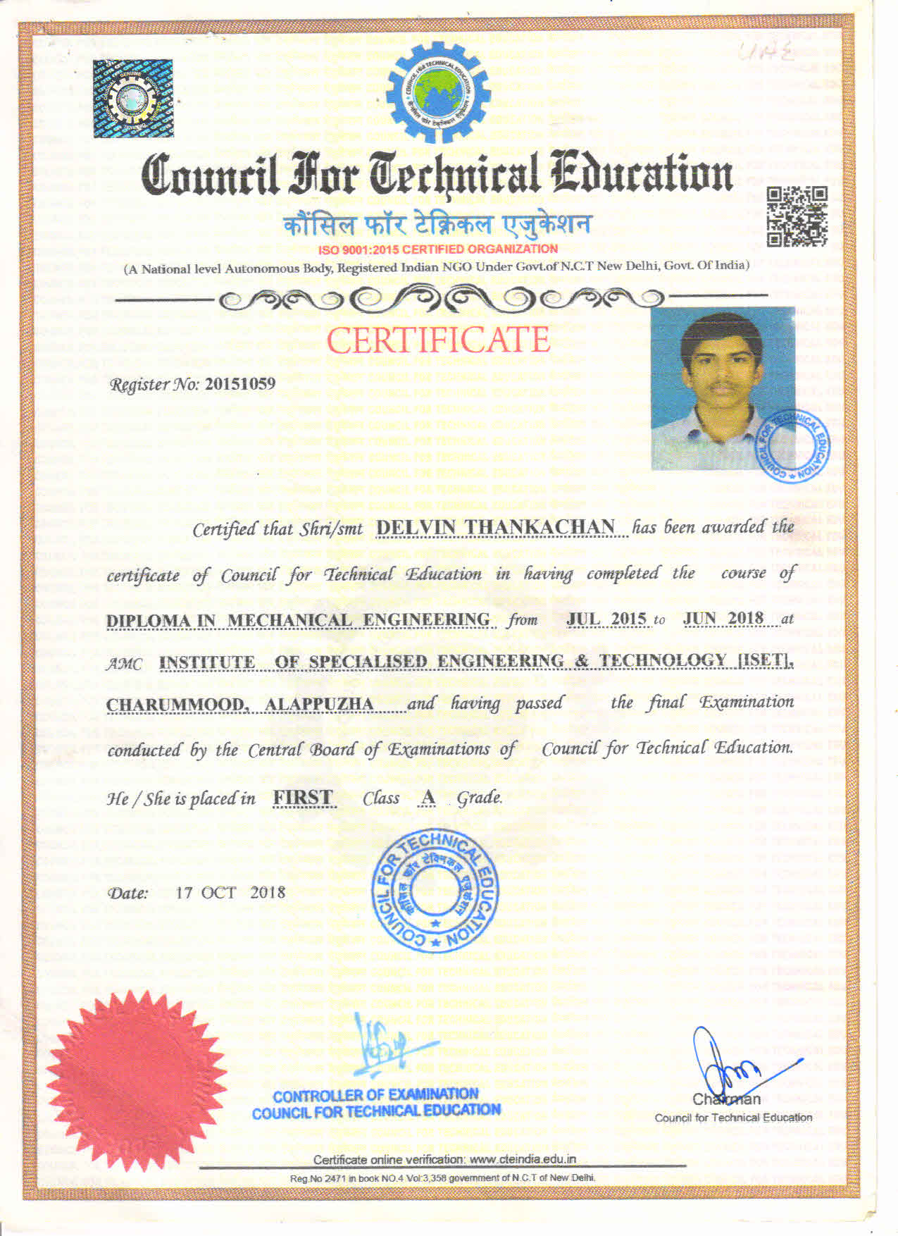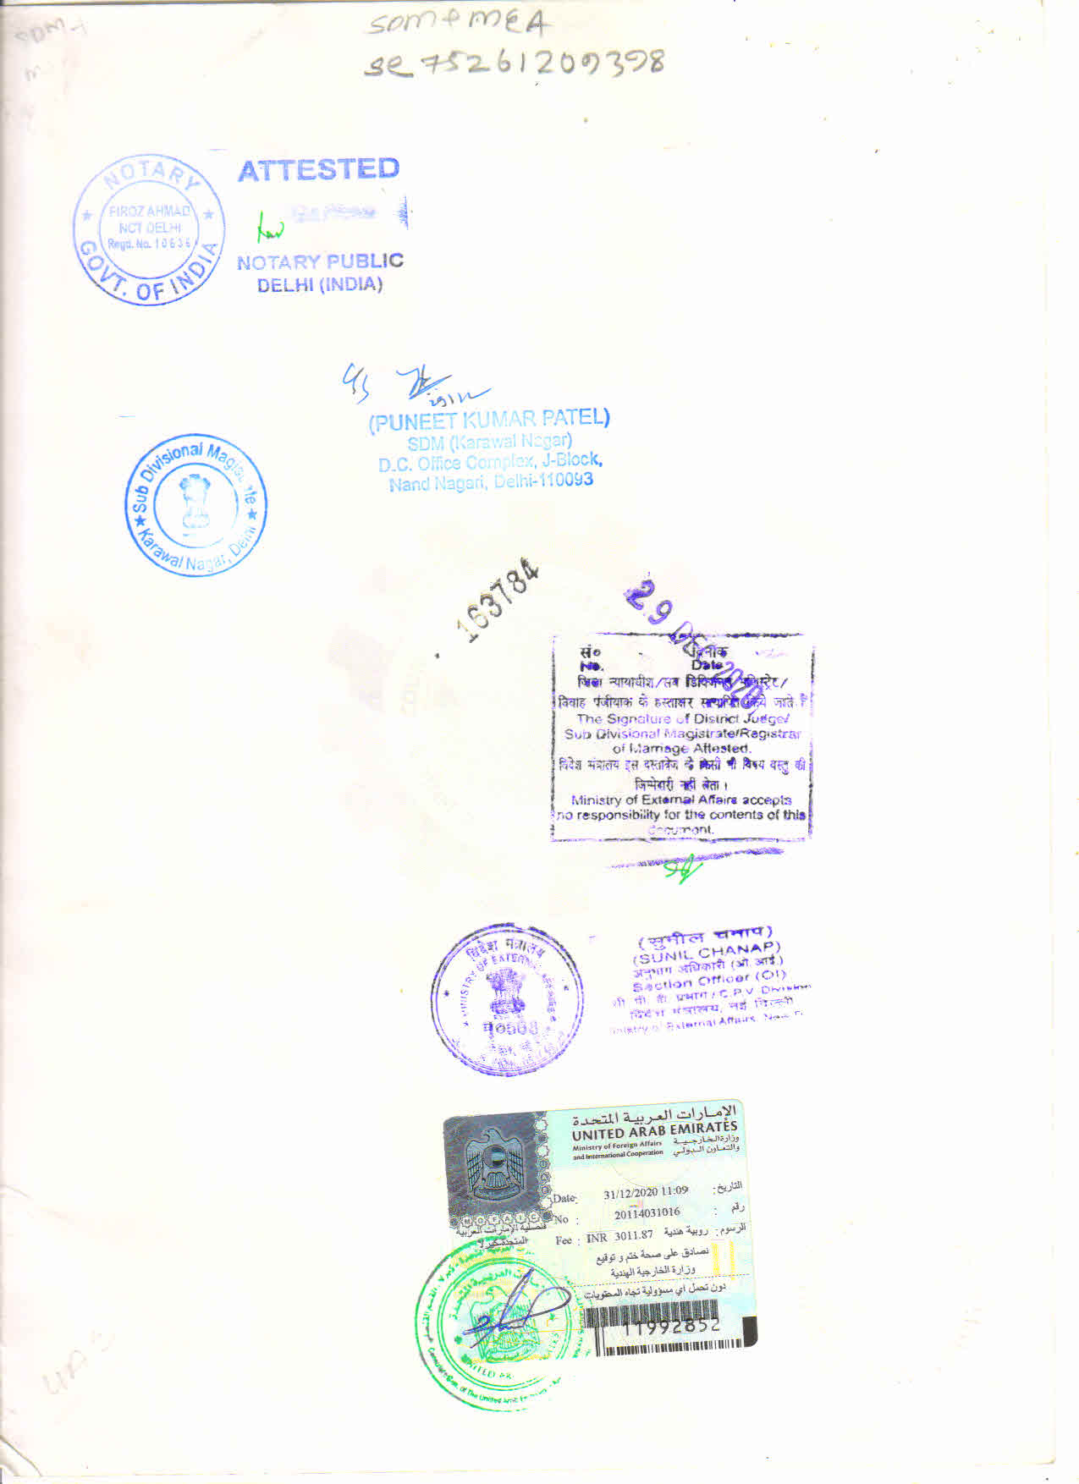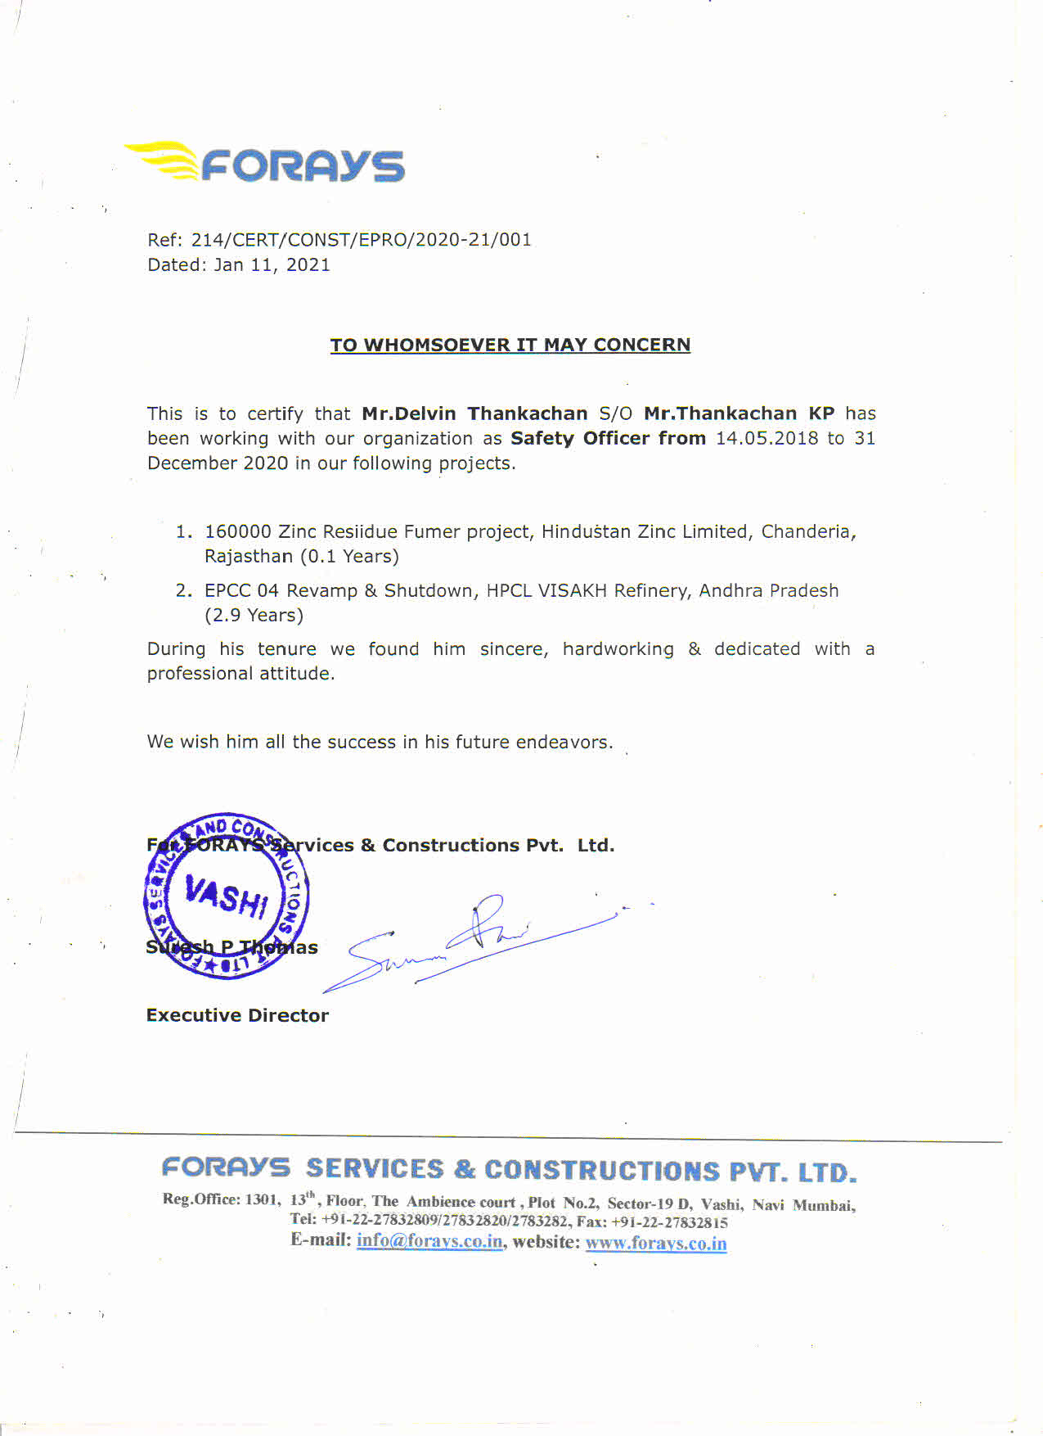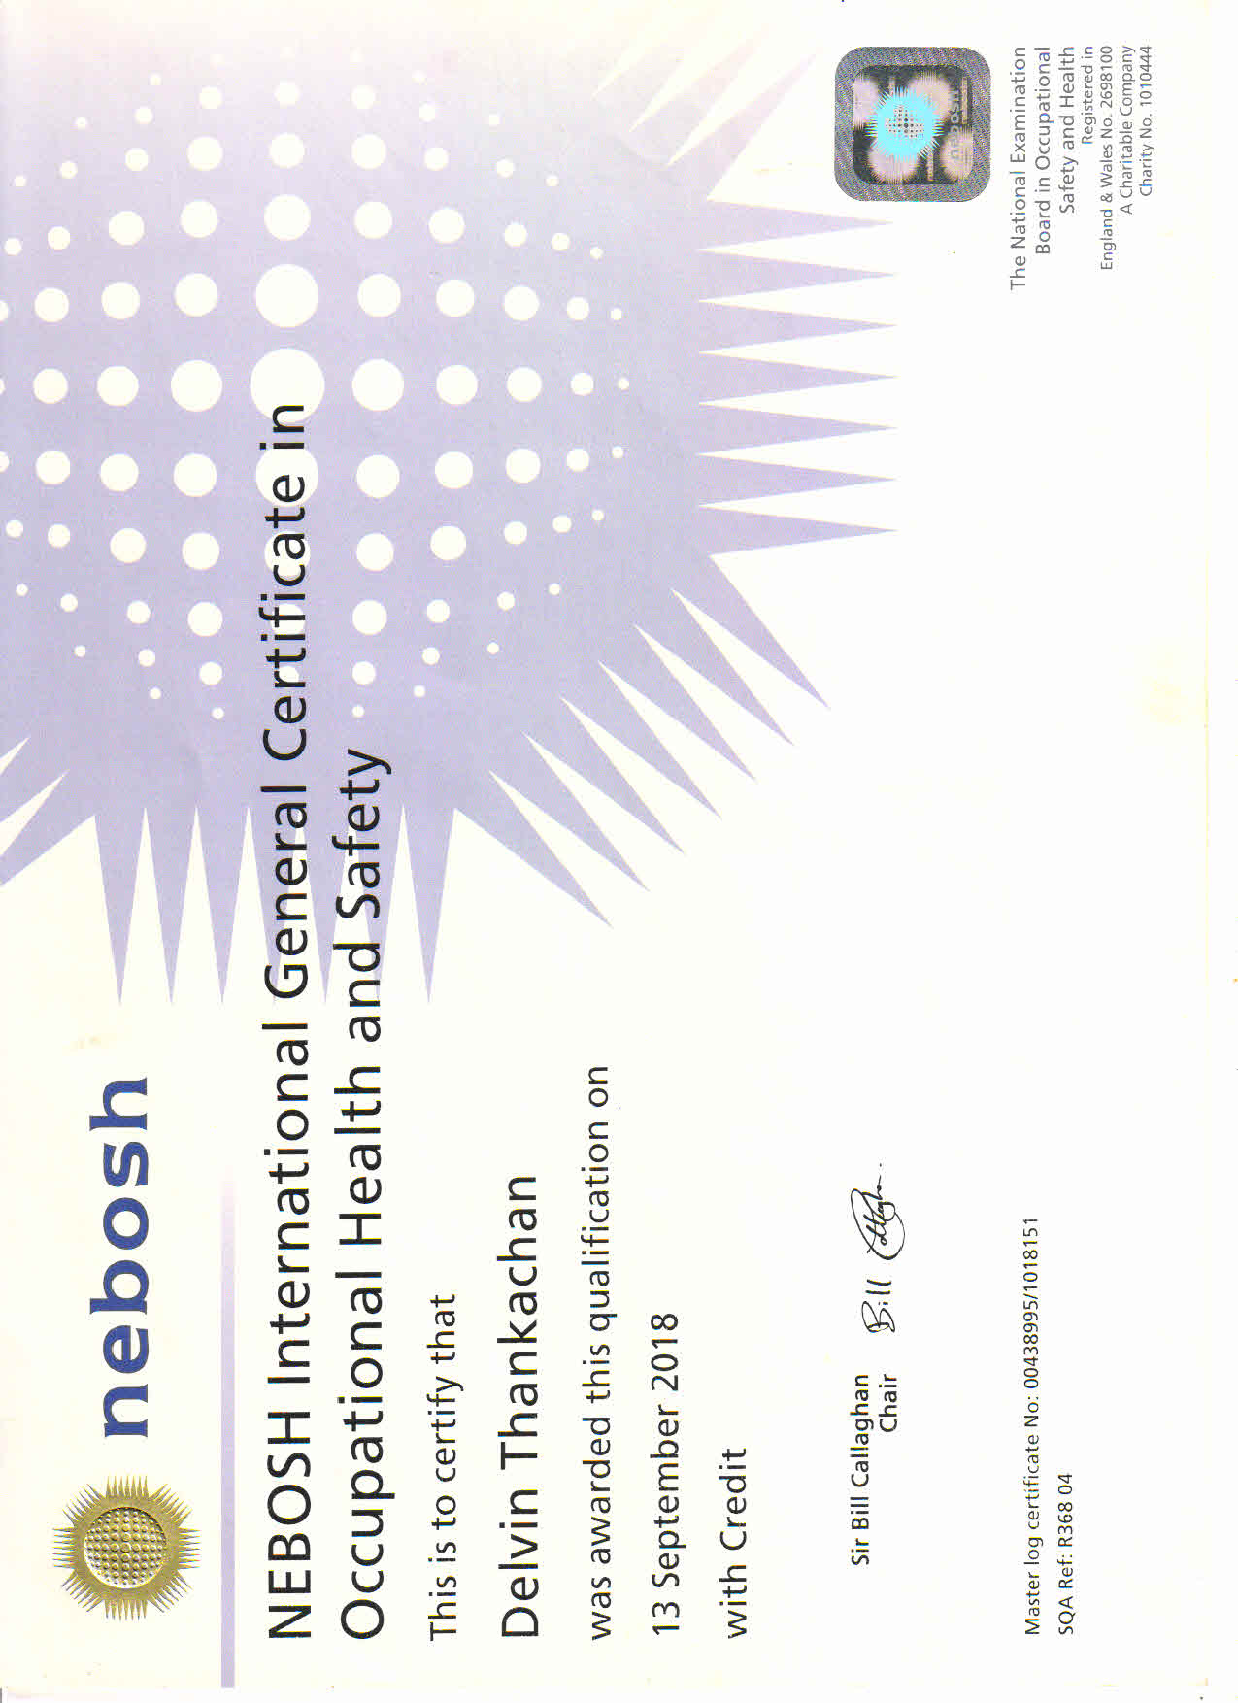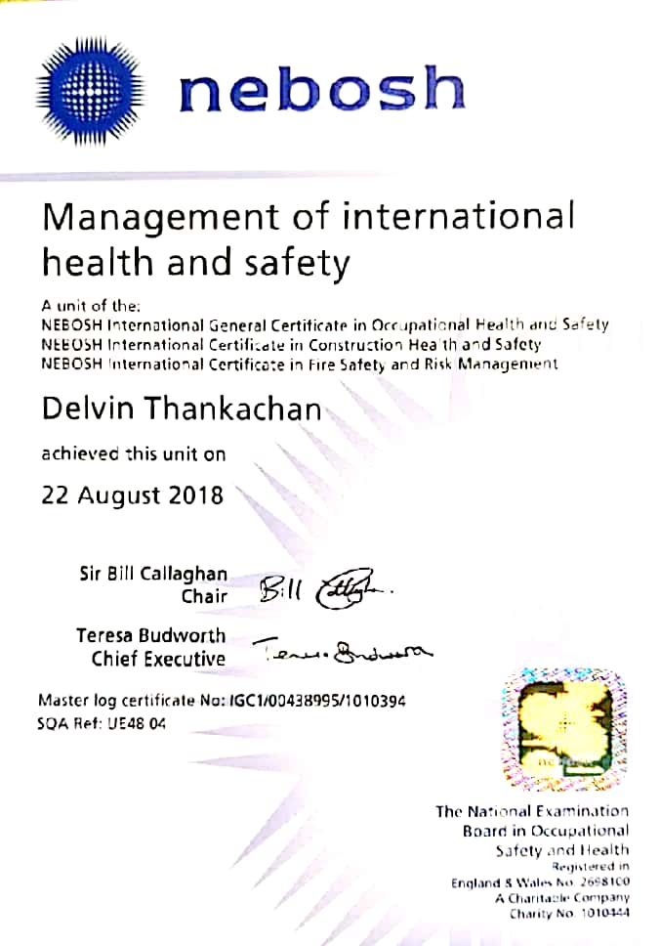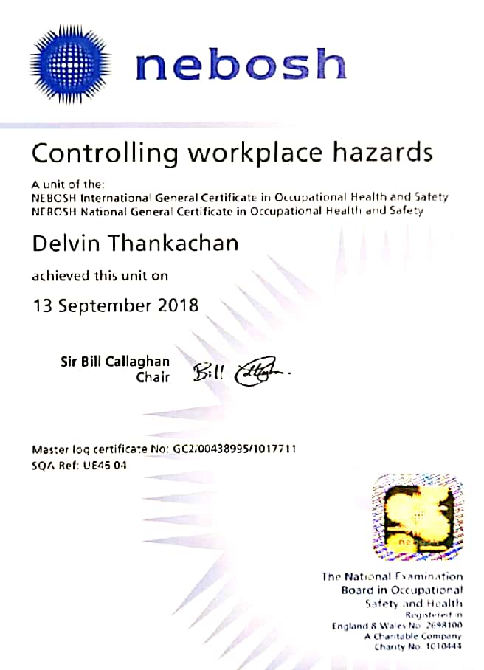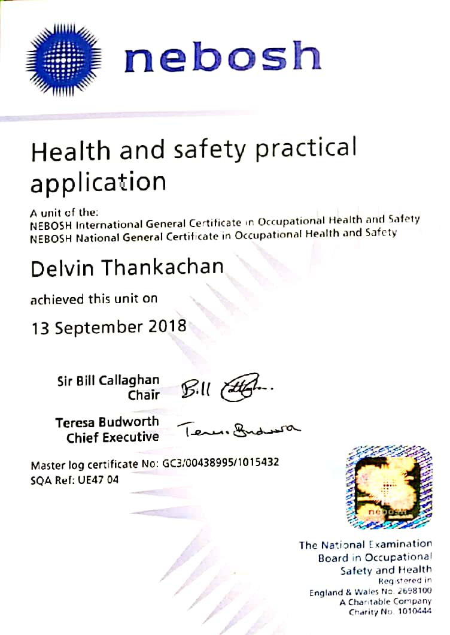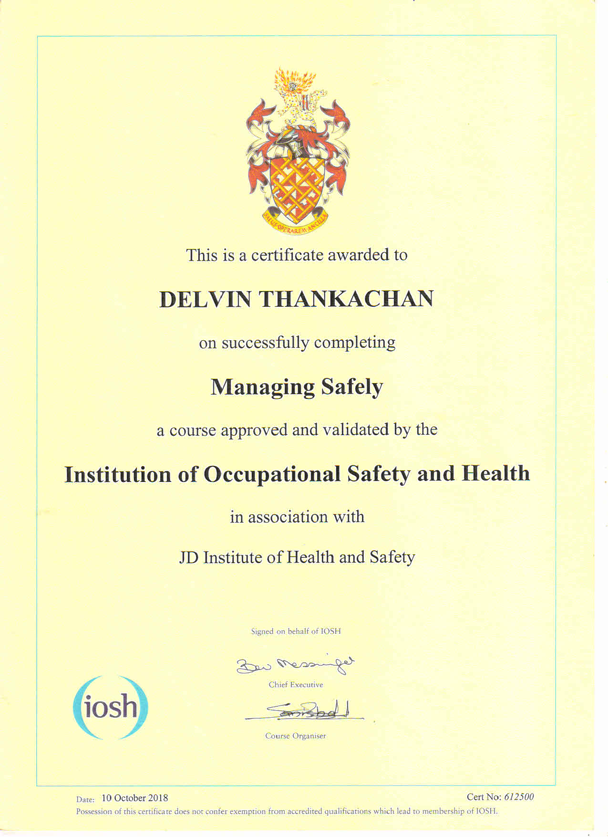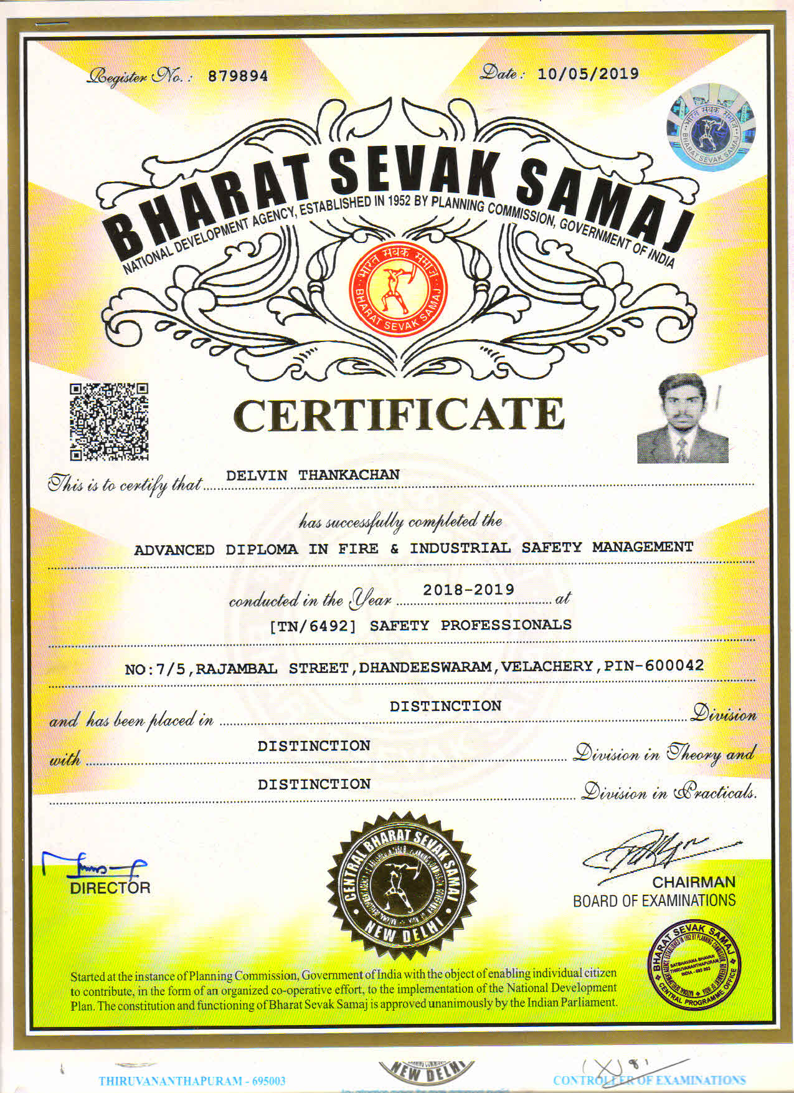

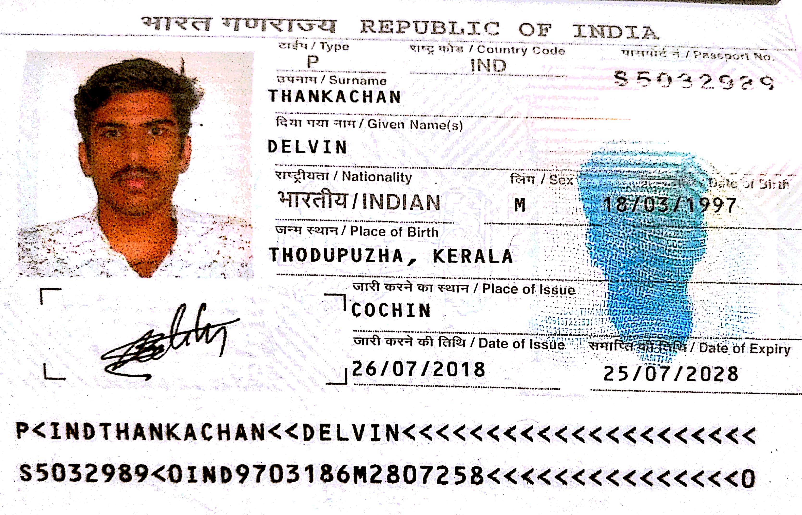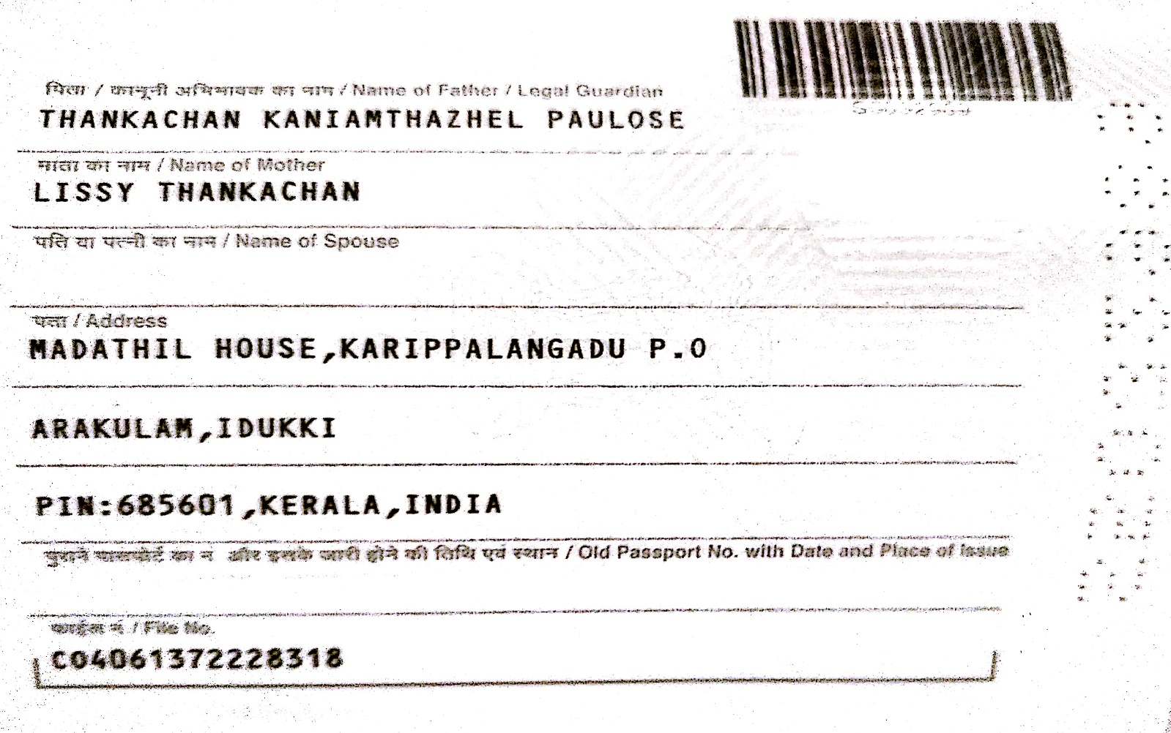s