CURRICULUM VITAE
JAWAD MAMUKOYA 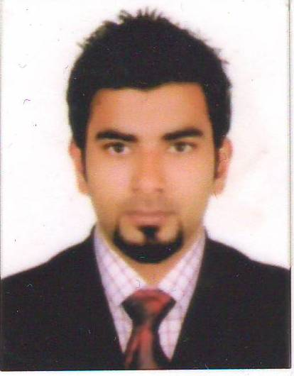
Mobile: 9895836626
E-mail: jwd1213rb@gmail.com
Calicut, INDIA

CAREER OBJECTIVE

To obtain a challenging and rewarding career that offers the opportunity to utilize my professional and inter-personal skills to add value to the organization, customers and myself.

PROFILE

A dynamic and ambitious person with the willingness to learn and excel. Always on the look out to lead the way and able to work under pressure as well as meet tight deadness. Active and excellent in work and interested in team work.

QUALIFICATION

- Higher Secondary School Certificate-Kerala Higher Secondary Board
- High School Certificate-Kerala State Board
- Graduation from calicut university

EXPERIENCE

- Worked as Customer Associate at Lifestyle

PERSONAL SKILLS

- Quick learner
- Self-motivated
- Will organize in a work and can work skillfully in team.
- Good team player.

COMPUTER

- Command of Internet and e-mail
- Microsoft Office

LANGUAGES KNOWN
English |  | Good
Hindi |  | Good
Malayalam |  | Mother Tongue
ARABIC |  | Good

PERSONAL SKILLS

- Fast learner
- Hard workers and self-motivated
- Will organized in my work and can work skillfully in team.
- Good team player.

PERSONAL INFORMATION

Nationality | : | Indian
Gender | : | Male
Date of Birth | : | 09/11/1986
Marital Status | : | Single
Father’s name | : | MAMUKOYA
Religion | : | ISLAM
Communication address | : | JAWAD MAMUKOYA  14/733, MARWA . H  KUNDUNGAL  P.O KALLAI  CALICUT
I certified that the above particulars are true and accurate at the best of my knowledge

Jawad Date: 27/10/2015

