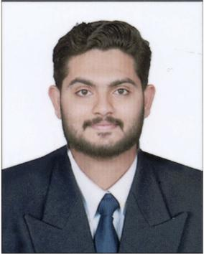Thoufeeq M R

Syed manzil (H)

Manapottakalam, Alathur PO,

Palakkad, KERALA

UAE: 971-507104780

India:9188766886, 9961361886

E-mail: Thoufeeqmr9@gmail.com

# Objective

Seeking an exciting and challenging opportunity to enhance my skills and abilities for the betterment of the company as well as my personal growth.

# Skills & Abilities

## Management

* Team Management
* Sales management

## dealings

* Suggesting Customers for best offers.
* Helping Customers to make the right choice.
* Closing a deal efficiently
* Providing After sales service

## Communication

* English, Arabic, Hindi, Malayalam and Tamil
* Able to communicate with customers and distributors in a professional manner.
* Resolving Customer issues and handling rejections.

Experience

**1 year of work experience as a cash supervisor in SAFARI MALL Sharjah.**

* Efficiency in managing a cash team.
* Ability to create and manage relationships with clients
* Excellent presentation skills
* Interact with the customers to provide and process information in response to enquiries, concerns about products and services.

**3 years of work experience as a customer service supervisor in LULU Dubai.**

* Ability to create and manage relationships with clients
* Strong negotiation skills and effective closing of deals
* Ensure pricing is correct
* Manage cashiers and people working on the floor (retail staff).

**2 years of work experience as a cash supervisor in LULU Dubai.**

* Answer customers' questions about products, prices, availability, product uses, and credit terms.
* Efficiently greet customers and provide excellent customer service.
* Close the deal effectively and quickly and provide the good results.

Education

* B.COM completed in C V Raman University.
* Passed +2 from State board of KERALA.
* Passed 10th From State board of KERALA.

Computer Knowledge

* Operating system : windows XP, 7, 8,10
* Microsoft tool : MS Office word, Excel, PowerPoint
* Data entry, SAP

# Personal details

* Date of Birth : 05-09-1995
* Passport no : M1205582
* Visa Status. :Visit Visa
* Sex :Male
* Marital Status :Married
* Nationality :Indian

# I do hereby declare that the above given statements are true to best of my knowledge and belief. I assure you that I will do my level best to discharge the entire satisfaction of higher authorities.

# Thoufeeq M R