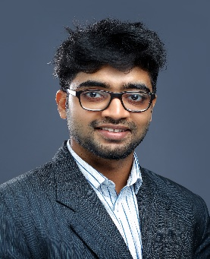 **DHANUSH G BANGERA**

Business Bay, Dubai, UAE

[dhanushgb.98@gmail.com](mailto:dhanushgb.98@gmail.com)

+971 503479091

www.linkedin.com/in/dhanushbangera

**PROFESSIONAL EXPERIENCE**

**Serial Blinds –** Production Engineer; Dubai, UAE October 2020 – Present

* Used AutoCAD to design stronger tubes to be manufactured using hot extrusion methods to make them 30% lighter.
* Improved project completion time by implementing fishbone analysis to determine the delays and reduced delay time by 25-30%.
* Managed technical teams everyday by assisting and monitoring their allotted work.
* Developed and maintained documents of projects each day after carefully reviewing the measurements, quotations, and order sheets.
* Tested & inspected roller blinds produced in each batch by conventional testing methods to avoid faulty fabrics, accessories, and motors.

**INTERNSHIP**

**New Mangalore Port trust,** Mangalore, IndiaAugust 2019

* Briefly understood the workings of 4 pumphouses located at the berths consisting of various types of engines, pumps, valves, and also gained knowledge on the working and uses of cranes used for loading, unloading, and stacking.

**Mangalore Chemical Fertilizers,** Mangalore, India January 2019

* Briefly understood the workings of ammonia plant, urea plant, diammonium phosphate plant, ammonium bi-carbonate plant, workshop, and the captive power plant.

**Caliper Engineering & Lab Pvt. Ltd,** Mangalore, IndiaAugust 2018 – May 2019

* Briefly understood the various methods of Non-Destructive Testing (NDT) and Computer Numerical Control (CNC) operations on grinders, lathes, and milling machines.

**EDUCATION**

**Sahyadri College of engineering & Management,** Mangalore, India 2016 - 2020

* Completed my Bachelor of Engineering course in Mechanical Engineering with multiple internships and projects.
* My Projects: Point Absorber Wave Energy Converter using Floating Buoy – Built prototype of floating buoy using 3D printing method for the generation of electricity with ocean waves using Faraday’s laws.
* Multi-axis Sawing Machine – Developed prototype of a cutting machine operational in XY axis.
* CAEDify - AR software developed using Onshape and Unity to make Computer Aided Engineering Drawings more interesting to understand.

**SKILLS**

* CAD & 3D Design softwares: Autocad, Fusion360, Blender, Keyshot, Product Design.
* Programming Languages & computer skills: HTML & CSS, Microsoft Office.
* Strong communication, Organizational, Independent, Team spirit, and problem-solving skills.
* Hobbies: Playing football, fitness, travelling, and photography.