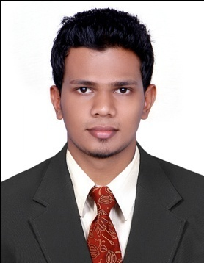
Shafeerudheen.K.S

Accounts & Finance
Mobile No: +971-555 073776
Email: shafeerudheen@gmail.com

Career Objective:

A suitable position in Accounts & Finance with a reputed organization where I can utilize my education and experience for the optimum growth of the organization as well as personal career growth.

Profile:

- Degree in Commerce (BBA).
- MBA-FINANCE (Presently doing).
- Have 4+ year experience in Accounts in UAE.
- Have UAE Driving license.
- Well-versed in Tally & Quick Book.
- MS Office & Internet.
- Have excellent planning, analytical & problem solving skills.
- Strongly commercial with good communication and influencing skills.
- Energetic and capable of working independently and a good deal of autonomy.
- Have excellent time management skills & can meet the deadlines without compromising on quality.
- Energetic, enthusiastic with great attention to details.
- Highly dependable & can prioritize and organize tasks.

Career History

- Accountant, NEW GOLD PERFUME LLC , RAK, UAE(Sep-2015 to Present)

Job Profile: Accounts

- Received and recorded invoices and arranged payments.
- Prepare and send invoices to debtors and follow up with debtors for payment by considering their credit period.
- Prepare VAT report.
- Prepare regular reports and summaries of accounting activities.
- Maintained Daybook, posted ledgers.
- Credit control and collection of accounts payables and receivables.
- Ensured that there are effective internal controls.
- Reporting fund position at the end of the day
- Provided required information to the internal / external auditors during audit.
- Entered credit bills, bank bills, Petty cash and to the accounting package, verified all entries and posted to the ledger.
- Submit all audit reports to management within the time frame.
- Respond to queries of potential clients & involve in follow ups; and convert the potential leads into actual customers.
- Develop strategy to address the individual needs and challenges facing each client and consider all critical issues that can impact the organization’s ability to achieve both internal & external objectives & goals.

Academic History
- Bachelor in Business Administration (BBA), Calicut University, India.
- Pursuing(3rd sem) Master in Business Administration (MBA , Finance), Sikkim Manipal university, India

Computer Skills:

Accounting Software : Tally, Quick book
Office Application : MS Office
Others : Internet & Email
Personal Profile:

Sex : Male
Date of birth : 4th Oct 1990
Marital status : Married
Nationality : Indian
Passport No. : T6881220
Visa status : Employment visa
Driving license No. : 195245
Language Proficiency : English, Arabic, Malayalam and Hindi

Declaration

I hereby declare that the above mentioned details are true to the best of my knowledge and belief
Shafeerudheen.ks
Dubai

