CURRICULUM VITAE

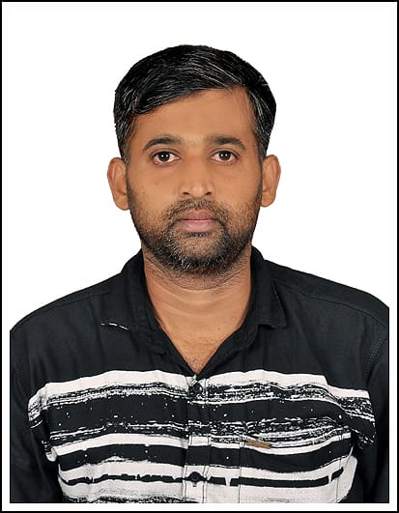

A.MOHAMED GULAM THASTHAKIR

43/30 Pudumanai Street, Thittachery,

Nagapattinam (Dist), Tamil Nadu.

Mobile UAE : +971569506069

EMail : [mohamedgulam2021@gmail.com](mailto:mohamedgulam2021@gmail.com)

CARRIER OBJECTIVES

To Seek A Challenging Position In A Growth Oriented Organization Where My Talent, Expertise, Innovative Capabilities Strong Analytical And Technical Skills Can Be Contributed Efficiently And Successfully. Job Satisfaction Is The Ultimate Aim. Being Versatile Always Eager To Take Up The Challenging Career

ACADEMIC QUALIFICATION

* Higher Secondary School Leaving Certificate (+2) From State Board Of Tamilnadu, India

COMPUTER KNOWLEDGE

* BASIC COMPUTER KNOWLEDGE

PROFESSIONAL QUALIFICATION

* THREE Months Worked As An **Warehouse Assistant Dr. Nutrition** At Dubai From Feb 2021 To May 2021
* TWO Year Worked As An **Salesman AMA** Electronics At Chennai From 2018 To 2020
* SEVEN Year Worked As An Waiter Indian Corner Hotel At RIYADH SAUDI ARABIA 2011 to 2018
* Five Years Worked As An Salesman **Karai** Electrical At Karaikal From 2007 To 2011
* Six Years Worked As An Salesman Kalimah Electronics At Karaikal From 2000 To 2006.

PERSONAL STRENGTH

* Easy adaptability to new situations.
* Open to challenges and opportunities.
* Can maintain confidentiality of a concern

INTEREST :

* Internet Browsing
* Playing Carrom
* Watching Movies

PERSONAL PROFILE

Father's Name : ABDUL MAJEED

Date Of Birth : 20.05.1982

Gender : Male

Nationality : Indian

Religion : Muslim

Marital Status : Married

Languages Known : English, Tamil, Hindi, Arabic & Malayalam

PASSPORT DETAILS

Passport No : K 5130019

Date Of Issue : 16-06-2013

Date Of Expired : 15-06-2023

Place Of Issue : RIYADH

Visa Status : Visiting Visa ( 18. MAY . 2021 - TO - 23. AUGUST .2021)

Place:

Date: ( A.MOHAMED GULAM THASTHAKIR )