CURRICULUM VITAE
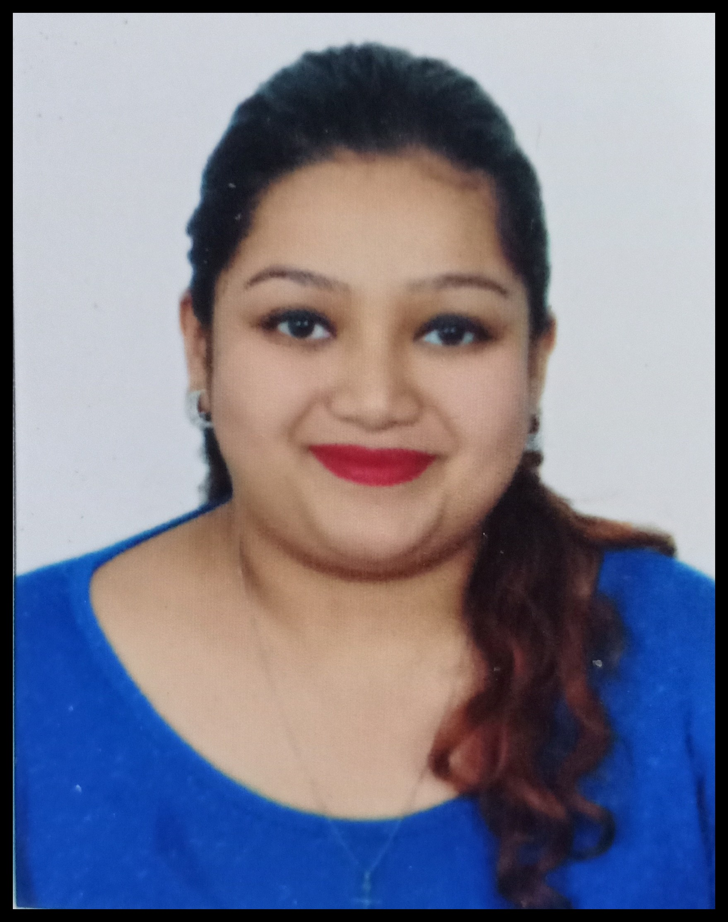

Siyona Vijay Shinde (Total no. of work experience approx 6.6 years)

Address: -Chandralok CHS C-13, Sec-10, Koperkhairane, Navi Mumbai.400709

Contact No: - 9920854413
Email ID: - shindesiyona@yahoo.com
Skype: - siyona.shinde
Botmin: - Siyona Shinde

JOB EXPERIENCE:

- Working with Accenture Solutions Private Limited as a Customer Service Associate (Business Process Delivery) for an HRO Process (Human Resource) from Jan 31st, 2018, till date.

- Working for B2B process.
- Working as 1 stop solution for all the HR queries of the associate.
- Handled all the HR queries and concern through voice, emails and Chat.
- Instructed and Navigated the associates, Managers, District Manager, AVP, VP etc. to handle recruiting, transfers or promotion, process of compensation, HR guidelines and Rules as per the companies and much more.
- Handle employees concern, complaints, escalation and grievance.
- Team related responsibilities : Assisted new joinee with process information and also helped them with their initial days to go live (on call or emails)
- Did Floor Walking (Being ready ,if anyone in the team needs assistance on calls or email)
- Coordinated with client whenever any need arises from the agent or associate regarding a process or for any process improvement.
- SPOC to keep team up to date with new updates in the process.
- Work on Workday.

- Working in Value Direct Communication Pvt.Ltd as Assistant Manager Client Servicing from April 7th, 2017 to Jan 16th, 2018

Work Experience: 10 months

- Developing and maintaining healthy relationship with existing clients.
- Handling Queries efficiently on mails, phones, as well as in meetings.
- Actively engaging with Sales and Operations Team to ensure that the solution being presented to the client meets/exceed expectations.
- Managing customer centric operations & ensuring customer satisfaction by achieving delivery & service quality norms.
- Attending to client's complaints and undertaking steps for effectively resolving them.
- Interacting with the customers to gather their feedback regarding the product satisfaction.
- Generating client reports.
- Handled Retargeting.

- Working in Logicserve Technology as an Account Manager (Couponraja.in) from 3rd Nov 2014 to 17 March 2017.

Work Experience: 2.5 years
- Client servicing.
- B2B Partnership and business alliances.
- Updating the client details on the website. ( Updating logo, gallery images, offers etc.)
- Verification of the client.
- Handling the complaints.
- Bringing new clients on board.
- Maintaining hygiene of the website.
- Training the sales persons.
- Content proof reading.

- Managed Social Media Marketing for clients as a freelancer 5th June 2016 to 4th Jan 2017.

- Managed their Facebook, Twitter, Pinterest, Tumblr, Instagram and LinkedIn promotions.
- Have knowledge on sponsor add and paid promotion on Facebook and Instagram.
- Have basic knowledge of content writing.

- Worked in Obox Solutions from 3rd April 2012 to 17th July 2013 as Customer Service Representative (startours.co.uk).

Work Experience: 1. 3 years
Work Experience: 1.3 years

- Handled inbound and outbound calls.
- Handled customers account (Booking their tour packages, Booking of Flights and hotels, handling their visa arrangements etc.
- Coordination with clients in UK for tour arrangements.
- Training new recruits.
- Auditing the booking form entered by the new recruits.
- Handling irate customers.

COMPUTER SKILLS
- MS- Office
- MS- Excel(Basic)

OTHER SKILLS

- Done Elementary drawing Exam recognized by state government in year 2007.
- Done Basic Computer Fundamentals and Excel.
- Basic Knowledge of Content Writing, Social Media Marketing, Email Marketing, Mobile Marketing.
- Have Basic knowledge of Digital Marketing

EDUCTAIONAL QUALIFICATION

- Passed SSC in year 2008
- Passed HSC in year 2010
- BMS( Bachelor in Management Studies) Graduate in year 2015.

PERSONAL DETAILS

Date of Birth : 01st April 1991
Gender : Female
Nationality : Indian
Marital status : Single
Languages Known : English, Hindi and Marathi

HOBBIES

- Dancing, Art and Craft, Reading Books, Socializing, Listening to Music and DIY.
- Manage my own Instagram Page and Facebook Page @BeautyWithQuotista
- Beauty Blogging.

LinkedIn : https://www.linkedin.com/in/siyona-shinde-45243078/

Date:
Place: (Siyona Vijay Shinde)

