**CURRICULUM VITAE**

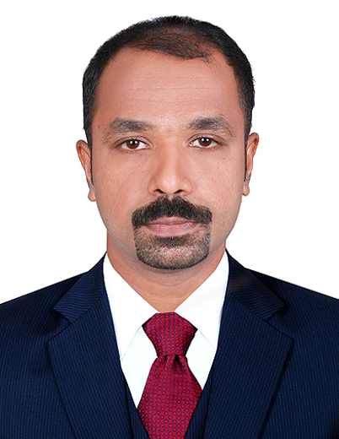

**SHAJI.P.K**

**Email:**[**shajipk313@gmail.com**](mailto:shajipk313@gmail.com)

**Mob: +971-55 8264600**

DUBAI-UAE

**CAREER OBJECTIVE:**

To seek a challenging career for a suitable position, utilizing my skills and experience to contribute towards the progress of organization and at the same time has the prospect for professional growth and development of my career.

**EDUCATION QUALIFICATION:**

* **Bachelor of Commerce (B.COM)** (Year-2004) passed from University of Calicut, Govt. of Kerala and India.
* **Pre-Degree** (year-2000) passed from University of Calicut, Govt. of Kerala and India.
* **SSLC** (1997-1998) passed from Board of Examination, Govt. of Kerala and India.

**COMPUTER QUALIFICATION:**

* **Advanced Diploma in Computer Application (A DCA)** (1999-2000) Passed from Hi-tech Computer Education Foundation in Trissur, Kerala, India.
* [MS. Office (MS Word, MS Excel, MS Power Point, Dos, Windows, E-mail, Internet]
* **Diploma in Computerized Financial Accounting (DCFA**) (2004) Passed from Hi-tech computer Education in Trissur, Kerala, India.
* Complete working knowledge of Accounting Software Tally 9, Peachtree, Infos, Quick Books and Tata Ex & Wings.

**WORK EXPERIENCE:**

**Worked as an Accountant (Moosa Safar Elect.Equipment &A/C Services llc.), (Dubai -United Arab Emirates) from 1st June 2018 to 27th June 2020.**

**Duties:**

* Monitor all debtors’ invoices and follow up for the Accounts receivables, Accounts Payable.
* Preparing Quotation,TaxInvoice,Security Cheque, Completion Note,Warranty Letter,AWD,PO Uploading To EO Portal.
* Preparing Access Pass, Statement of Account.
* Prepare Daily Attendance Sheet, Petty Cash handling, Utility Bills and Renewals.
* Bank Reconciliation, WPS-Payroll, bank reconciliation with book of accounts and projects.
* Keeping track of VAT output and vat input on customer and suppliers invoice respectively.
* Preparing weekly, monthly project wise cash flow, fund flow Statements in excel sheet, Job Costing.
* Allocation material, labor, sub-contract and other direct cost project wise and arrive at actual profitability of that project.

**Worked as an Accountant (Bread Boutique LLC.), (Dubai -United Arab Emirates) from 3rd March2016 to 5th February 2018.**

**Duties:**

* Monitor all debtors’ invoices and follow up for the receivables.
* Sending of SOA to customers and enquire the payment status from customers.
* Reconcile any differences between the invoice and the payment and resolve the difference in a timely manner.
* Prepare AR Ageing Report
* Responsible for the monthly closing as well as maintenance of all accounting ledgers.
* Petty Cash handling.
* Cost calculation at the time of purchase.
* Inventory variance calculation
* Preparation of Financial Statements.
* Reconciliation of Bank & Inventory.
* Preparation of payroll.

**Worked as an Accountant (Al Ikhderar Fishing Cages Supply, AlRahoomi Group), Dubai – United Arab Emirates from 7thNovember 2008 to 21st January 2014.**

**Duties:**

* Passing journal entries in tally software for preparation of monthly, annual reports of financial statements.
* Passing accounting entries for receipt, payment, cash, bank, sales, purchases, journal & bank facility.
* Preparation of final accounts, consolidation of accounts and annual reports.
* Maintaining cash book, ledger, purchase register and sales register.
* Accounting, Monitoring and controlling the finance.
* Maintaining physical verification of stocks.
* Preparation of payroll.
* Monthly and annual reconciliation of bank statements, Ageing Report and ledger Accounts.
* Managing receivables and payables and reporting to Directors.
* Preparation of Trail balance, Profit & Loss Account & Balance Sheet for Audit purpose.
* Preparation of monthly reports for Auditors through accounting software-tally package.
* Verification of purchase invoices and sales invoices manually and computerized.

**DRIVING LICENSE (UAE):**

**License No : 1740052**

**Permitted Vehicle : Light Vehicle**

**Date of Issue : 05/12/2011**

**Date of Expiry : 05/12/2021**

**Place of Issue : Dubai**

**PERSONALDETAILS:**

**Fathers Name : Kunjumon**

**Date of Birth : 31/03/1982**

**Nationality : Indian**

**Marital Status : Married**

**Religion : Muslim**

**Languages Known : English, Hindi and Malayalam**

**Recent Position : Accountant**

**PASSPORT DETAILS:**

**Passport No : M 6682908**

**Date of Issue : 26/02/2015**

**Date of Expiry : 25/02/2025**

**Place of Issue : Cochin, India**

**Visa Status : Employment Visa (Expired)**

**Notice Period : Immediately**

**DECLARATION:**

**I hereby declare that the above-mentioned details are true and complete to the best of my knowledge.**

**SHAJI.P.K**