RESUME

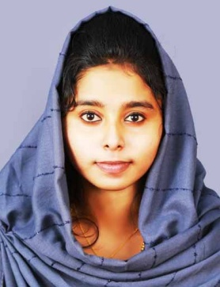

**THASNI ASHRAF**

PANAYIL VEEDU

SAMBRAMAM ,VATTATHAMARA P O

KADAKKAL , KOLLAM (DIST)

KERALA. PIN: 691536

MOBILE NO : 9745114378

e-mail:thasniashraf98@gmail.com

**OBJECTIVE**

To enhance my knowledge and capabilities by working in a dynamic organization that prides itself in giving substantial responsibility to new talent.

**PERSONAL PROFILE**

Name : THASNI ASHRAF

Name of father : Ashraf K

Date of birth : 18/03/1998

Gender : Female

Marital status : Married

Nationality : Indian

Languages known : English, Malayalam, Tamil

**EXPERIENCE**

* Three Month experience in Spotter Online Company
* Six month experience in DTP Centre
* Two Year experience in Accountant and Billing.

**ACADEMIC QUALIFICATION**

* SSLC, G.H .S.S Kummil
* Higher Secondary Education (HSE) , MGHSS Pala
* BSc Physics , Kerala university

**OTHER QUALIFICATION**

* Diploma in computer application ( c- dit )
* Completed medical coding and billing from Transorze solutions
* Computerised Foreign Accounting
* PG Diploma in Hospital Administration

**SKILL**

* Honesty
* Team Spirit
* Accepting Challenges

**STRENGTH**

* Ability to work under pressure in a demanding environment
* Flexible and adaptive to new situations depending on market conditions
* Hardworking, highly motivated, result oriented, reliable, punctual and sincere individual

**SPECIAL MENTION**

I am friendly, reliable and fit in as part of a team and also would work individually to my full effort.

**DECLARATION**

I hereby declared that all the above information furnished by me is true to the best of my knowledge and belief.

Yours Sincerely

THASNI ASHARAF