**CURRICULUM VITAE**

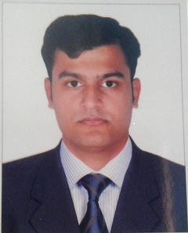

**MUHAMMAD IMRAN**

Email Id: Imranjan8@gmail.com

Mob: 058 240 8896

**PERSONAL DETAILS**

Name MUHAMMAD IMRAN

Date of Birth 15-03-1997

Sex Male

Nationality Pakistani

Marital status Married

Religion Muslim

**EDUCATIONAL QUALIFICATION**

* **Matric**

**PERSONAL STRENTHS**

* Can re-orient myself to any environment
* Willing to work hard & shoulder additional responsibilities.
* Can function independently as well as team player.
* Clear understanding of management principles & practices.

**PROFESSIONAL** **EXPERIENCES**

* I have five Years experience Receptionist In UAE.
* I have five Years experience in a rental company moon
* rent a car.

Top of Form

Language

Bottom of Form

**English, Hindi, Urdu,**

**HOBBIES**

* Cycling, Cricket & Football.

**DECLARATION**

I hereby declare that all the details furnished above are true to the

best of my knowledge and belief

**MUHAMMAD IMRAN**