CURRICULUM VITAE

MUHAMMADZOHAIB
Mobile: (+92) 0311-9209731
Village Deri Mian Ishaq, Post Office Mohib Banda
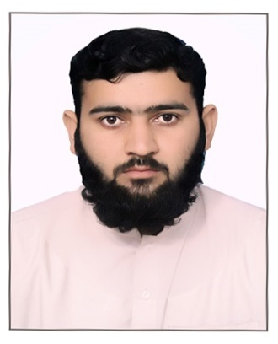
Tehsil Pabbi, District Nowshera, KPK, PAKISTAN
=====================================
OBJECTIVE:
Seeking a challenging career in a growing organization where my knowledge and experience can be applied and which can provide me with a dynamic work atmosphere to extract my inherit skills. Use and develop my aptitude to further the organization’s objectives and also my career in the process.

PERSONAL PROFILE:

- Name : Muhammad Zohaib
- Father’s Name : Muhammad Shoaib
- CNIC No. : 17201-5183384-5
- Date of Birth : 29-march-1994
- Domicile : Nowshera, KPK
- Religion : Islam
- Gender : Male
- Marital Status : Married
- Nationality : Pakistani
- Email : mzohaib635@gmail.coM

EDUCATIONAL QUALIFICATION

Qualification | Passing Year | Total Marks | Board/University
MBA 1.5 | 2019 | 3.38 CGPA | Abdul Wali Khan University Mardan
BBA Hons | 2017 | 3.34 CGPA | Abdul Wali Khan University Mardan
F.Sc (Pre-Engineering) | 2013 | 640/1100 | MARDAN BOARD
SSC Science | 2011 | 653/1050 | MARDAN BOARD

WORK EXPERIENCE

Currently working As” TELLER SERVICE OFFICER” in MCB Bank limited
Worked As Brand Ambassador in PAKISTAN TOBACCO COMPANY.

COMPUTER & TYPING SKILLS:
- Microsoft Word advance
- Microsoft Excel advance
- Microsoft PowerPoint
- Quick-Book accounting software
- Tally Erp 9 accounting software
- Internet
- Typing

HOBBIES

- Financial statement analysis of best firms.
- Internet Surfing
- Social Networking
- Sports
- Reading

LANGUAGES KNOWN

- Urdu
- English
- Pashto.

REFERENCE:
- Available upon request..

