**Resume**

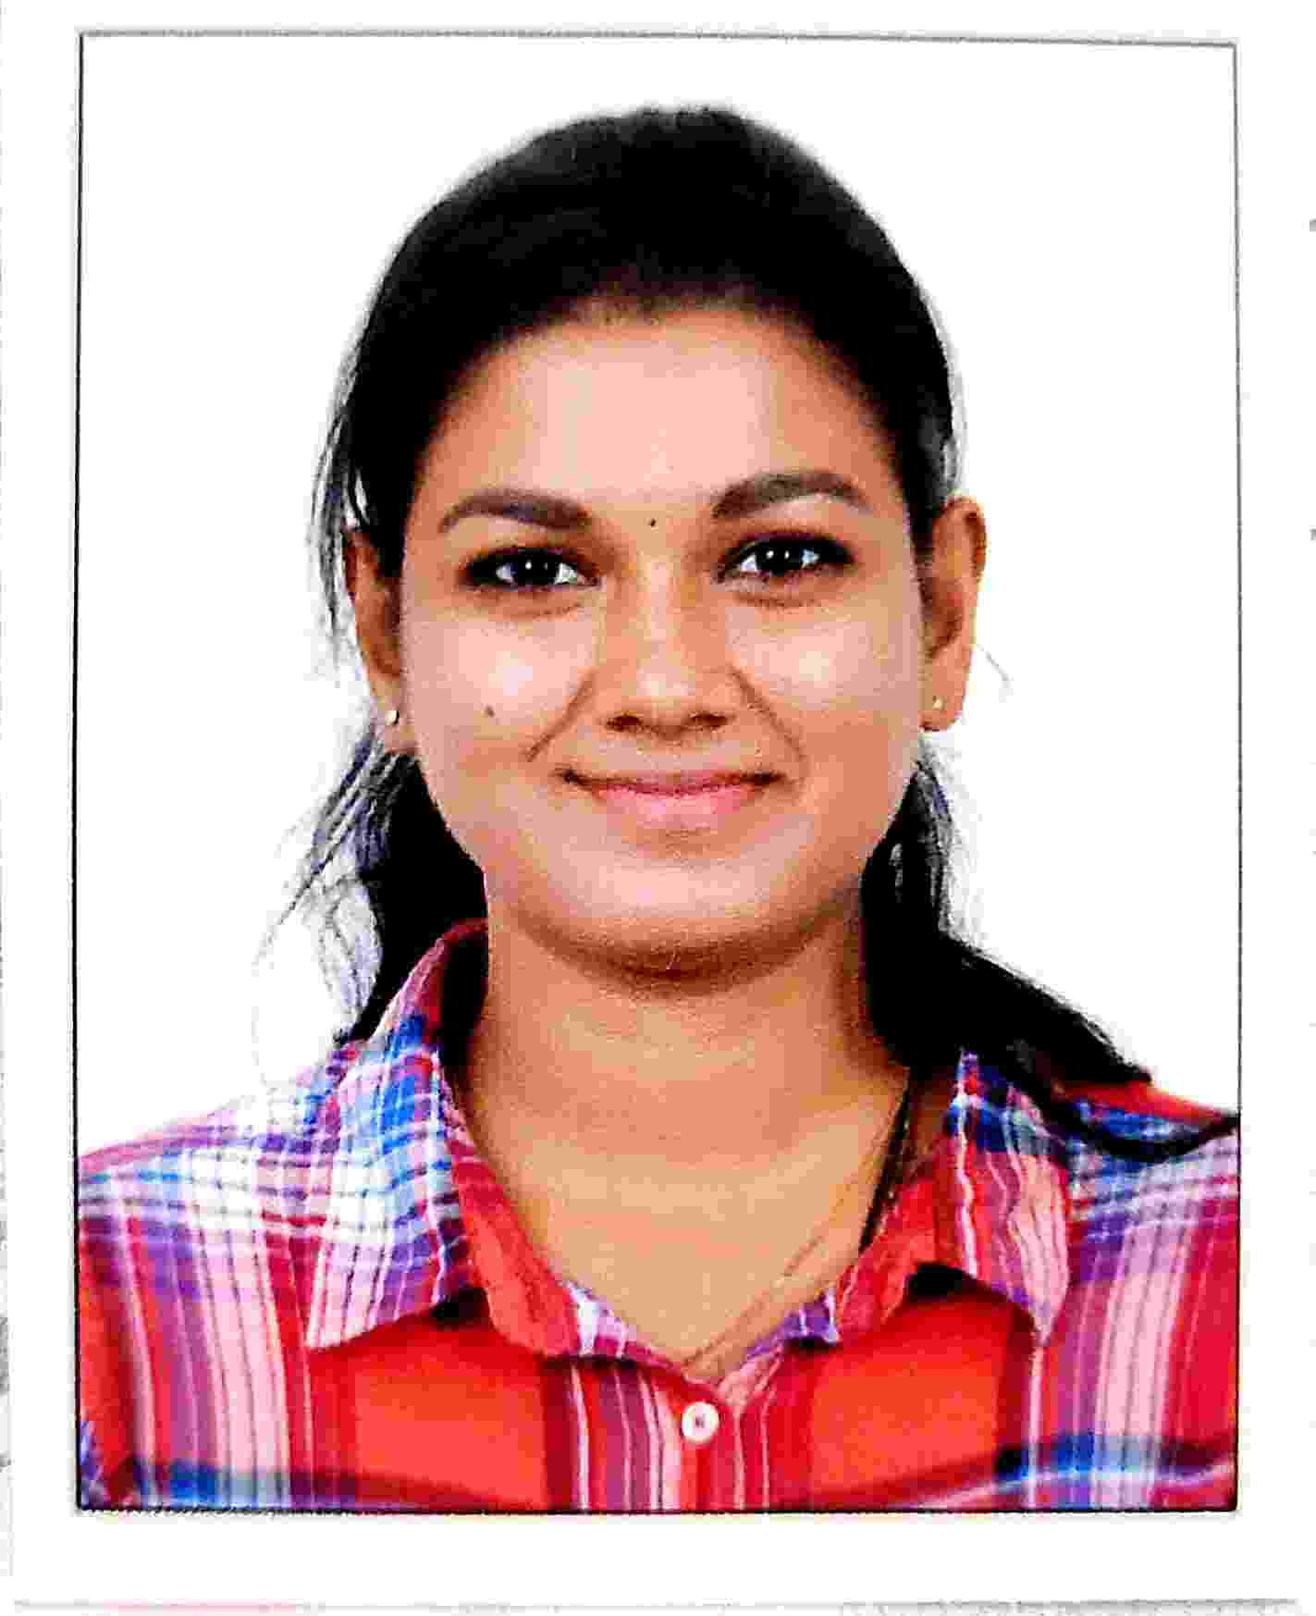

**ANCY JOSEPH**

**Address:** Kandathiparambil House

Elamkulam, Kadavanthra P.O

Ernakulam, Kerala, India

Pin: 682020

**Contact No** (Mob): +91 9567193865

**E-mail:** ancyjoseph9567@gmail.com

[ancyjoseph323@gmail.com](mailto:ancyjoseph323@gmail.com)

**Job Title: International Recruitment Consultant**

**Client Handling: UK- IRELAND-SAUDI-QATAR – HEALTHCARE RECURITMENT**

**PROFESSIONAL OVERVIEW:**

A dynamic professional with total experience of 3 plus years into Human Resource, An effective communicator with excellent relationship building & interpersonal skills, strong analytical, problem solving & organizational abilities & dedication, commitment towards work.

**ASPIRATION:**

**To achieve a career in HR where in I can use my skills to the best of my abilities and be a useful asset to the organization.**

**Skills:** Relationship Management, Recruiting, Healthcare, Non Healthcare, Human Resources. Administration.

**EXPERIENCE**

**Dynamic Health staff services Ernakulum, Kerala, India**

Date of Employment:28/01/2021 to till date

**Projects:** NHS Trust/HSC/HSE/PRIVATE

**Designation: Recruitment Executive Healthcare division UK/IRELAND/Middle east**

**Duties & Responsibility**

* Post and manage postings to external sourcing sites as directed by manager Coordinate candidate interview scheduling with site HR and site hiring managers.
* Expertise in the areas of Sourcing, Headhunting
* Handling End to End Recruitment process.
* Understanding the requirements received from clients, Plan and schedule a road map towards achieving the targets.
* Sourcing candidates from various job portals, referrals, internal database and professional networking sites.
* Involved in screening the resumes, closely working with Seniors for scheduling Meetings/appointments and interviews with the candidates.
* Helping the offered candidates in their NMC documentation process
* Guiding the candidates of their document process
* Negotiating & convincing the candidates to accept the offer
* Building good relation with the candidates and maintaining the database,  
  End- to- End follow-up of candidate.

**Jesseena Marine Services Ernakulum, Kerala, India**

Date of Employment**:** 3/03/2019- 31/07/2020

Projects:MOH & MOD (SAUDI, QATAR)

**Designation: Recruitment Executive Healthcare division- Saudi/ Qatar MOH/MOD**

**Duties & Responsibility**

* Execute recruiting strategies to achieve required staffing levels for Certified Nurses & all Non nursing professionals to Saudi & Qatar.
* Weekly calls with the hiring manager to define position requirements, job competencies and candidate profile.
* Precisely complete all required ATS protocol for current and new hire documentation.
* Follow-up with the HR department, and training team when necessary to check the status of a candidate in the hiring and training process

**Soften Technologies, Ernakulum, Kerala, India**

Date of Employment:7/02/2017- 31/10/2018

**Designation: Front Office Administration**

**Duties & Responsibility**

* Management of incoming and outgoing mail, e-mails, telephone calls, and correspondence, including where appropriate re-routing to executive.
* Administrative support including management of personal data.
* Developed and maintained professional communication with Organization's key contacts, internally and externally.
* Created Invite lists, consolidation, sending invites, greetings and thank you notes, etc. for various festivals and events for the entire mailing list.

**Key Responsibility**

* Going through the JD & multiple times for better understanding.
* Goggling the specific profiles jargon to strengthen the role awareness.
* Approaching supervisor for clearing the doubts.
* Making use of all job pormitment technology portals to source the best candidates.
* Sending LinkedIn connection requests to eligible profiles with reference to the job roles description.
* Posting jobs on portals like Naukri, LinkedIn, monster, times job etc.
* Filtering resumes based on keywords and approaching those possible candidates through Email or phone.

**EDUCATIONAL QUALIFICATION**

|  |  |  |  |  |
| --- | --- | --- | --- | --- |
| **Qualification** | **Name of the**  **College/Institution with place of study** | **Stream** | **State & District** | **Year of Passing** |
| SSLC | St. Mary's School, Ernakulum |  | Kerala | March 2011 |
| Plus Two | NSS, Thripunithura | Commerce | Kerala | March 2013 |
| Degree | Vidyanikethan College off campus, Ernakulam  (MG University) | B.com  (computer application) | Kerala | April 2016 |
| Post-Graduation | Annamalai University  (Distance Education) | M.B.A (HR) | Tamil Nadu | May 2019 |

**PERSONAL DETAILS**

Name : **ANCY JOSEPH**

Spouse Name : Noble George

Date of Birth : 14/08/1995

Marital Status : Married

Sex : Female

Nationality : Indian

Passport : V5027832

Expiry Date : 15/12/2031

Languages Known : Malayalam, English, Hindi

**DECLARATION**

I do hereby declare that all the above mentioned particulars are true and correct to the best of my knowledge and belief.

Place: Ernakulam

Date: ANCY JOSEPH