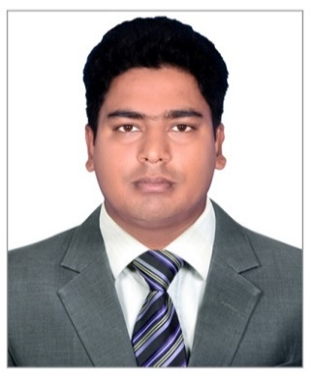

**CURRICULUM VITAE**

* Name : Amzad Hossain
* Address : Abu Dhabi, United Arab Emirates, (UAE)
* Contact : Phone +971505727521

: Email-amjad.sawaeedemployment@gmail.com

* Apply for : Office clerk / Document Controller / Data entry operator or office driver

**PERSONAL DATA:**

* Nationality : Bangladeshi
* Date of Birth : 01/01/1989
* Place of Birth : Pirojali, Gazipur, Dhaka Bangladesh.
* Gender : Male
* Marital Status : Married
* Religion : Muslim

**EDUCATIONS QUALIFICATIONS:**

* (SSC-2006) : Secondary School Certificate ( Pirojali high school, Gazipur Dhaka Bangladesh)
* (HSC-2007) : Higher secondary school (1st year) ( Bhawal badre alam government college, Gazipur Dhaka Bangladesh)

**EXPERIENCES:**

* **Driving** : UAE-Driving License (Light Vehicle) (Manual)
* **Working Experiences:**

: Office clerk / Document controller in **Sawaeed Employment LLC** -Abu Dhabi (UAE) since 2008 to till now.

: Office clerk 06 Month in 2016 & 2017 in **Tamkeen LLC**-Abu Dhabi(UAE)

: Data entry operator 01 year in 2017 & 2018 in **National Avian**

**Research centre** (UAE) Abu Dhab-Sweihan Al ain

* **Computer skills :** Good experience of Microsoft excel & word.
* **Languages:** : Bangla / English / Hindi / Urdu / Arabic

**:** Good communications skills in English, Arabic, Urdu & Hindi

CURRENT JOB DETAILS:

: Office clerk / Document controller in **Sawaeed Employment LLC** Abu dhabi (UAE).

**CURRENT JOB DESCRIPTIONS:**

* Receiving all kind of documents from head office & SRC administrations, which is related with operation active workers (on site) as Labour contract / CAN PASS / Emirates id / Insurance cards / ATM cards / Cash salary & Workers payslips etc. and handing over to all site supervisors for workers acknowledgment.
* Receiving all kind of documents from site supervisors & Timekeepers as From-C/ Timesheets / Cancellation documents / Visa renewal documents / Leave request / Sick leave certificate / CAN pass etc. After review & verifications forwarding to head office or SRC administrations managements for further process.
* Preparing timesheets collection details of construction sector / Oil & gas & Sawaeed facility management after end of the month as per actual mobilization records & forwarding to all site supervisors & other relevant personnel for accurate timesheets collection to avoid any issue regarding workers salary & invoice.
* Receiving all timesheets from site supervisors & verifying as per mobilization records & making scan & updating to system for further records, then sending to payroll for workers’ salaries & invoice purpose.
* Preparing workers additional allowance details, as site allowance / Hardship allowance / Travel allowance / Trade allowance and then forwarding to payroll for further process.
* Preparing form-C / Time sheets / Leave request / Cancellation documents etc. for normal & emergency purpose as per site supervisors instructions and forwarding to mobilization & administrations team for further process.

**DECLARATION:**

* I hereby declaring that the above mentioned all information is true & correct according to the best of my knowledge & my experience. If selected I assure that I would perform to the best of abilities, early awaiting a positive response.

**AMZAD HOSSAIN**