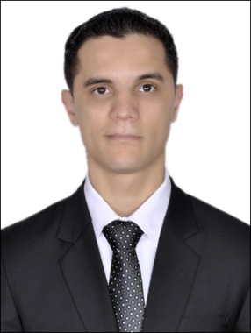 **Messaoudi Farouq**

Day of birth   : 16-06-1987 in Errachidia

Nationality : Moroccan

Phone  : 055-796 2399

E-mail  : [frmd@live.fr](mailto:frmd@live.fr)

Civil Status : Single

Religion : Muslim

Passport N° : UV7857519

UAE driving license N° : 2445418

|  |
| --- |
| **CURRICULUM VITAE** |

* ***Education***
* **2007-2009**: *Diploma Specialized Technician in Computer Networks*

« *Specialized institute of Applied Technology* » Séfrou.

* **2006-2007:** Bachelor Degree Technical Branch: « Electronics »

« *Technical high school* » Errachidia.

* *Works experience*
* ***November 2015***: *Security Supervisor at Armed Forces Officers Club & Hotel*

*Company: Emirates Gateway Security Services Abu Dhabi*

* ***February 2014****: Security guard at Armed Forces Officers Club & Hotel*

***CCTV control room operator***

*Company: Emirates Gateway Security Services Abu Dhabi*

* ***January 2012****: Security guard at Armed Forces Officers Club & Hotel*

*Company: Emirates Gateway Security Services Abu Dhabi*

* **March 2011**: *Salesman and technical helper (Paradise Store)*

*IT Hardware and Software*Séfrou

* **2009-2010:** *Supervisor Renault group* «*Renault-Dacia-Nissan*» *Section Department of electric Tanger*

* **August 2007:** *Responsible of cyber Net Coffee* *Administration And Controlling* Fès.
* *Training :*
* **December 2014:** *Fire Safety & Prevention at Armed Forces Officers Club & Hotel Abu Dhabi*
* **March 2014**: *Operating X-Ray Machine at Armed Forces Officers Club & Hotel Abu Dhabi*
* **January 2014:** *CCTV Control Room monitoring and review recording editing and extraction videos at Armed Forces Officers Club & Hotel Abu Dhabi*
* **2010-2011:** *Youth hostel Rahal Almeskini*

*Installed software, repair equipment informatique* Kenitra

* **May 2009:** *Final internship training*

*«Specialized institute of Applied Technology»* Séfrou

* **July 2008:**  *The Urban district of Sefrou Section civil: status: Establishment of birth certificates And other forms of civil status* Séfrou
* *Computer skills :*
* Software design & development : ICDL
* Operating system : MS-DOS, Windows 2000/XP/Vista/7/8/10 Linux (Ubuntu, Red hat, Backtrack, Debian)
* Full knowledge of Supervising Systems · Video Management · *Endura by pelco*
* Maintenance materiel and software installation
* Installation and configuration of internet router setup
* Configuration and administration of a workstation
* Câblages, Routers, Hubs.

* *Languages*
* Arabic : Mother tongue.
* French : Good.
* English : Good.

* *Interests*

Music, Sports, Travel]

**Strengths and capabilities**

Software installation and configuration, problem solving, technical troubleshooting, technical training, patient and respectful.

