ABDUL HAMEED MULLA (B.E CIVIL) (CIVIL ENGINEER/SITE ENGINEER)  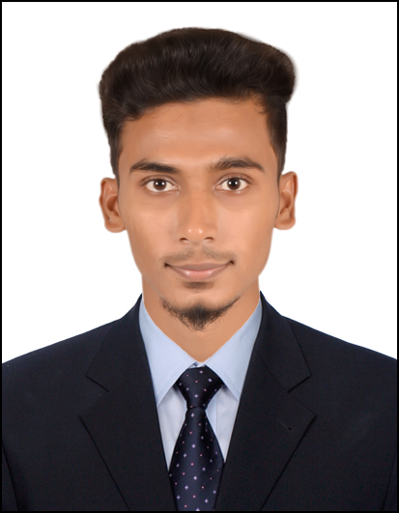  PERSONAL DATA:  Name :ABDUL HAMEED MULLA  Father’s Name : ABDUL SAMAD MULLA  Mother Name : TASKEEN BEGUM  Date of Birth : 19.03.1995  Nationality : INDIAN  Marital Status :SINGLE  Current Salary :26,000INR  Languages Known : ENGLISH,HINDI,URDU, KANNADA  Place to work : Open to work on site execution, Quality control & its implementation  Passport No :U6586636  Present Address:  Kesav nagar, mundwa , PUNE -411036  Permanent Address:  s/o ABDUL SAMAD MULLA  #463 LODI GALLI NARGUND  Dt-GADAG St-KARNATAKA  Pin Code: 582207  Mobile: (+91) 9742565712  CONTACT  Email: hameedmulla95@gmail.com  Mobile:+91 9665699632  LINKS  Whatsapp : +91 9665699632  Skype : live:2c834f94c151520d | Objective:  To work in an organization wherein I can utilize my skills to contribute towards the company’s growth. I seek challenging and have a desire assignments for further career experience in construction, execution, Quality control & its implementation, quality inspections of High-rise and super high-rise residential & commercial buildings.  Key Skills  - SITE ENGINEER  - CIVIL ENGINEER  Academic Profile  B.E In Civil Engineering H  U.B.D.T College of Engineering Davanagere  2013-2017  Aggregate Percentage: 62.5%  PUC  S.M.P.U College Dharwad 2011-2013  Aggregate Percentage: 73%  SSLC  Karnataka Board of secondary education, in 2011  Aggregate Percentage: 87.6%  Additional skills  TECHNICAL  - Auto CADD  - 3DS-MAX  - Microsoft Project  STRENGHTS  1.HARD WORKING ,LOYAL AND PANTUAL  2.COMMUNICATING EFFECTIVELY WITH SUPERIOR AND INFERIOR  3.LEADING TEAM TO ACHIEVE GOAL  4.PROBLEM SOLVING THROUGH LOGICAL AND CREATIVE THINKING
Professional Experience: 1 years
SITE ENGINEER (Sept2019-Till date )
Associated with KNIGHT FRANK (INDIA) PVT LTD (under the pay role of RJSS)
For Snagging, De-snagging, Handover Takeover, Possession of flats On a
High-rise Residential and Commercial Building project GODREJ INFINITY At keshavnagar mundva PUNE with Client-GODREJ PROPERTIES LTD.
And High-rise Residential and Commercial Building project VTP URBUN NEST at UNDRI PUNE
With client-VTP REALTY

Project Description:-
Godrej Infinity is a 42.95 acre residential development located on the banks of the Mula-Mutha River at Keshavnagar, Pune. Project includes 6 towers, 14 wings of 1204 flats.
VTP Urban Nest is a 8.72 acre residential and commercial building project having 5 towers of 362 flats.

Duties & Major Responsibilities:-

- Snagging and De-snagging of flat by analyze and evaluate the defects to provide
Major and minor rectification work
- Prepared report is Hand-over to GODREJ & CBRE team.
- Handover of T2B tower which have 22 floor includes 88 flats of 2BHK flats
And T1 tower 52 flats of 3BKH flats which have 28 floor of 112 flats at Godrej infinity.
- Scheduling customer visit from CRM team before possession
and taking customer observation points.
- Solving customer observation points before and after the possession.
- Possessions and flats Hand over to customer.
- Snagging and De-snagging of Common area.
- Day to day flats condition report submitted to our team manager.
- Co-ordination with the client & attending the weekly client meeting regarding the status of work.
- Co-ordinate with the site team for work execution as per schedule.
CIVIL ENGINEER (July 2017-AUG2019)
Associated with BHARATH CONSTRUCTION
As a CIVIL ENGINEER on a Residential building projects At HANGAL St-KARNATAKA

Duties & Major Responsibilities;

- Visiting the site before planning, for taking actual area, condition, and direction of site.
- Planning of home according to vastu and client needs.
- Site inspection before, during and after work activities to check & ensure proper implementation, generate defect lists.
- Experience in analyzing, reading, and understanding CAD drawings.
- Conduct inspections for Improvement in quality of Workmanship at all sites.
- Co-ordinate with the site team and workers for work execution of as per drawings.
Declaration:

I hereby declare that the information furnished above is true, correct and complete to the best of my knowledge. I consider myself familiar with management aspect. I am also confident of my work in a team.

Place : PUNE Sincerely
(ABDUL HAMEED MULLA)

