RESUME

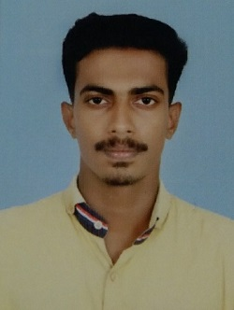
MONU SURENDRAN

: Kaduvinkal ,
Neduvarmcode P. O, Thuruthimel
Chengannur , pin : 689508
: monusurendran123@gmail.com
- : +917034964462

OBJECTIVE:

To make a sound position in corporate world and work passionately in team to achieve goal of the organization with dedicated and hard work.
EXPERIENCE:

- One Year experience as an Electrical Supervisor trainee at Prabhuram Mills Ltd., Kotta, Chengannur, Kerala
- One year experience as an Electrician Under the Supervision of Mr.Ajesh Kumar , Electrical B Class Contractor , Highlight Electricals, Knnanmthanam , Pathnamthitta
- Conducted an Industrial Visit at Aluminium Industries Ltd. Kuttamperoor, Alappuzha, Kerala from 2017 June 15 to 2017 June 30

EDUCATION:

2019 | Diploma in Electrical and Electronics Engineering |61%|
Kerala State Board of Technical Education, Government Polytechnic College, Kottayam, kerala

2015 | plus two |65% |
Government of Kerala Board of Higher Secondary Examination
S.N.T.H.S.S, Neduvaramcode, Chengannur, Kerala

2013 | S.S.L.C |89% |
S.N.T.H.S.S, Neduvaramcode, Chengannur, Kerala

SKILLS:
- Good understanding in Electrical Drawing
- Good and fast trouble shooting in electrical machinery complaints
- Knowledge in House Wiring
- Demonstrate good organizational and Team management skills
- Demonstrate Effective problem solving and analytical skill
- Knowledge in MS Office (Excel, PowerPoint, Word)
- Flexible to work across shifts and time zones

INTEREST AND ACTIVITIES:

Athletics and Cricket | Listening to music |Co-curricular activity (NCC)

PERSONAL PROFILE:

Name : MONU SURENDRAN
Date of Birth : 19/10/1997
Father’s Name : SURENDRAN
Sex : Male
Marital Status : Single
Languages Known : Malayalam, English ,Tamil
Nationality : Indian
Permanent Address : kaduvinkal, Neduvaramcode P. O, Chengannur, kerala
Pin code : 689508

DECLARATION:

I hereby declare that the information furnished above is true to the best of my knowledge.

Date:

Place: MONU SURENDRAN

