Curriculum Vitae
_____________________________________________________________________________________

NAME:ROMAN SAPKOTA
Permanent Address: PANAUTI 09 KAVREPALNCHOK
Temporary Address: Gairigaun 09, Kathmandu
Contact No: +977 9860146706
Mobile:+977 9860146706
Whats app,viber ,imo :9860146706
E-Mail:romansapkota27@gmail.com
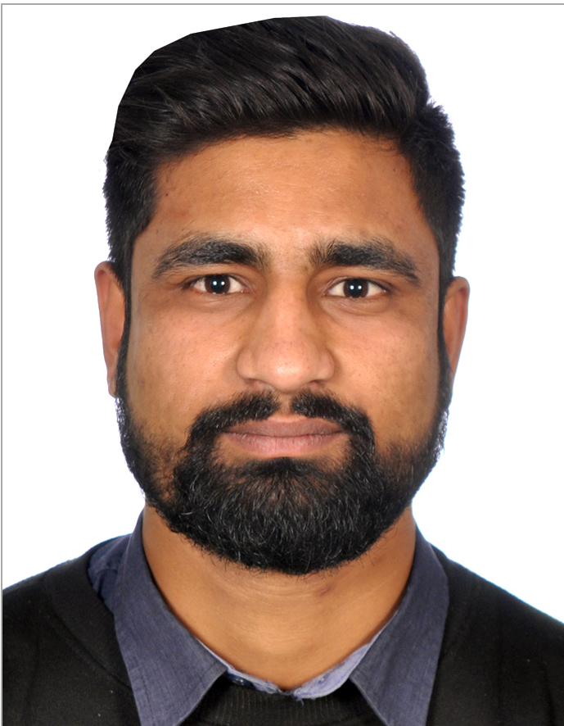

Career Objective:
To find myself in a challenging position and work as an enthusiastic staff in the rising industry to provide services and solutions in a creative environment that will provide the opportunity to exploit my caliber and enable me to grow professionally along with the organization.
Personal Details:

Date of Birth: 1997-01-04
Gender: MALE
Nationality: NEPAL
Religion: HINDU
Marital Status: SINGLE
Citizenship: NEPALESE
Height: 5.10’’
Weight: 70 kg
Color of Eyes: BLACK BROUN

Family Details:-
Father Name: ARJUN SAPKOTA Mother Name: KAMALMAI SAPKOTA
Date of Birth: 1962-05-31 Surname before married: TIMALSINA
Address: PANAUTI 09 KAVREPALANCHOK Date of Birth: 1971-07-21
Occupation: AGRICULTURE Occupation: AGRICULTURE

Curriculum Vitae

Passport Details:
Passport No: 09771901
Date of Issue: 16 May 2016
Date of Expire: 15 May 2026
Place of Issue: Mofa, Department Of Passport

Spouse Details: Children's Details:
Name: None Name: None
Date of Birth: None Date of Birth: None
Address: Address:
Occupation: Occupation:
Surname Before Married:

Academic Qualification:
- Passed SLC in first division from Suryodaya H. SEC School in 2070.
- Passed 12 from (NIC) National Integrate Collage.
- Good Knowledge about call centre and international e-ticketing along with its certificate ticketing software I used (Galileo & Sabre Red).

Work Experience:-
- 5 years working experience in travel agency as Manager Sales & Operation.
- Still working in same field.

I, the undersigned, certify that to the best of my knowledge and belief, these data correctly describe my qualification, experience and me.

…………………………………………………….. ………………………………………
(Applicant) (Date)

