**RESUME**

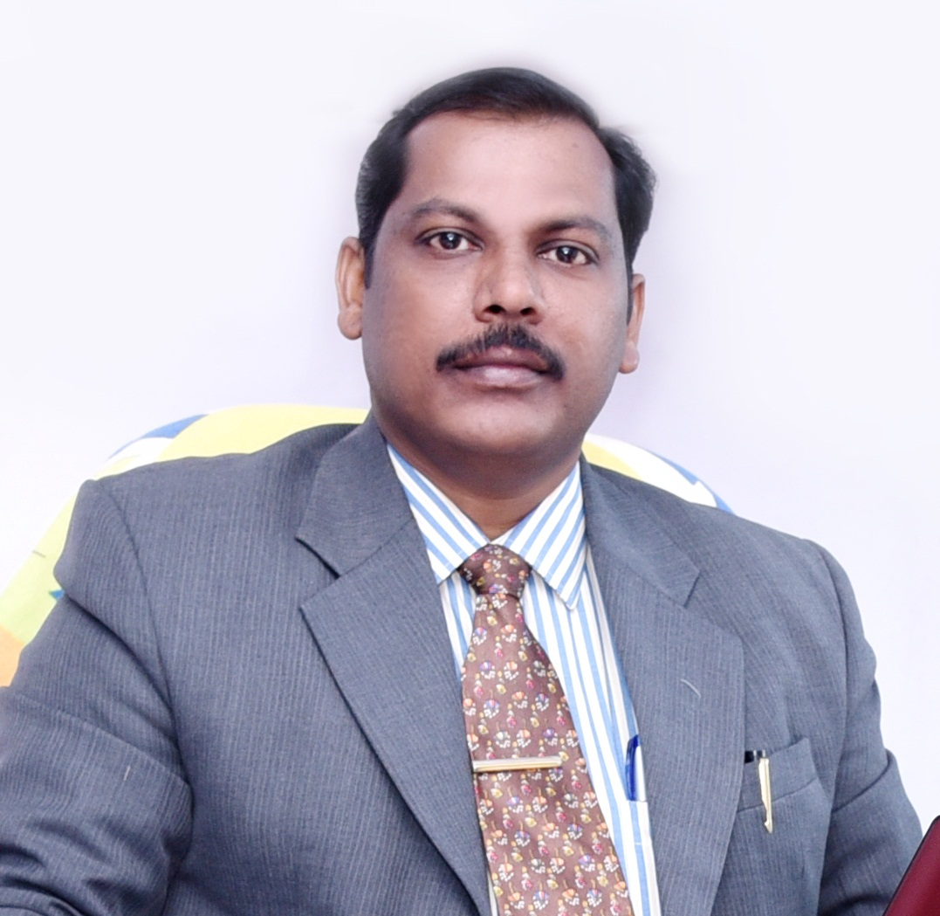

**Mr. THOMAS. N. M**

**trythomas@gmail.com**

**thomasmjaya@gmail.com**

**+916268789767, + 91 9780297287, +91 9483993198**

OBJECTIEVES

To contribute greatly in Administration and Management services, which enhances and develops smooth functioning of the Institution/Organization/etc. Moreover, want to serve the firm with full capacity and commitment especially in the areas of Administration and Management where I would owe to be a blessing to the organization in carrying out the services faithfully and honestly with full responsibility.

**EDUCATIONAL QUALIFICATIONS**

* **Bachelor of Business Administration (BBA) from RNT University, Madhya Pradesh.2018-2021**
* **Master of Science (MS) in Counselling and Psychotherapy** (2006-2008),Recognized by ***The Indian Hospital Association, New Delhi***, *Affiliated* with ***The Open International University for Complementary Medicines*** *(Medicina Alternativa)* established as per **W.H.O**. Alma Ata (U.S.S.R), and Recognized by ***The United Nations Peace University***. From Institute for Behavioural and Management Sciences (IBMS), Chittoor, Andhra Pradesh.
* **Post Graduate Diploma in Counselling (PGDC**) (2006-2007),

Under ***Christian Medical Association of India***, New Delhi (PG in DPHM), from South India Biblical Seminary, Bangarapet, Karnataka.

* **Bachelor of Theology (B.Th)** (2002-2006),

Under ***Asia Theological Association****,*Secured 72% (Second Class) from South India Biblical Seminary (SIBS), Bangarapet, Karnataka State.

* **Higher Secondary Education (HSE)**, Science Group (March 2001),

*Board of Higher Secondary Examination*, Kerala Govt., Secured 52% (Second Class).

* **Secondary School Leaving Certificate (SSLC)** (March 1998),

*The Board of Public Examinations*, Kerala State. Secured 59% (Second Class).

**Additional Qualification:**

* **Computer skills course consisting of MS Windows, MS Excel, MS Word, MS Office,**
* **Trained in Tally 9 and finance Management ERP, and familiar with different School ERP and Internet.**

**WORKSHOPE AND SEMINAR:**

* Attended training program for the **School Management and Administration, Financial Management and Purchases, etc.** conducted by the Education Department of CFI, at Bhopal
* Attended the training program on **Emerging Landscape of School Leadership Skills & Management – Good Practices for Holistic Approach** conducted by **Sahodaya School Complex (CBSE)**, Pathankot, Punjab and **Expression India** in the month of July 2015.
* Attended Workshop on **Pastoral Care in Health Care organized by Madras Medical Mission (MMM) and Christian Medical Association of India (CMAI)** in the month of June 2006.
* Attended A Strategic Conference for Healthcare Professionals on Biblical Christian Healthcare, Wholeness, Healing and Holiness in Jesus Christ in the month of February- March 2007 at **CMC Vellore** conducted by **Healthcare in Christ- Australia, HCFI- South Asia and CMC Vellore**
* Attended various other Workshops and Seminars on **Disaster Management, Addiction, Pastoral Care and Counselling**, etc.

**STRENGTH, SKILLS & CHARACHERS**

Complete School administration, pioneering schools, Managerial works, Supervision, Good leadership quality and abilities, Good team player and management, Excellent Problem solving skills, excellent communication skills, Counselling, Financial Management and integrity, Production and Profit oriented abilities, Good computer knowledge, quick learning skill, Successfully Manages all work pressure, Boldness to face any challenges, take up responsibilities, faithfulness, commitment, Confidence, Leading exemplary lives, Keeping good moral values and Christian qualities, etc.

**PROJECTS DONE**

**1. Research Paper done during PGDC course:** An empirical study using quantitative and qualitative methods on **“Suicide”** mainly focused among college students age between 16-25 to find out the causes leading to suicide, suicide attempts and suicidal thoughts, as well as to find the symptoms of suicidal behaviour and how a Christian counsellor can intervene this major growing crisis among the youngsters and also to see the different role of parents, teachers, pastors, etc.

**2. Research Paper done during MS programme:**An empirical and exploratory study **on the crisis of Depression with special reference to the wives of Alcoholic addicts**, using quantitative methods, it gives in-depth understanding of the disease Alcoholism and how it causes damage to the life of family members specially to the spouse, also to analyze how seriously depression catch hold on to this people and concluding how society and professionals of mental health can stretch their helping hand to these crisis.

**WORK EXPERIENCES (12 plus years)**

1. **SCHOOL MANAGER /ADMINISTRATOR**

**(July 2016 to Present, Madhya Pradesh)**

**Since July 2016**, working with **CFI Charitable Trust**, as a **Manager for the Higher Secondary school at Sleemnabad, Katni Dist., Madhya Pradesh.** (Grace Mission Eng. Med. Higher Secondary School)Where I am taking care of complete **administrative works and all Finance management of different Schools** in Madhya Pradesh, I am given responsibility of two Higher secondary schools and one high school, there are around 100 plus staff working under my supervision, and I administrates all finance related matters of these schools and carrying out various other administrative responsibilities for the enhancement and development of the institution.

Recruiting teachers and other non-teaching staff, managing transportations purchasing vehicles and maintenances, other assets purchases, constructions, campus developments, other developments of school as and when it is required. Taking different roles in many of the occasion like of complete **HR related policies, role of the Admission counsellor, staff counselling and guidance, student’s counsellor, role of PRO many a times, Academic coordinator and involves in various academic improvement** responsibilities, Bank related works, etc All other Government related works with various departments, Land purchases and registrations, preparing files and reports for FCRA accounts, etc. all together I am carrying out multiple responsibilities in the school.

1. **SCHOOL MANAGER/Administrative Assistant**

**(August 2012 to January 2016, New Delhi and Punjab)**

In the month of **August 2012**, I had joined **Indian Evangelical Team (IET),** one of the largest Christian Organization in India ([www.ietmissions.org](http://www.ietmissions.org)) and I had worked at IET’s Head Quarter in New Delhi as a **Administrative Assistant**- taking care of various administrative responsibilities, and along with I was given various roles such as: Publications in-charge, corresponding and coordinating with publishers, printers, translators, sponsors, etc .

After one and half year, I was given another responsibility to take care of the **International school** which IET has at Pathankot, in Punjab State as a **Manager,** in the month of **January 2014** I had taken up the responsibility of **Rhema International School (CBSE School)** ([www.rhemainternational.in](http://www.rhemainternational.in)). Where I was taking care of all administrative works of the school, Accounts in-charge, conducting teaching and non-teaching staff meetings, all external affairs with Govt. Offices and Education Board, affiliation works, all CBSE works, appointment of staff, student counselling and guidance, and carried out various other campus development works, maintenance, construction, etc.

1. **MANAGER**

**(May 2009 to July 2012, Vellore and Bangalore)**

From **May 2009** onwards, I joined **Medico-Counselling Association of India (MCAI)** an autonomous Christian organisation, its registered office at Bangalore. I was **in-charge** of various projects MCAI had in Vellore, Tamil Nadu. And also I was taking care of the Administrative part of MCAI, such as Academic Dean of the South India Theological College, Teaching various subjects to the PG Diploma students of Counselling discipline, and also in charge of Ashakiran Institute of Education (Vocational Training programme initiated by MCAI) and Ashakiran Children Home (MCAI is taking care of 20 Tsunami affected children for last many years, we family were in-charge and taking care of these children’s academic, spiritual and other developmental areas).

From **February 2011**, I came to Bangalore, where MCAI had shifted its projects from Vellore to Bangalore except the children’s Home. I was working as a **Manager** for MCAI’s Bangalore Projects until July 2012.

1. **PROJECT ASSISTANT**

**(October 2008 to April 2009, Bihar)**

From **10thOctober 2008** onwards I was working as a **Project Assistant** with **Emmanuel Hospital Association(EHA)** in the Department of Disaster Management place called Madhepura in **Bihar State**. There I was involved in the relief work, filed visit, project planning and organizing, making surveys and reports, etc.

1. Went to the Psychiatric Department of **Christian Medical College (CMC), Vellore** for a short period of training from **14th July 2008** onwards. There I had good exposure to the patient counselling, record maintaining, various cases attending, etc,
2. One year I had taken part in the administrative works of **Christ English School**, Palad, Nilambur, Kerala (During the year **June 2001 - June 2002** and in the months of **April, May and June from 2002-2006).**

**REFERENCES**

1. **Dr. Ezeckiel Shanthakumar J.C. (known to me for 18 plus years)**

**Director**

Medico-Counselling Association of India (MCAI)

No.124, Opp. BPL, Hope Farm,

Whitefield,

Bangalore- 560066

Phone: +91 944 81 85 274, +919740319175

E-Mail: ezeckiel@satyam.net.in ezeckielsk@gmail.com

1. **Dr. Shajee George**

(Clinical Psychologist and Hypnotherapist)

Psychology Clinic

Manalodi Road, Nilambur,

Malappuram (Dt.)

Kerala, India

Phone: + 91 9846279444

E-Mail: shajieepappadi@yahoo.com

1. **Pastor: Shaji Idiculla (known to me for 9 plus years)**

Elim A.G. Prayer Center

D. 1337, A.E.C.S. Layout,

Kundalahalli,

Bangalore-560 037, Karnataka State

Phone: +91 9343309655

**LANGUAGES KNOWN**

**Speaking -Fluent :** English, Hindi, Tamil, and Malayalam

**Speaking -Average :** Kannada

**Reading** **:** English, Hindi, Tamil, and Malayalam

**Writing :** English, Hindi, Tamil, and Malayalam

**PERSONAL DETAILS**

**Father’s Name :** N.T.Mathew

**Date of Birth :** 11th August 1982

**Sex :** Male

**Marital Status :**Married

**Wife’s Name :** Mariamma Thomas

**Details of the Children : 1. Eunice Lee Thomas**

Date of Birth: 14th November 2010, Sex:-Female,

**2. Eugene M. Thomas**

Date of Birth: 14th January 2014, Sex:- Male

**3. Emmanuel M. Thomas**

Date of Birth: 05th June 2019, sex: Male

**Nationality :** Indian

**Mother Tongue :** Malayalam

**Permanent Address:**  Naduvilethu (House),

Muthukulam, Uppada (PO),

Malappuram (Dist.),

Kerala (State), Pin- 679354, India

**Present Address:** Cherukattoor Ebenezar House

Kuttoor P. O.

Thiruvalla

Pathanamthitta Dist.

Kerala-689106

**Mob :+91 6268789767, + 91 9780297287, +91 9483993198**

**E-Mail : [trythomas@gmail.com](mailto:trythomas@gmail.com), [thomasmjaya@gmail.com](mailto:thomasmjaya@gmail.com)**

**Passport Details:**  Passport No. **S 4167607,** Place of issue: **Trivandrum**

Date of Issue: **31/08/2018**, Date of Expiry: **30/08/2028**

**DECLARATION**

I affirm that the information given above is true and correct to the best of my knowledge and belief.

**Thomas N.M. Date: 01.09. 2021**