CURRICULUM VITAE

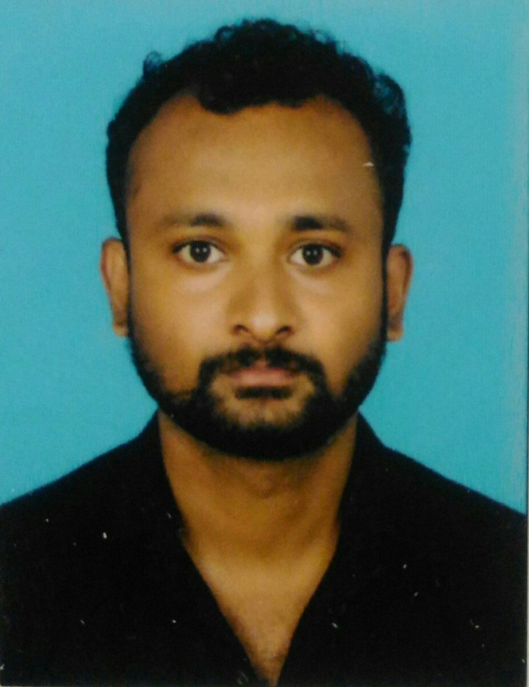
NIKHIL JOHNY
UAE DUBAI
Mob No (UAE):+971 565507069
Mob No (IND) :+917 96566 74846
Email: nikhiljohny89@gmail.com

Objective:-
To work in an environment which offers a good opportunity to share my knowledge and skills with others and participate myself and work towards for a complete satisfaction of the company.
Personal Details:-
Name : Nikhil Johny
Father’s Name : ML Johny
Nationality : Indian
Date of Birth : 22/09/1989
Gender : Male
Religion : R/C
Marital Status : Single
Languages Known : English, Hindi, Tamil & Malayalam
Educational Qualification:-
SSLC
One year diploma in Automobile and Auto electrician

Passport Details:-
Passport No : U5215291
Date of Issue : 11/03/2020
Date of Expiry : 10/03/2030
Place of Issue : Cochin
Visa Status : visit visa
Work Experience:-
- Worked as a “Auto Mobile Mechanic Auto Electrician” with “Technik Auto Service Counter Co LLC” in Dubai, UAE last 3 years.
- Insurance work
- Worked as a “Auto Mobile Machanic Electrician” in India for 5 years.
Strength:-
- Ability to work under pressure & independently.
- Excellent communication skills, Confident & Hard working.
- Quick Learner & cooperative nature.
Declaration:-
I hereby declare that the above mentioned statement is correct & true to the best of my knowledge & belief.
NIKHIL JOHNY

