**CURRICULUMN VITAE.**

**PERSONAL DETAILS** 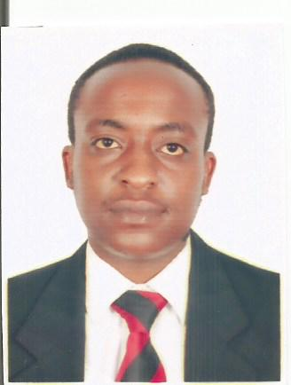

1. **Name: Stephen KImsni**
2. **Nationality: Kenyan**
3. **Contacts: +971589737421**
4. **Marital Status: Single**
5. **Religion: Christian**
6. **Email: gichboyk@gmail.com**
7. **Visa Status: Resident Visa (employment Visa)**

**CAREER OBJECTIVE:**

To be able to have an opportunity to practice and conduct my acquired skill and knowledge in a manner compatible with the dignity of my profession, and to be able to meet new challenge that would promote constant learning and professional maturity.

**WORKING EXPERIENCE: ATANA HOTEL, DUBAI**

**TELEPHONE OPERATOR.**

* Answers incoming calls.
* Directs calls to guest rooms,staff or departments through the switchboard or PBX system.
* Recieves guest messages and deliver the same to the guest.
* Provides information about hotel to guest.
* Understand the telephone operator board or PBX switchboard operations.
* Knows what action to take when an emergency call is required.
* To be fully aware of and adhere of health and safety , fire and bomb threat procedures.
* Must be polite and courteus while answering the phone.
* Provide relay service for hearing-impaired guests.
* Following telephone ettiquette.
* Multitasking ability will always come in handy, because a switchboard operator must be asked to do other jobs as well.

**TELEPHONE OPERATOR.**

GHAYA GRAND HOTEL (IMPZ)

**Duration 2017- 2018**

**DUTIES AND RESPONSIBILITY**

* Answering incoming calls.
* Direct calls to the guest rooms, staff or department through the switchboard or pxb system.
* Place outgoing calls.
* Receive guest messages and deliver them back to the guests.
* Log in wakeup call requests and perfoms call services.
* Knowledge of how to take action when an emergency call is required.
* Assists in reporting telephone equipment or service complaints or problems.
* Must be polite and courteous when answering the calls.
* Upate directory information in the front office software.
* Provide relay servicesfor hearing impaired guests.

**EDUCATIONAL QUALIFICATION:**

* Primary School Leaving Certificate 2008 – Muthaiga Primary School
* High School Leaving Certificate -St Joseph High School.
* IAT university for an international computer driving licence**.**

**PERSONAL SKILLS**:

▪ Good communication and interpersonal skills

▪ Hard working team member

▪ Have the ability to work under pressure

Honest, patient and ambitious

**DECLARATION:**

I hereby declare that all the information's furnished above are true and correct to be best

**REFEREES: Will be handed upon request.**