Resume 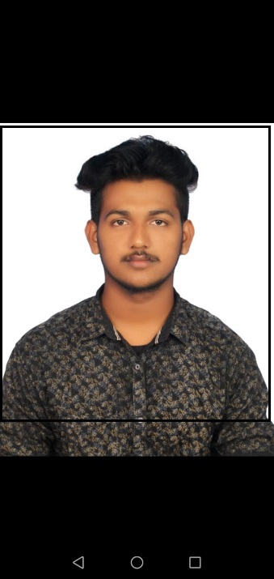
Name: Sarbutheen
Contact: +971561126208
Email: Sarbudeen389@gmail.com
Career Objective
To seek an opportunity in an organization and venture to be a part of its growth through innovative and dedicated approach to the emerging challenges and tailor them to upgrade my skill. My aim is to work in a good company with my best effort towards my organisation.
Education Qualification
Serial No | Education qualification | School/college | Board/university | Year of passing
1. | ITI (AC Mechanic) | National ITI, Jayankondam | DOTE | 2019
2. | 12th | Government Hr Sec School,Jayankondam | State Borad | 2018
3. | SSLC | Government Hr Sec School,Jayankondam | State Borad | 2016

Strength
Punctuality, Hardworking
Hobby
Singing, Dancing

PERSONAL DETAILS
Name: Sarbutheen
Father Name: Sathick Batcha
D.O.B: 21/06/2001
Gender: Male
Religion- Islam
Nationality- Indian
Passport No: U 8104174
Marital Status- Un-Married
Language Known - Tamil, English
Declaration
I do hear by declare that all the above Information is correct as per my knowledge and belief.

DATE: SIGNATURE,
PLACE: Sarbutheen,

