**CURRICULUM VITAE**

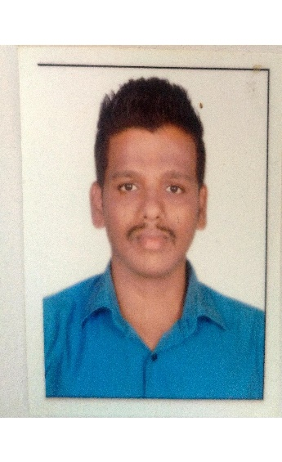**PERSONAL DETAILS**

**Name Anil Bansi Pawar**

**Father’s name Bansi Kashinath Pawar**

**Sex Male**

**Dare of birth 06/07/1989**

**Nationality Indian**

**Languages known Hindi, English, Marathi**

**Marital Status Married**

**Strengths Early learner and Smart working**

**Hobbies Listening Music, Watching Movies,Travelling, Playing Cricket.**

**Mobile:** **+918369586645, +971583087110**

**E-Mail:**  **panil8086@gmail.com**

**Address:** **A Wing, R No 518, 5st Flr,**

**Jai Ambe CHS, Anand Nagar,**

**Near Mega Mall, New Link Road,**

**Jogeshwari (W) Mumbai: 400102.**

**CAREER OBJECTIVES**

* **Work in a lab environment utilizing my work experience and demonstrated ability to perform increasingly responsible positions in a variety of manufacturing environments.**
* **Seeking an opportunity to grow and utilize skills and knowledge gained through previous education and employment.**
* **To obtain a meaningful and challenging position that enables me to learn and contribute to Radiology field and allows for career advancement.**

**WORK EXPERIENCE**

* **10 /9/2009 To 10/2/2010 – Trainee, Health Centre Goregaon.(W) Mumbai.**
* **1/12/2010 To 31/8/2011 – Lab Technician, Link Lab Diagnostic Centre , Malad (W) Mumbai.**
* **17/01/2013 To 31/12/2015 -Lab Technician, Suburban Diagnostics, Andheri (W) Mumbai.**
* **29/04/2016 To 31/05/2017 - Lab Technician, Namaha Healthcare Hospital, Kandivali (W) Mumbai**
* **1/03/2017 To 04/09/2018- Lab Technician, Thunga Hospitals, Malad (W) Mumbai**
* **22/09/2019 To 24/09/2021- Phlebotomist, Dr.Lal Path Labs, Malad (W) Mumbai**
* **As worked in were house in Dr Lal path labs**

**EDUCATIONAL QUALIFICATIONS**

* **B.Sc. MLT** -**Tata Institute of Social Science, Mumbai**
* **DMLT - Maharashtra Paramedical Institute ,Mumbai**
* **H.S.C. - Bhavans College, Andheri (W) Mumbai Board**
* **S.S.C. - Adarsh High School, Mumbai Board**

**Computer knowledge**

Bsc(IT)- **C++ certified**

**Msc(IT)Maharashtra certified**

**Ms office**

**Oracle**

**Java**

**Power point**

**Ms excel**

*.*JOB PROFILES AND RESPONSIBILITIES

* **Collected and analyzed data collected from the aforementioned characterization techniques.**
* **Perform lab standard operating procedures (sop), hazard analysis & critical control points conduct gravimetric analysis on finished products to determine specific active contents.**
* **Responsible for conducting quality control testing on new reagent inventory.**
* **Completed and passed a demonstration of capability testing and era proficiency testing for the lab.**
* **Maintained a safe work environment, using best operating procedures and observed appropriate safety measures and precautions.**
* **Collect and study blood samples to determine the number of cells, their morphology, or their blood group, blood type, or compatibility for transfusion purposes, using microscopic techniques.**
* **Establish or monitor quality assurance programs or activities to ensure the accuracy of laboratory results.**
* **Verified test procedures are performed in accordance with standard operating procedures.**
* **Installed, maintained, and/or wrote laboratory standard operating procedure for several instruments in lab, including turbiscan, densitometer and alcoliser units.**

# DECLARATION

**I hereby declare that the information furnished above is the true to the best of my knowledge.**

**Date :**

**Place :** **(Anil Pawar)**