**CURRICULUM VITAE**

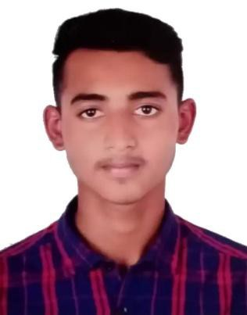

**SHAHINUR ISLAM**

**Mobile No**

**+971 557498770**



**Email**



[**kudous154@gmail.com**](mailto:kudous154@gmail.com)

**OBJECTIVE:**

To work in a position where I can utilize my skills, ability and build upon my practical experience and be part of profession organization. Seeking challenging opportunity in a progressive organization.



**PERSONAL DETAILS**

* Date of Birth : 10/10/1996
* Gender : Male
* Nationality : Bangladesh
* Passport No : BY0888478
* Passport Issue Date : 19/02/2019
* Passport Expiry Date : 18/02/2024
* Visa Status : Visit Visa (valid till 30th May 2021)



**PERSONAL SKILLS**

* Critical Thinking.
* Problem Solving.
* Customer Service Skills.
* Teamwork Skills.
* Communication



**EDUCATIONAL BACKGROUND**

10th Class Completed (Dhaka Education Board)



**LANGUAGES KNOWN**

English

Hindi



**DECLARATION**

I hereby declare that the above information is true in resume.

**SHAHINUR ISLAM**