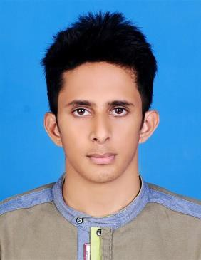

SHEFEER K S

**MOB: 0526643361**

**Email:** [**sheffirkssheffir@gmail.com**](mailto:sheffirkssheffir@gmail.com)

A Challenging Position that will give me an opportunity to use my established Technical Skills and Experience

**POST APPLIED FOR : MEP DRAUGHTSMAN/ Jr Engineer**

**WORKING EXPERIENCE : 4+ YEARS**

Worked with **CAD+ MEP Consultancy Thrissur, Thalikulam, Kerala**

**as a MEP Draughtsman/ jr. Engineer (From 7th September 2015 to 23 Dec: 2020)**

# HANDLING PROJECTS

* **Abu Dhabi Health City**
* **American School (Abu Dhabi)**
* **Al Juri 05**

# JOBS & RESPONSIBILITIES

* Depth study of Architectural Drawing
* Following the instructions of client/consultancy
* Keep the standards & instructions
* To complete the work before designated period
* Good communication with coordinator & engineers for further movement
* Maintain the symbols standard the level best
* Submit / report to the In-charge

# EDUCATIONAL QUALIFICATION.

* Diploma in MEP Engineering
* Higher Secondary Education

# CREDENTIALS

* Well knowledge about HVAC
* Deep knowledge about Design drawing & shop drawing
* Deep knowledge about Plumbing & Electrical services

# PERSONAL PROFILE

Father : Mr. SALAHUDHEEN K.A

Date of Birth : 29/09/1995

Marital Status : Single

Languages Known : English, Malayalam, Hindi and Tamil

# PERMANENT ADDRESS

Kalathiparambil House

P.O Vatanappally,Thrissur Pin-680614

# PASSPORT DETAILS

Passport Number : N2509552 Place of Issue : COCHIN

Date of Issue : 04/09/2015

Date of Expiry : 03/09/2025

# REFERENCE

SHIHAS EBRAHIM SENIOR MANAGER

CAD+ MEP Consultancy Thrissur, Kerala,India Mob: +91 9744453921

# DECLARATION

I hereby declared all the information furnished is correct to best of my knowledge.

**SHEFEER K S**