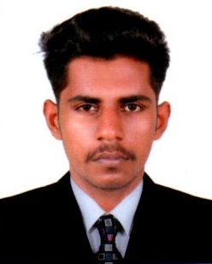

HARIKRISHNAN S
Contact: +971589775245
E-Mail: harikrishnan.s518@gmail.com

OBJECTIVE

To have a growth-oriented career in a reputed Company, where I can enhance my knowledge & gain professional experience lined with company’s objective. To perform well and serve in best efforts in whichever field that I would be assigned.
EMPLOYMENT HISTORY (2 YEARS)
JUNE 2017 to till date as Draftman and Site supervisor at NANDANA CONSTRUCTIONS Pvt. Ltd, Kerala, India.

ROLE

● Follow engineering and architectural recommendations on the blue prints when completing
construction tasks for the project.
● Order construction materials, tools and machines in relation to needs according to the schedule
of constructions.
● Counseled team members and evaluated their performance throughout the scope of the
project with appropriate personal actions when needed.
● Extensive knowledge of site safety practices and regulations.
● Strong monitoring of personal ensure project deadline met.

ACADEMIC QUALIFICATION

- Diploma in computer aided interior designing (AutoCAD 2017, 2D, 3D, PDM, (Rivet Architecture))
- AutoCAD 2017 (Credit 957 Mark)
- Artfusion 360 (Credit 918 Mark)
- Rivet Architecture (900 Marks)
- ITI/ITC Civil Engineering (2015-17), Kerala 67% (First Class)

IT QUALIFICATION

- Windows 9X/2000/XP, Vista, 7 and Linux.
- MS Word, MS Excel, MS Power Point

PERSONNEL SKILLS

- Good Team player.
- Challenging Lover.
- Self confidence.
- Comprehensive problem solving abilities.
- Responsible for other duties as assigned.

PERSONAL PROFILE

Date of Birth : 18th November 1997.

Gender : Male

Marital status : Single

Nationality : Indian

Languages Known : English, Hindi, Malayalam & Tamil

Passport No. : N 8201415

Driving License : Holding Valid Indian driving license

Visa Status : Visit Valid till 10/5/2020

DECLARATION

I hereby declare that the above-mentioned information are correct up to my knowledge, and I bear the responsibility for the correctness of the content. If I am offered an opportunity, I will discharge the duties entrusted to me, to the best of my capacity and to the entire satisfaction of my superiors.

HARIKRISHNAN S DUBAI
S/d

