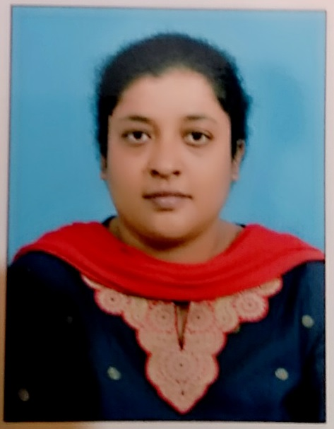

TESSY K. THOMAS, M. Sc, RN
tssykthomas@gmail.com

Job Objective Seeking Administrator position to make a useful contribution to the organization.

Highlights of Qualifications:

- Excellent experience in designing curriculum for nursing studies
- Sound knowledge of nursing principles and standards
- Profound knowledge of nursing administration
- Ability to motivate staff members for various activities
- Ability to develop academic courses for nurses
- Proficient in Microsoft Office applications
  - Engaging Nursing Lecturer effectively conveying nursing concepts and procedures in classroom laboratory and clinical settings.
  - Committed to incorporating knowledge gathered from ongoing research to educate students in nursing concepts.
  - Specialize in preparing lectures grading papers and providing meaningful feedback.

- Qualified professional in clinical nursing having experience combined with administrative skills and staff leadership, resulting in high-performing medical units with exceptional quality and service standards.
- To develop and execute programs, improvising productivity and effectiveness with a focus on effective patient care.
- Experienced as skillful educator nurse with sound knowledge of the patient care and nursing services having computer and Interpersonal communication skills.
- Proficient in medical surgical nursing having knowledge of advanced devices used and upcoming technologies. Skilled in collaborating with cross functional team meeting needs of patients in demanding environments. Applying a solution-oriented approach to resolve conflict, manage staff, and work with strategic partners to achieve optimal results.
- SKILLS:
- Orientation skill in planning and implementation of the educational programs.
- Sound knowledge of the mandatory training requirements, measurements and tools for achieving goals.
- Profound ability to adapt the environment easily and strong demonstration power.
- Good communication skills and interpersonal skills.
- Ability to develop and design the training program according to the need of students.
- Analytical and critical thinking, problem solving.
- Creative and having a strong clinical background.
- Analyze and assess student’s ability and course material.
- Able in provide the feedback to the students according to their performance.
- Ability to train and educate new students and direct them in using medical equipments.
- Interpersonal and organizational skills as well as leadership quality
- Skilled in motivating students for effective results in their respective task.
- Assigning projects to the students and directing them in being effective at work.
- Providing example of best practices to the students and demonstrating them the work.

- Handling current subjects in Medical Surgical Nursing, Biochemistry, Pharmacology, Management subjects and Research program in various disciplines.
- Core Qualifications
- ¥ Significant understanding of nursing practices
¥ Strong ability to engage students and encourage participation
¥ Ability to provide instruction in laboratory and clinical settings
¥ Proficient in the use of MS applications
¥ Excellent public speaking abilities
¥ Extensive communications skill

Responsibilities:
- Maintained subject matter expertise for administrative and teaching activities.
- Administered clinical and classroom teaching for post graduate and undergraduate programs.
- Participated in development of course and other related curriculum.
- Designed appropriate learning materials in coordination with senior staff members.
- Facilitated students for various workshops and simulation activities.
- Provided instructions in both traditional and non-traditional learning methods
- Coordinated with faculty members to develop courses.
- Participated in preparing content for community health nursing programs.
- Supervised efficient working of students in clinical area.
- Performed research for various department activities.
- Ensured optimal quality for nursing programs.
- Prepared presentation for various community programs.
** Presently responsible for students from MSc (N), PBB.Sc (N),BPT, B.Sc. (N), BMLt, Gnm academics.
** Assisting in Inspection for MSc (N),PBBSc (N),BPT, B.Sc (N), BMLt,Gnm programs.
** Teaching MSc (N),PBBSc (N),BPT, B.Sc (N), BMLt,Gnm nursing students
Technical skills and competence in clinical area:
** Have sound knowledge in demonstrating the use of ventilators, defibrillator, cardiac monitoring, CVP monitoring, IABP, ECG, Hemodynamic monitoring and Dialysis.
** To manage critically ill patients in ICU, CCU, in providing basic life support and assisting in advanced life support, in-service education, precipitating in nursing research.
Education and professional qualifications:

- Master of Science in Nursing (2012 -2015)
(Cardiovascular and thoracic under Medical Surgical Nursing)
Aruna Institute of Nursing Education, Tumkur, Karnataka RGUHS
Rajiv Gandhi University of Health Sciences, Bangalore Karnataka (2012)

- Bachelor of Science in Nursing (2008-2010)
(Post Basic B.Sc Nursing)
M S Ramaiah Institute of Nursing Education and Research, Bangalore, Karnataka RGUHS

- Diploma in nursing (2002-2005)
(General nursing and midwifery)
M S Ramaiah Institute of Nursing Education and Research, Bangalore, Karnataka KSDNEB

ADDITIONAL QUALIFICATION:
- Specialized in Critical Care Nursing (Cardiology) (2007-2008)
CONTINUES NURSING EDUCATION PROGRAME from
St. John’s National Academy of Health Sciences, Medical and Teaching Hospital, Bangalore, Karnataka
PROFESSIONAL DETAILS:
NURSING PRACTICE LICENSE:

Certified as RN and RM by Karnataka Nursing Registration Council (KNC)

- Msc NURSE REG NO: 008382 23 JAN 2016

- P.BSc NURSE REG NO: 2823 30 APRIL 2011

- Gen NURSE MIDWIFE REG NO 63726 23 JAN 2006

WORK EXPERIENCE:

- Royal College of Nursing, Bangalore. (Oct2015-2018)
M.Sc (N) ‘Lecturer’ In Department of Medical Surgical Nursing.

- Aruna institute of Nursing Education, Tumkur (Nov2011-Aug2012)
Nursing Tutor

- Columbia Asia Multi-National Hospital, Bangalore (Dec2010-June2011)
Sr. Staff Nurse in Intensive Care Unit (ICU)

- St.John’s National Academy of health sciences and Research, Bangalore (Sept 2006-Aug 2008)
Sr. Staff Nurse in Critical Care Unit (CCU)

- St.John’s National Academy of health sciences and Research, Bangalore (Jan2006-Sept2006)
Junior Staff Nurse in Medical, Surgical, OBG, Deluxe rooms, suite rooms and ICU

COMPUTER SKILLS:
** MS office, Word, Excel and PowerPoint.
** Windows 2007, 7 and 10.
** Internet, Literature Search.
** Statistical Packages.
** Use of computers in teaching, learning and research.

RESEARCH EXPERIENCE’S MSC NURSING, B.SC NURSING
- “A descriptive study to assess the knowledge on factors causing delay in institution of treatment among patients with cardiovascular disease at a selected hospital, Tumkur with a view to develop Self instructional module.” 2015 -Masters Dissertation

- “A descriptive study to assess the factors causing delay in institution of treatment among patients with cardiac problem at MSRMH hospital, Bangalore.” 2010- Post Basic Bsc Nursing Dissertation

- “A analytical study to access the factors causing delay in institution of treatment of patient with cardiac problem at St. John’s medical teaching hospital. Bangalore2007-2008-CCN (CARDIOLOGY) Continues Nurses Education program.
** Certification course on
Basic Life Support and Advance Cardiac Life Support
St. John’s National Academy of Health Sciences Medical Hospital, Bangalore 2006 And from COLUMBIAASIA hospital Bangalore 2011

** Attended conferences on NORKA ROOTS-2016
**Attended workshop “RESEARCH METHODOLOGY”MSRINER-2017

PERSONAL DETAILS:
Age & Date of birth : 35yrs. & 26th December 1982
Marital status : Married
Husband Name : Sunil Thomas
Child : 9yrs old Son Jeremiah Sunil Thomas
Language proficiency : English, Hindi, Kannada, Malayalam, Tamil, arabi.

Declaration:
I hereby declare that the above information is true to the best of my knowledge

Date:
Place:

