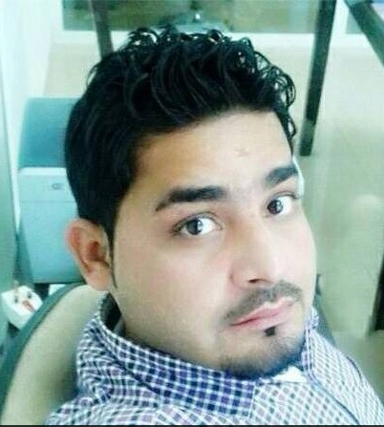**Muhammad Zubair**  
Tel: 00 971 52 9650636  
Email: [rajaz27@yahoo.com](mailto:rajaz27@yahoo.com)

Objectives:

Seeking any position for in a growth oriented company that allows me to, showcase my potential and experience for the advancement of the organization. Looking forward to, an opportunity to, serve the organization to the best of their interest by providing all the dedication and hard work to achieve the result.

### Experience:

*Hotspot Group of Internet café and Restaurants Dubai UAE*

*July 2010 – February 2013.*

*Position:* clerk

**Responsibilities:**   
Entered customer billing data into the computer system.

Responsible for the filing of billing requisitions as well as the retrieval of archived requisitions.

Performed a variety of general clerical jobs.

Responsible for accurate archiving and retrieval of billing requisitions.

Al Muaini Service line Coring Ditching and Building Contracting LLC.  
January, 2014 to Present.

*Position: (Document Controller)*

**Responsibilities:**

**(ADMINISTRATION DEPARTMENT)**

Archived and keep various for Construction and Legal documents.  
 Preparing all documents to be reviewed and signed by Project Manager.  
 Filling of Variation / Change Order, Revision of plans and Site Instruction of Construction Project Manager.  
 Preparing Request of Submittals, Pouring Request, Request for Information and Transmittals of documents to Superior, Construction Project Manager, and Subcontractors.  
Answer phone calls, follow-up delivery of materials for construction and follow-up issuance of cash or check from head office for site office use.  
Expedite company weekly petty cash for site office use.

**CASH COLLECTION:**   
Ensure that revenue invoices are issued according to contract and get paid on timely manner.  
**ACCOUNTING:**   
Ensure that Invoices are correctly posted, in accordance with company’s policies.

**TRANSPORT SUPERVISOR**

Ensure implementation day-to-day activities of transportation.

Supervise workloads, schedule, tasks and other related functions.

Maintain and manage all databases relating to transportation activities.

Ensure compliance of safety standards in transportation functions

**PRO**

Having experience new visa, visa renewal, medical id and online visa processes

### Education:

* Metric
* Certificate in Office Management

### Skills:

Great leadership skills  
Great customer service and communication skills  
outgoing, eager to learn personality  
open availability  
Knowledge of Microsoft Word, Excel,

**Languages:**

* Fluent in English, Hindi Urdu Punjabi and Arabic

**Hobbies and Interests:**

* During the 2005 Pakistan Earthquake I had volunteered and raised money for charity to help transport food and medicines to remote and inaccessible areas of Kashmir and KPK.
* Enjoy playing cricket, football, table tennis and cycling.
* Like reading novels, news articles.

**Personal Information:**

* Father’s Name: Muzaffar Hussain
* DOB: 25th August, 1986
* Marital Status: Single
* Nationality : Pakistani
* Current location: Dubai, United Arab Emirates.

**Driving License: Valid UAE driving license # 3.**