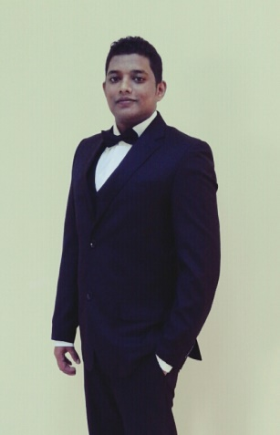

**PERSONAL INFORMATION**

MOHAMAD SHARIFDEEN MOHAMAD VOLEED

5000 Man camp, King Khalid military city, Hafar Al batin, Dammam

MOBILE:- +966503346228 WhatsApp:- +94756534177

Email: - [Voleedmsm.31@gmail.com](mailto:Voleedmsm.31@gmail.com)

**Objective:**

I have 8 years of experience in F&B Department. My primary objective as a Head waiter is to ensure prompt and courteous service to the customers and make them feel special and important. I can fulfill this by seeing to it that every customer’s need and requests are attended.

**PERSONAL DETAILS**

* Full Name :Mohammad Sharifdeen Mohammad Voleed
* Date Of Birth : 31st Of March 1993
* Age : 29
* Gender : Male.
* Civil Status : Single
* Religion : Islam
* Nationality : Sri Lankan
* School Attended : Hindu College, Rattota

**PROFFESIONAL QUALIFICATIONS**

* Successfully completed Diploma in INFORMATION TECHNOLOGY
* Successfully completed Hotel Operation Course at Government Hotel School Matale.(REDA), covering the below modules:

1. Food & Beverage
2. House Keeping
3. Front Office
4. Professional cookery and International Cookery

**WORK EXPERIENCE**

* **TREE OF LIFE – Kandy – Sri Lanka**

**Waiter (F&B) Aug 13 – Feb 14**

* **Kinnaree Contemporary Thai Cuisine Colombo Sri Lanka**

**Waiter (F&B) Mar 2014 to Aug 14**

* **The Ritz Carlton Abu Dhabi Grand Canal - Waiter at Mijana Restaurant (**LEBANESE CUISINE**)**

**08th June 2015 – 15th April 2017**

* **Ministry of defense and aviation Dammam - Waiter**

**7th October 2017 – 02nd October 2019**

* **Ministry of defense and aviation Dammam – Head Waiter**

**03rd October 2019**

(Currently working here)

**EDUCATIONAL QUALIFICATIONS**

* Passed G.C.E. A/ Level Examination 2012

**REFERENCES**

1. **Mr. Hussein asfan**

Manager, the Ritz Carlton Grand Canal,

Abu Dhabi.

Tel: +971-50 615 7408

1. **Mr. Thuwan**.

Food and beverage Supervisor

Ministry of defense and Aviation Riyadh

Tel: +966-552 481 275

1. **Mr.Mohideen**

Consultant Chief Instructor

Regional Economic Development

Agency,

Hotel School, Matale, Srilanka.

Tel: +94-77 731 8444