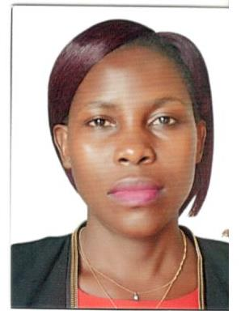
NAME : RUTH NAMUJUZI

MOB : +971555947470

EMAIL ID : ruthnamujuzi@gmail.com
ADDRESS : ABU DHABI, UAE
Date of Birth : 01-08-1992
Gender : Female
Marital Status : Single
Nationality : Uganda
Visa Status : Visit Visa
Languages : English

APPLIED FOR HOUSEKEEPING

CAREER OBJECTIVE:

Brilliant, reliable and courteous Cleaning with over two years’ extensive experience in performing cleaning and sanitation work at commercial. Eager to create and maintain a hygienic and clean environment on employer’s premises. Uses manual and automatic cleaning equipment safely.

SKILLS:

- Good math skills to maintain the inventory of cleaning supplies
- Excellent physical stamina
- Thorough understanding of health and safety protocols and regulations
- Ability to comply with job and safety instruction
- Team player who has a strong ability to motivate others and resolve conflicts.
- Hard working, creative, honest
- Excellent interpersonal, verbal and written communication skills
- A friendly, cheerful, and polite attitude
- Flexible with working hours

WORKING EXPERIENCE:

Company : Byansi Clinic
Position : Housekeeping
Location : Uganda
Duration : 2 years

RESPONSIBILITIES
- Cleaned and sanitized restroom and other areas of the Clinic to ensure patient and employee safety
- Emptied waste baskets to eliminate hazards from the Clinic
- Replenished soap and paper supplies to ensure cleaning supplies for safety
- Changed sheets and linens in Clinic room to meet a patient everyday needs
- Use powered equipment where needed

EDUCATION BACKGROUND:

- A Level Certificate
- O level Certificate

PASSPORT DETAILS:

- Passport No. : B1569281
- Issue Date : 19-12-2017
- Date of Expiry : 19-12-2027

DECLARATION:

I hereby certify that the above information are true and correct according to the best of my knowledge and belief.

