**CURRICULUM VITAE**

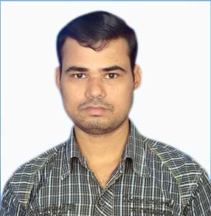**DULLABHA SAHU**

ChandiGhosh Building, A.T. Roy Road,

P.O.-Talpukur, Dist.- 24 Pgs. (N),

Kolkata-700123, West Bengal, India

Contact No. : 0588238924

EMAIL:- dulabhasahu@gmail.com

……………………………………………………………………………………………………………

**KEY SKILLS:**

Enthusiastic, responsible, Flexible, can handle work under pressure, always willing to accept significant responsibility and involvement and very quick learner.

**POST APPLIED FOR :** Waiter/House Keeping /Office Assistant

**WORKING WXPERIENCE:**

|  |  |  |  |
| --- | --- | --- | --- |
| **Sl. No.** | **Name of the Organization** | **Designation** | **Period** |
| 01 | Sanjeevini Restaurant (Rajmandry, AP ) | Waiter | 2 year |
| 02 | Dolphin Hotels (Visakhpatnam, AP ) | Waiter/House Keeping | 2 year |
| 03 | Fabcon Industrial Services FZ L.L.C.  (Ras al khaima, UAE) | Office Assistant | 2 year |
| 04 | Fabcon Industrial Services FZ L.L.C.  (Ras al khaima, UAE) | Office Assistant | Still date |

**PASSPORT DETAILS:**

Passport No. : R 4872939

Date of Issue : 07/09/2017

Date of Expiry : 06/09/2027

Place of Issue : Kolkata (West Bengal, India)

**PERMANENT ADDRESS: PRESENT ADDRESS:**

DULLABHA SAHU DULLABHA SAHU

ChandiGhosh Building, A. T. Roy Road, ChandiGhosh Building, A. T. Roy Road,

P.O.- Talpukur, Dist.- 24 Pgs. (N), P.O.- Talpukur, Dist.- 24 Pgs. (N),

Kolkata-700123, West Bengal, India Kolkata-700123, West Bengal, India

**PERSONAL INFORMATION:**

Name : **DULLABHA SAHU**

Father’s Name : GovindaSahu

Date of Birth : 20/11/1982

Sex : Male

Marital Status : Married

Religion : Hindu

Nationality : Indian

Near Railway Station : Titagarh&Barrackpore

Educational Qualification : 10th Pass

Computer Knowledge : MS Excel, MS Word

**DECLARATION:**

I hereby declare that all the information furnished by me is true and fair to the best of my knowledge and I shall be sorely responsible for all of the declaration made above.

**LOOKING FORWARD FOR YOUR POSITIVE RESPONSE.**

Date:

DULLABHA SAHU

Place: …………………………………………