CURRICULAM VITAE

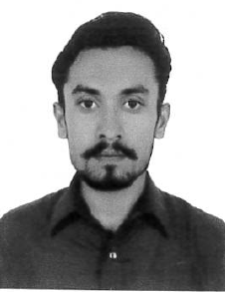  Muhammad Amir Khan  PERSONAL DATA:  Name : Muhammad Amir Khan  Father name : Liaqat Ali Khan  Date Of Birth : 20/MAR/1995  Gender : Male  Nationality : Pakistan  Marital Status : Single  Email : ak8947891@gmail.com  Mob : 00971-523006379  Languages known.  - Arbic {Very Good}  - Engligh {Very Good}  - Urdu {Excellent}  - Saraiki {Excellent}  - Hindi {Excellent}  - Punjabi {Excellent}  - Pushto {Home Language}  Passport Details  Passport No. : RY4136011  Date of Issue : 29/09/2016  Date of Expiry : 28/09/2021 | Post Applied for AC Technician.  Seeking a challenging career by occupying a suitable position, utilizing my Skills and Experience to contribute towards the Progress of the Organization and the same time has the Prospectus for Professional growth and Development of my career  AC TECHNICIAN  Pakistan Experience.  - 11 years Of Experience As AC senior Technician.  UAE Experience.  - Currently Working In Power Magic Electrical Works LLC Dubai Since 2018.  - Intermediate  (board of intermediate & secondary Education Kachi Paind Khan (D.I.Khan) Pakistan)  - Install, inspect, maintain, and repair air conditioner.  - Perform regular maintenance work on cooling units.  - Diagnose electrical and mechanical defects and malfunctions.  - Install, replace, or repair equipment that has been damaged.  - Make adjustment and do calibrations of thermostatic controls.  - Clean blowers and coils, check tensions of belts and motors.  - Organizing skills  - Communication  - Hard working  - Target oriented  I hereby declare that the above-mentioned information is correct up to my knowledge and I bear the responsibility for the correctness of the abovementioned particulars.
  Objectives
  Professional Experience
  Academic Qualifications
  Area Of Experience
  Personal Skills
  Declaration

