**Resume**

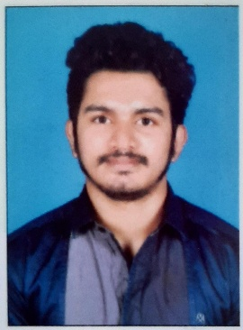

**Richard Brice**

**Mail id:** [bricerichard115@gmail.com](mailto:bricerichard115@gmail.com)

**Visa status**: visiting visa

**Passport number**: U4573430

**Current location**: Sharjah

**Mobile number**: 0565872731

**CAREER OBJECTIVE**

To work for a progressive organization in a highly motivating and challenging environment that provides the best opportunities to grow and utilize my potential to the fullest to achieve the organization’s goal while achieving my personal goals.

**EDUCATIONAL PROFILE**

|  |  |  |
| --- | --- | --- |
| **COURSE** | **YEAR** | **Institution/ University** |
| B.com( Taxation) | 2017-2020 | M.G University |
| Higher secondary | 2015-2017 | Church View College Ponkunnam |
| SSLC | 2014-2015 | JJ Murphy Memorial School Yendayar |

**PERSONALITY TRAITS**

* Good Communication skills & Positive Thinking.
* Sincere hard work & motivation.
* Confident & optimistic in arriving at a solution.
* Eagerness to learn new things

**TECHNICAL SKILLS**

* Good knowledge in Microsoft Word, Excel, Power Point
* Good knowledge in Tally
* Time management
* Team player
* Having fast learning skills for any technology

**STRENGTHS**

* Determinant to work
* Self-confidence
* Goal oriented
* Flexibility

**PERSONAL profiles**

Name : Richard Brice

Gender : Male

Fathers Name : Brice V Mangalam

Date of Birth : 28-07-1999

Marital Status : Single

Nationality : Indian

Hobbies : Motorcycling, Travelling, Music, Football   
 Permanent address : flat no 306,Noushad cafeteria building

Near Al Zahra hospital, Sharjah

Phone no : 0565872731

Language known :English,Malayalam,Hindi

**DECLARATION**

I hereby declare that the above information is correct to the best of my knowledge and belief.

:(Richard Brice)