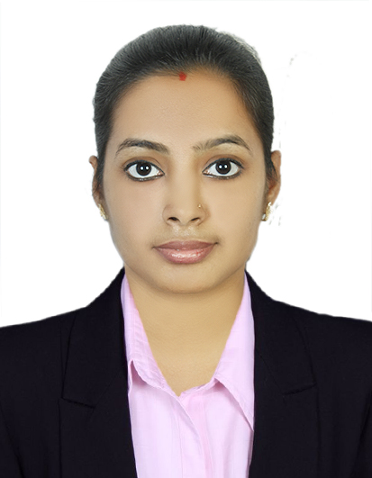
Gayathri Suresh
gayathrisuresh993@gmail.com
+971-0527279830
Villa No :58,
33A Street,
Rashidiya,
Dubai,UAE.

Objective

Looking for a challenging position in Admin Assistance with my demonstrated track profile in utility industry with an experience of 12 months Willing to provide the best of my experience in the field of HR and Admin.
Strengths

Optimistic, Hardworking and Capable to work under pressure
Good communication and interpersonal skills
Ready to take on challenges and fulfill goals
Coordination and handling of tough situations
Confident, Intelligent, ability to work hard and emotional stability

PROFESSIONAL WORK HISTORY

Admin Assistance
Mediators consultancy, Tamilnadu,India. (Dec17 To Jun18)
- Providing customer service
- Coordinating between departments and operating units in resolving day-to-day administrative and operational problems
- Sending out and receiving mail and packages
- Preparing business correspondence, agendas, and presentations, typically using Microsoft Office (Word, Excel, PowerPoint, Access, Outlook)
- Managing documents and files
- Sending and receiving documents for the company
- Answering the phone
- Operating a range of office machines such as photocopiers and computers
- Managing mailing or distribution lists as needed
- Greeting guests and visitors.

RECEPTIONIST CUM CASHIER

M.N.EYE.HOSPITAL.Pvt.Ltd. Tamilnadu,India. (NOV18 TO SEP20)
- Greet to patients.
- Register patients according to established protocols.
- Assist patients to complete necessary forms and documentation including medical insurance.
- Ensure patient information is accurate including billing information.
- Inform patients of medical office procedures and policy.
- Maintain and manage patient records.
- Move patients through appointments as scheduled.
- Answer incoming calls and deal with inquires.
- Transfer calls as required. schedule patient appointments.
- Manage daily balancing and reconciling of office accounts and handle daily bank deposit
- Enter all payments received from suppliers, cafeteria and pharmacy into designed databases.
- Records returned checks into patient accounting systems and initiate follow – up.
- Maintain petty cash logs, receipts and balances.
- Coordinate activities with the accounting department to ensure the creation of daily, weekly, and monthly reports.

Technical Skills

- Windows98/Me/XP professional
- MS-word, Excel, Power point

Certificates

- Master of Arts (human Resources management)

EDUCATION

- Master of Arts (Human Resource Management) with (80%) First Class (2015-2017) SRI Kanyaka Parameshwari COLLEGE OF ARTS AND SCIENCE Chennai, affiliated to MADRAS University Chennai.

Specialization: HRM (9th Rank holder)
- Project work done on ‘Workers participation in management’ in SRF Ltd’, At Manali.
- Bachelor of Business Administration with First Class (68%) (2012-2015) SRI Kanyaka Parameshwari COLLEGE OF ARTS AND SCIENCE Chennai, affiliated to MADRAS University Chennai.

- Project work done on ‘Effectiveness of employers and employees’ in Chennai port trust’, At Chennai.
- HSC with (73%) First Class from Muruga Dhanushkodi Girls Higher Secondary School, Chennai from Board of Secondary education Tamilnadu.

- SSLC with (74%) First Class from Muruga Dhanushkodi Girls Higher Secondary School, Chennai from Board of Secondary education Tamilnadu.

PERSONAL INTEREST

Internet | Cinema | Games

LANGUAGES

English, Malayalam and Tamil.

PERSONAL DETAILS

Date of Birth : 10/02/1995
Sex : Female
Nationality : Indian
Visa Status : Visit Visa (Exp: 10 Dec 2020 )
Religion : Hindu
Marital Status : Marrieds

REFERENCES

References are available on request.

Date: Signature:

