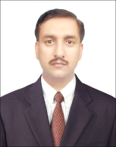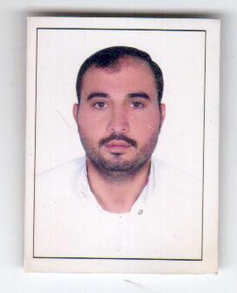

**CURRICULUM VITAE**

**Post Applied For: Light vehicle Driver**

**Naseem Ul Haq**

Mobile: **0527325005 /what's up**

**0507138973**

**Email: rajanaseem1@gmail.com**

**Objective:**

Seeking a suitable position, where my past experience would be fully utilized in a career opportunity and where would make a significant contribution to the success of my employer will be gained me a career advancement.

**Personal Profiles:**

Father’s Name : Haji Mohammed Saleem

Gender : Male

Religion : Islam

Nationality : Pakistani

Marital Status : Married

Languages Known : English, Arabic & Urdu

**Passport details:**

Passport Number : AA6557753

Place of Issue : Dubai

Valid up to : 12 Mar 2025

**License details:**

License Number : 503274/A

Place of Issue : Abu Dhabi, UAE

Date of Issue : 03-09-2005

Valid up to : 02-08-2025

Vehicle Permitted : Light vehicle & Heavy Bus (3&6)

**Educational Qualification:**

* S S C

**Work Experience:**

* **Making attendance sheet for the HR department on monthly basis.**
* **I am working as transport renew registration maintains of all vehicles and handle petty cash for daily expenses and bank transition**
* **Al Mostajed Technologies Co. LLC Light vehicle driver (March 8,2014 to 23july 2019)**
* **Gloria Hotel Dubai Media City Light vehicle driver (May 5, 2013 to 19 January 2014)**
* **SIDEM in F2 Sea Water Desalination**

**Power and Water Plant Fujairah (July 9, 2008 to February 28, 2011)  
Light vehicle driver.**

* **Light Vehicle Driver in Al Ghazal Transport (May2007-June2008)**

**A Division of Abu Dhabi National Hotel, Abu Dhabi.**

* **Driver cum sales man Al Bouhira Lacnor N.F.P.C Abu Dhabi (2003-2007)**
* **Light Vehicle Driver (M/S First Choice General Maintenance company Dubai) (Feb 1999 to Oct 1999).**
* **Light Vehicle Driver (M/S Al Rayaan Aluminum Works, KSA) (1995-1998).**

**Declaration:**

**I hereby declare that all the information’s furnished above are true and correct to the best of my knowledge and belief.**

**Naseem Ul Haq**