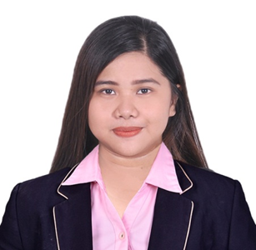
Patricia Monique Exconde

OBJECTIVES
To be able to work in a prestige company where I can apply my skills and abilities and to enhance my strengths and capabilities.

EDUCATIONAL BACKGROUND

TERTIARY:
Dalubhasaan ng Lunsod ng San Pablo
“Bachelor of Science in Hotel and Restaurant Management”
2020

SECONDARY:
Manuel S. Enverga University
High School
2012-2015

WORKING EXPERIENCE

Clyde’s Bread and Pastry
(San Pablo City Laguna)
Position: Service Crew /Barista

PERSONAL DATA

Age: 22
Gender: Female
Status: Single
Birth Date: May 4, 1998
Birth Place: San Pablo City
Nationality: Filipino
Religion: Roman Catholic
Height : 5’2”
Language: Filipino and English
Skills: Ability to work under pressure
Computer Skills
( Microsoft word, Excel, PowerPoint)

Jumerah, UAE
Contact #: +971581893815
Email Address: epatriciamonique@gmail.com

EXTRA-CURRICULAR ACTIVITIES

Food and Beverage Service, Catering Service and Housekeeping Bed Making Seminar

Marriott Hotel Manila
Pasay City, Manila
October 02, 2015

Hotel Overview, Front Office Operations and Bartending Seminar

The Heritage Hotel Manila
Pasay City, Manila
October 02 - 03, 2015

Simple treats Restaurant
San Pablo City
300 hours On-the-Job Training
Under Food Production and Food Services Development

Sto. Thomas Suites
Sto. Thomas, Batangas City
600 hours On-the-Jobe Training
Housekeeping Department

Certificate of Barista 2021
San Jose, Batangas
Brightwell Technical Assessment Center

CHARACTER REFERENCES
Mr. CARTNEY C. LAGAYA
College Professor
Dalubhasaan ng Lunsod ng San Pablo,
San Pablo City
Contact Number: 09205722329

Information is true and correct according to the best of my knowledge and belief.

PATRICIA MONIQUE EXCONDE
Applicant

