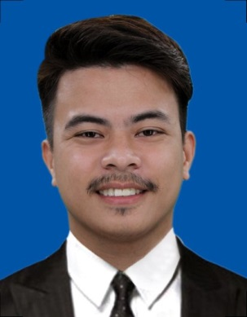***EUGENE S. VILLAVERDE***

*Al Karama Dubai, UAE*

**santiagoeugene92@gmail.com**

*+97156 472 7943*

***OBJECTIVES***

Seeking a position with a demanding environment where I can use and apply all my knowledge and skills that would enable me to reach the goals of the company.

***EDUCATIONAL BACKGROUND***

**TERTIARY BESTLINK COLLEGE OF THE PHILIPPINES**

Brgy. Sta. Monica, Quezon City

Hotel and Restaurant Services

2014-2015

**SECONDARY**  **CAMARIN HIGH SCHOOL**

Cadena de Amor St. Camarin, Caloocan City

S.Y. 2012

**PRIMARY** **CAMARIN D.ELEMENTARY SCHOOL**

Camarin D. Caloocan City

S.Y. 2005

***SKILLS & ABILITIES***

* Ability to work under pressure
* Attention to detail
* Computer Literate (Microsoft Word)
* Dependable
* Self-motivated
* Excellent guest, customer, and employee relations skills
* Experience creating recipes for food preparation
* Knowledge and understanding of food, beverage, and labor and safety rules and laws

***WORKING EXPERIENCE***

***Receptionist*** *November 2018 – March 2020*

***Smart Power General TRD***

***(Kuwait)***

***Messenger*** *December 2016 - May 2017*

***Trees Residences Condominium***

***(SMDC)***

***Messenger*** *May 2016 - November 2016*

***Flash Cargo Logistic***

***Warehouse Agent*** *October 2015 - March 2016*

***Manila Catering***

***Sales Agent*** *` January - September 2013*

***Pinoy Genie Corporation***

***Sales Agent***

***RGG Enterprise*** *October 2013 - March 2014*

***SEMINAR ATTENDED***

***HOTEL FAMILIRIZATION/OPERATION SEMINAR***

*“Globalization and the Challenges in the Hotel World*

*Industries for Future Hostiliers and Restaurants”*

*Held on February 3-4, 2015 at M&H Subic Inc.*

***PERSONAL INFORMATION***

***Name:****Villaverde, Eugene Santiago*

***Age:*** *28 Yrs. Old*

***Gender:*** *Male*

***Height:*** *5’10 ft.*

***Weight:*** *143.3 lbs.*

***Date of Birth:*** *October 3, 1992*

***Place of Birth:*** *Caloocan City*

***Religion:*** *Catholic*

***Mother:*** *Racquel S. Villaverde*

***Father:*** *Romeo V. Villaverde*

***Contact no. :*** *09122133005*

***Occupation:*** *Motorcycle Mechanic*

***CHARACTER REFERENCE***

**RAMBO JAYOMA** Bestlink College of the Philippines

College Professor

09078185209

**SUMMY SAMSONA** Bestlink College of the Philippines

College Professor

09472165701

**CLARICE S. SORIANO** Barangay 175, Camarin, Caloocan City

Office Clerk

09055999222

*I hereby certified that the above information is true and correct to the best of my knowledge and belief.*

**EUGENE S. VILLAVERD**