SANDRA C. SUYMAN 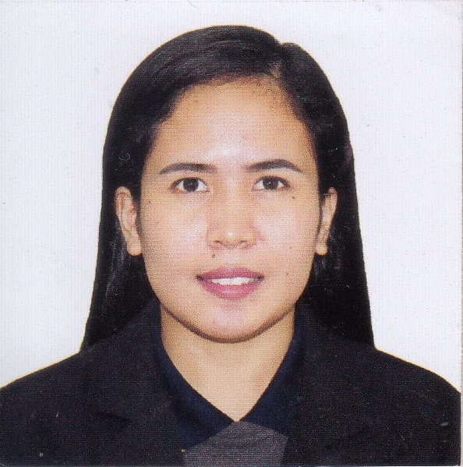
Sheik Majid Building Businessbay Dubai, United Arab Emirates
Email add: Zandrinacruz@gmail.com
Contact Number: 0565665887

OBJECTIVES:
- To be able to work in your company to utilizing my knowledge, expanding my previous work experience, to provide assistance support to financial needs and develop self-motivation as an individual.
- To continuously develop discovered potential and enhance the development of more in a business environment conductive to learning.
- Pay loyalty and best contribution to the company that will give me the opportunity to grow as a professional in my field of specialization.

QUALIFICATION SUMMARY:
A hardworking person who can works under pressure and can work independently trustworthy and reliable.

SKILL AND CAPABILITIES:
- Flexibility
- Responsible and passionate workers
- Work under minimal supervision
- Open to all learning options
- Diligent and sees to it that goals set are just met exceeded
- MS Office Application

JOB EXPERIENCE:

Cashier / Waitress at Dip n Dip Hot Chocolate

Sharjah, Uae (august 31,2018 – september 11, 2020

- Handling all cash transaction
- Make order, suggest and upsell our products.
- Follow and maintain the hygiene and cleanliness procedure of the restaurant.
- Greet the incoming and outgoing customer from the restaurant.
- Do daily cash report and store inventory report.

GENEVIEVE GOZUM

SM City Baliwag, Bulacan Philippines (APRIL 27,2015 -SEPTEMBER 26, 2015)
POSITION – SALES STAFF
- Greeting customers who enter the shop.
- Be involved in stock control and management.
- Assisting shoppers to find the goods and products they are looking for.
- Being responsible for processing cash and card payments.
- Stocking shelves with merchandise.
- Answering queries from customers.
- Reporting discrepancies and problems to the supervisor.
- Giving advice and guidance on product selection to customers.

SM PRIME HOLDINGS

SM City Baliwag, Bulacan Philippines (APRIL 18,2015 -NOVEMBEREMBER 18, 2015)
POSITION – MARKETING STAFF
- Assisting with promotional activities.
- Helping to organize market research.
- Compiling and distributing financial and statistical information such as budget spreadsheets.
- Writing reports, company brochures and similar documents.

ALFAMETRO MARKETING INC.

SM CORPORATE OFFICES, MALL OF ASIA COMPLEX, PASAY CITY PHILIPPINES

POSITION – Store leader/cashier
- Greet the customers entering into organization
- Handling the selected products transaction of an organization
- Checking and monitoring product delivery and orders
- Guiding and solving queries of customer
- Providing training and assistance to new joined employee
- Maintaining monthly, weekly and daily report of transactions

Mariel Food (McDonald's)

Baliwag,Bulacan Philippines (February 17, 2012- July 17, 2012)

POSITION – SERVICE CREW / CASHIER
- The first duty of cashier is to greet the customers entering into organization
- Handling all the cash transaction of an organization
- Receive payment by cash, credit card etc.
- Checking daily cash accounts
- Providing training and assistance to new joined cashier

SEMINARS and TRAINING ATTENDED

TRANSCENDING VISION OF EXPERTS
Baliwag Polytechnic College, Baliwag Bulacan
Graduated: November 24, 2011
On the Job Training:
Galilee Wonderland Waterpark and Hotel (Housekeeping / Reception)
San Pedro Highway Bustos, Bulacan Philippines

December 11, 2012 to March 16, 2013
SHAJRAH MUNICIPALITY (2019)
Food and safety procedure

EDUCATIONAL BACKGROUND
TERTIARY

Course: HOTEL & RESTAURANT MANAGEMENT
Baliwag Polytechnic College
Baliwag, Bulacan, Philippines
Graduated April 2013
PERSONAL BACKGROUND
Nationality – Philippines Gender - Female
Date of birth – September 3 ,1992 Religion – Roman Catholic
Language Spoken – English – Tagalog Height – 5’3

